SIGNATURE PAGE

______________________________
David Robert Jones, P.E.
Hazen and Sawyer

05/29/2020
Date

______________________________
M. Scott Goldman, P.E.
Woodard & Curran, Inc.

05/29/2020
Date

Table of Contents
SECTION PAGE NO.
1. Background and Approach Summary 1-1
1.1 Facilities Master Plan Goals 1-1
1.2 Facilities Master Plan Approach 1-1
1.3 Facility Description 1-3
1.4 Plant Overview and Upgrade History 1-3
1.5 Existing Facilities 1-4
1.5.1 Preliminary Processes 1-5
1.5.1.1 Influent Lift Stations 1-6
1.5.1.2 East Hydraulic Structure 1-6
1.5.1.3 Influent Metering Station 1-6
1.5.1.4 Septage Receiving 1-7
1.5.1.5 Bar Screens 1-7
1.5.1.6 Grit Removal 1-7
1.5.2 Primary and Secondary Treatment 1-8
1.5.2.1 Primary Clarifiers 1-8
1.5.2.2 Primary Sludge Pumping 1-9
1.5.2.3 Secondary Treatment 1-10
1.5.2.4 RAS Pumping Systems 1-13
1.5.2.5 WAS Pumping Systems 1-13
1.5.3 Nitrogen Removal Carousel 1-14
1.5.4 Solids Handling 1-14
1.5.4.1 Solids Thickening 1-14
1.5.4.2 Anaerobic Digestion 1-15
1.5.4.3 Digester Gas Management 1-16
1.5.4.4 Sludge Dewatering 1-17
1.5.4.5 Solids Storage 1-17
1.5.5 Disinfection 1-18
1.5.6 Odor Control 1-18
2. Asset Inventory 2-1
2.1 Introduction 2-1
2.2 Data Collection 2-1
2.2.1 Above-Ground Assets 2-2
2.2.2 Yard Piping 2-2
2.2.3 Data Attributes 2-5
2.3 Asset Register Framework 2-5
2.3.1 Asset Identification and Asset Tagging System 2-8
2.4 Summary 2-8
3. Condition Assessment 3-1
3.1 Condition Assessment 3-1
3.1.1 Introduction 3-1
3.2 Focused Condition Assessment 3-1
3.2.1 Remaining Useful Life 3-3
3.2.2 Consequence of Failure 3-4
3.2.3 Assets Identified for Field Condition Assessment 3-5
3.3 Field Condition Assessment Approach 3-6
3.4 Field Condition Assessment Results 3-8
3.5 Updated Remaining Useful Life 3-12
3.6 Summary of Findings 3-13
4. Risk Assessment 4-1
4.1 Business Risk Exposure Methodology 4-1
4.1.1 Probability of Failure 4-2
4.1.2 Consequence of Failure 4-3
4.2 Risk Results 4-4
4.2.1 Probability of Failure Summary Results 4-4
4.2.2 Consequence of Failure Summary Results 4-8
4.3 Business Risk Exposure Summary Results 4-14
5. Facility Planning Assumptions 5-1
5.1 Current Projects with Potential Impacts to the Facilities Master Plan 5-2
5.1.1 East Valley Water District Sterling Natural Resource Center 5-2
5.1.2 East Valley Water District Sewer Exchange Flow Agreement 5-3
5.1.3 Clean Water Factory 5-3
5.2 Santa Ana River Discharge Considerations 5-4
5.2.1 Rapid Infiltration Extraction Facility 5-5
5.2.2 1969 Judgement Water Discharge Obligations to the Santa Ana River 5-5
5.2.3 Upper Santa Ana River Habitat Conservation Plan 5-6
5.2.4 Center for Biological Diversity Agreement 5-6
5.2.5 Impacts to the Facilities Master Plan 5-7
5.3 Flood Hazard 5-8
5.4 Stormwater Management 5-9
5.4.1 Zones 1A and 1B 5-9
5.4.2 Zone 2 5-10
5.4.3 Zone 3 5-10
5.4.4 Zone 4 5-10
5.4.5 Offsite Stormwater Flows 5-10
5.5 Groundwater 5-10
5.6 Seismicity 5-13
6. Wastewater Characteristics 6-1
6.1 Flows and Loads Analysis 6-1
6.1.1 SBMWD, EVWD, and Loma Linda Service Areas Population Projections 6-1
6.1.2 SBWRP Current and Projected Flows 6-2
6.1.3 SBWRP Current and Projected Loads 6-5
6.2 Summary of Projected Flows and Loads 6-8
7. Existing and Future Regulatory Considerations 7-1
7.1 Discharge Requirements 7-1
7.1.1 Rapid Infiltration/Extraction (RIX) Facility 7-1
7.1.2 SBWRP Direct Discharge to the Santa Ana River 7-2
7.1.3 Capacity Trigger in NPDES Permit 7-2
7.1.4 Potential Future Changes to Discharge Requirements 7-3
7.1.5 Inland Empire Brine Line Collection Station 7-3
7.1.5.1 Hydrolysate of Human Remains 7-4
7.2 Biosolids Disposal 7-5
7.2.1 US EPA Part 503 Rule 7-5
7.2.1.1 Management Practices 7-5
7.2.1.2 Pollutant Limits 7-6
7.2.1.3 Pathogen Reduction Requirements 7-6
7.2.1.4 Vector Reduction Requirements 7-7
7.2.2 Synagro Composting Biosolids Requirements 7-8
7.3 Air Quality 7-8
7.3.1 South Coast Air Quality Management District 7-8
7.3.2 California Air Resources Board 7-12
7.3.3 Senate Bill 1383 (Short-lived Climate Pollutants) 7-12
7.3.4 Odor Control 7-13
7.4 Federal Aviation Administration 7-14
7.5 Safety 7-15
7.5.1 Cal/OSHA 7-15
7.5.2 San Bernardino County Fire Protection District 7-15
7.5.3 National Electrical Code 7-16
7.6 Utility Considerations 7-16
8. Existing Process Performance and Capacity 8-1
8.1 Hydraulic Capacity 8-1
8.2 Influent Distribution Performance 8-2
8.3 Primary Process Performance 8-2
8.4 Secondary Process Overall Performance 8-3
8.5 Secondary Process Nitrogen Removal Performance 8-3
8.6 Secondary Clarifier Performance 8-4
8.7 Secondary Treatment Capacity 8-4
8.8 Solids Handling Capacity and Performance 8-6
9. Recommended Rehabilitation and Replacement Projects 9-1
9.1 Near-Term R&R Projects (1 to 5 Years) 9-1
9.2 Medium-Term R&R Projects (6 to 10 Years) 9-4
9.3 Long-Term R&R Projects (11 to 20 Years) 9-5
10. Operational Efficiency and Optimization Projects 10-1
10.1 Primary Treatment 10-4
10.1.1 Primary Flow Equalization 10-4
10.1.2 Chemically Enhanced Primary Treatment 10-5
10.2 Secondary Treatment 10-7
10.2.1 Liquid Process Optimization 10-7
10.2.2 Secondary Capacity Reduction 10-7
10.2.3 NRC Conversion to Diffused Air 10-11
10.2.4 Unit 3 Expansion and Completion 10-11
10.3 Solids Handling 10-16
10.3.1 Digester B Replacement 10-16
10.3.2 Digester Cleaning 10-17
10.3.3 Digester Mixing Optimization 10-17
10.4 Brine Line Improvements 10-17
10.5 Influent Lift Stations 10-18
10.5.1 Downsizing of the East Influent Lift Station 10-18
10.6 Special Studies 10-19
10.6.1 Electrical Master Plan 10-19
10.6.2 SCADA Master Plan 10-21
10.6.3 Biosolids Strategic Plan 10-23
10.6.4 RIX Facility Plan 10-24
10.7 Project Ranking and Recommendations 10-24
11. Capital Improvement Plan 11-1
11.1 Ongoing Projects 11-1
11.1.1 Digester Gas Beneficial Use Program / Fuel Cell Project 11-1
11.1.2 Blower Electrification Project 11-1
11.1.3 Duty Flare and Backup Flare Replacement 11-2
11.1.4 Arrowhead Lift Station Electrical Supply and Pump Conversion Project 11-2
11.1.5 Digester Gas Holder Project 11-2
11.1.6 Primary Metering Project 11-2
11.1.7 Clean Water Factory Tertiary Treatment System Design 11-2
11.1.8 Receiving Station for Fats, Oils, Grease and Other Anaerobically Digestible Materials 11-2
11.2 Current Capital Improvement Projects 11-3
11.3 2020 – 2040 CIP Implementation Road Map 11-4
11.4 Unit 3 Expansion and Completion Project 11-6
11.4.1 Phasing 11-6
11.4.2 Cost Comparison and Financing 11-7
11.5 Project Implementation 11-8
11.5.1 Near-Term Projects (1 to 5 Years) 11-9
11.5.2 Recommended Medium-Term Projects (6 to 10 Years) 11-11
11.5.3 Recommended Long-Term Projects (11 to 20 Years) 11-12
11.6 CIP Summary 11-13
12. References 12-1

TABLES
Table 1-1: Major Systems and Components 1-4
Table 1-2: Influent Lift Station Design Information 1-6
Table 1-3: Bar Screen Design Information 1-7
Table 1-4: Grit Removal Design Information 1-7
Table 1-5: Primary Clarifier Design Information 1-9
Table 1-6: Primary Sludge and Scum Pumping Design Information 1-10
Table 1-7: Aeration Basin Design Information 1-11
Table 1-8: Secondary Clarifier Design Information 1-11
Table 1-9: Secondary Aeration System Design Information 1-12
Table 1-10: RAS Pumping Design Information 1-13
Table 1-11: WAS Pumping Design Information 1-14
Table 1-12: NRC Design Information 1-14
Table 1-13: Solids Thickening Design Information 1-15
Table 1-14: Anaerobic Digestion Design Information 1-16
Table 1-15: Dewatering Design Information 1-17
Table 1-16: Solids Storage Design Information 1-17
Table 1-17: Chlorine Disinfection Design Information 1-18
Table 2-1: Sources of Information 2-2
Table 2-2: Typical Asset Attributes for Water and Wastewater Treatment Facilities 2-5
Table 2-3: Typical Asset Attributes for Water and Wastewater Treatment Facilities 2-8
Table 3-1: CoF Description and Related Score 3-4
Table 3-2: Location of Assets with Condition Score 4 3-9
Table 3-3: Location of Assets with Condition Score 5 3-10
Table 4-1: Asset Condition Rating Guidelines 4-2
Table 4-2: Process/Location-Level Scoring Guide 4-3
Table 4-3: Process/Location Level Weighting Factors 4-4
Table 4-4: Asset Level CoF Scoring Guide 4-4
Table 4-5: Calculation of PoF Example 4-5
Table 4-6: PoF Thresholds 4-5
Table 4-7: High PoF Assets per Process 4-7
Table 4-8: Process/Location Level CoF 4-8
Table 4-9: High CoF Assets 4-13
Table 4-10: High Risk Assets 4-16
Table 5-1: RIX Flows August 2018 – July 2019 5-5
Table 5-2: Projected RIX Flows to the Santa Ana River 2040 5-7
Table 5-3: Observed Groundwater Levels 5-11
Table 6-1: Projected Population Growth for SBMWD, Loma Linda and EVWD 6-1
Table 6-2: Current and Projected Population of SBWRP Service Area 6-2
Table 6-3: SBWRP Historic Influent Flow Peaking Factors and Flow 6-4
Table 6-4: Current Influent Flow and Per Capita Usage 6-4
Table 6-5: Current and Projected Average Dry Weather Flow (mgd) 6-4
Table 6-6: SBWRP Influent Wastewater Concentrations 6-7
Table 6-7: SBWRP Current Influent Loading and Peaking Factors 6-8
Table 6-8: SBWRP Projected Influent Loading 6-8
Table 6-9: 2025 Projected SBWRP Flows and Loads 6-9
Table 6-10: 2040 Projected SBWRP Flows and Loads 6-9
Table 7-1: Summary of RIX Discharge Requirements Below 20:1 Dilution 7-2
Table 7-2: Summary of RIX Discharge Requirements at 20:1 Dilution or More 7-2
Table 7-3: Summary of SBWRP Discharge Requirements with 20:1 Dilution 7-2
Table 7-4: Part 503 Pollutant Limits for Biosolids Applied to Land 7-6
Table 7-5: Alternatives for Pathogen Reduction 7-7
Table 7-6: Vector Attraction Reduction Options for Class A Biosolids 7-7
Table 7-7: Rule 1110.2 Emission Limits for Digester Gas-fired Engines 7-9
Table 7-8: Emission Limits 7-10
Table 7-9: SCAQMD Permits to Operate 7-11
Table 7-10: Senate Bill 1383 Implementation Dates 7-12
Table 7-11: Most Hazardous Wildlife Species to Aircraft 7-15
Table 8-1: Peak Hydraulic Capacity of Treatment Units 8-1
Table 8-2: WRP Flow Distribution 8-2
Table 8-3: Primary Treatment Average Performance 8-2
Table 8-4: SBWRP Effluent Data 8-3
Table 8-5: Average Secondary Treatment Nitrogen Removal Performance 8-4
Table 8-6: Secondary Clarifier Performance 8-4
Table 8-7: Current Secondary Clarifier Capacity 8-5
Table 8-8: Design Secondary Clarifier Capacity with Improved SVI 8-6
Table 8-9: DAFT Performance 8-6
Table 9-1: Near-Term R&R Projects (1 to 5 Years) 9-2
Table 9-2: Near-Term R&R Project Scoring and Ranking 9-4
Table 9-3: Medium-Term R&R Projects (6 to 10 Years) 9-4
Table 9-4: Long-Term R&R Projects (11 to 20 Years) 9-5
Table 10-1: Classes of Cost Estimates 10-2
Table 10-2: O&M Unit Costs 10-3
Table 10-3 Summary of Cost Estimating Markups 10-3
Table 10-4: Simple Payback Analysis for CEPT 10-6
Table 10-5: Summary of Current and Future SBWRP Flows 10-8
Table 10-6: Estimated Operational Savings Due to Reduction in Flow (2025) 10-8
Table 10-7: SBWRP Capacity (mgd) 10-9
Table 10-8: Estimated Operational Savings due to Taking One Unit 2 Train Offline 10-10
Table 10-9: Summary of Cost Impacts of Secondary Capacity Reduction 10-11
Table 10-10: Unit 3 Expansion and Completion Cost Estimate (Class 4) 10-14
Table 10-11: Avoided R&R Costs with Unit 3 Expansion and Completion (2031 – 2046) 10-15
Table 10-12: Summary of EILS Downsizing Assumptions 10-18
Table 10-13: EILS Downsizing Simple Payback Results 10-19
Table 10-14: Potential Electrical CIP Projects 10-21
Table 10-15: Potential SCADA CIP Projects at SBWRP 10-22
Table 10-16: Operational Efficiency and Optimization Project Scoring and Ranking 10-25
Table 10-17: Avoided Costs with Unit 3 Expansion and Completion 10-26
Table 10-18: Recommended Capital Improvement Projects and Studies 10-26
Table 11-1: Capital Improvements in FY 2018 – 2020 CIPs for Sewer Treatment 11-3
Table 11-2: Near-Term Capital Improvements Project Costs 11-9
Table 11-3: Recommended Medium-Term Capital Improvement Projects 11-11
Table 11-4: Recommended Long-Term Capital Improvement Projects 11-13

FIGURES
Figure 1-1: Facilities Master Plan Development Approach 1-2
Figure 1-2: SBWRP Facilities Aerial View Looking Northeast 1-3
Figure 1-3: Digester Gas Management 1-16
Figure 2-1: SBMWD Water Reclamation Facility (Scope Area) 2-1
Figure 2-2: SBWRP Count of Above-Ground Assets by Process 2-2
Figure 2-3: SBWRP Yard Piping 2-3
Figure 2-4: SBWRP Yard Piping Length by Function 2-3
Figure 2-5: SBWRP Yard Piping Function-Based Hierarchy 2-4
Figure 2-6: Asset Register Hierarchy Parent-Child Relationship 2-6
Figure 2-7: Five Levels of Hierarchy for Drilling Down and Rolling Up 2-6
Figure 2-8: Process-Based Hierarchy 2-7
Figure 3-1: Assets in the Preliminary Register by Process 3-2
Figure 3-2: Focused Condition Assessment Methodology 3-3
Figure 3-3: RUL – Asset Count by Year (Age-Based) 3-4
Figure 3-4: Preliminary CoF Results 3-5
Figure 3-5: Remaining Useful Life Combined with CoF Results 3-5
Figure 3-6: Assets Selected for the Focused Condition Assessment 3-6
Figure 3-7: Mobile Data Collection Tools and Scoring Guide 3-7
Figure 3-8: Inspection Checklists for Mechanical, Electrical, Instrumentation and Structural Assets 3-7
Figure 3-9: Summary of Condition Assessment Results 3-8
Figure 3-10: Count of Assets with Condition Score of 4 (based on level 4 of hierarchy) 3-10
Figure 3-11: Count of Assets with Condition Score of 5 (based on level 4 of hierarchy) 3-12
Figure 3-12: Sample of Assets in Need of Rehabilitation or Replacement 3-12
Figure 3-13: Condition-Based RUL by Asset Count 3-13
Figure 4-1: Business Risk Exposure Methodology 4-1
Figure 4-2: Consequences of Failure Are Not All the Same 4-2
Figure 4-3: Consequence of Failure: Multiple Levels 4-3
Figure 4-4: Summary of PoF Results (Colored Map) 4-6
Figure 4-5: Summary of PoF Results (Grayscale Map) 4-6
Figure 4-6: Examples of Assets with Highest PoF 4-7
Figure 4-7: Summary of PoF Results 4-8
Figure 4-8: Final CoF Formula 4-8
Figure 4-9: Summary of Final CoF Scores 4-12
Figure 4-10: Process Level CoF Results (Colored Map) 4-12
Figure 4-11: Process Level CoF Results (Grayscale Map) 4-13
Figure 4-12: Examples of Assets with High CoF 4-13
Figure 4-13: Business Risk Exposure Formula 4-14
Figure 4-14: Risk Matrix 4-15
Figure 4-15: Location-Based BRE Results (Colored Map) 4-16
Figure 4-16: Location-Based BRE Results (Grayscale Map) 4-17
Figure 4-17: Asset Count by BRE Score 4-17
Figure 4-18: Risk-Based Prioritization of Assets 4-18
Figure 5-1: Planning Assumption Setting 5-1
Figure 5-2: Projected Wastewater Flow 5-2
Figure 5-3: Proposed Clean Water Factory Tertiary Treatment Facility 5-4
Figure 5-4: RIX Flows and Discharge Obligations to the Santa Ana River: August 2018 – July 2019 5-7
Figure 5-5: RIX Flows to the Santa Ana River: 2040 with Projected Flows from SBWRP and Colton 5-8
Figure 5-6: Site Drainage Areas 5-9
Figure 5-7: Water Data Library Wells at SBWRP 5-12
Figure 5-8: Water Data Library Wells at SBWRP 5-12
Figure 6-1: SBWRP Population Projections 6-2
Figure 6-2: SBWRP Historic Flow 6-3
Figure 6-3: SBWRP Influent BOD Concentration 6-5
Figure 6-4: SBWRP Influent TSS Concentration 6-6
Figure 6-5: SBWRP Influent Ammonia Concentration 6-7
Figure 7-1: Inland Empire Brine Line Collection Stations 7-4
Figure 7-2: Sensitive Receptors 7-14
Figure 8-1: Digester Hydraulic Retention Time (30-day average) 8-7
Figure 10-1: Peak Wet Weather Flow Event (2/14/2019) 10-5
Figure 10-2: Unit 1, Unit 2N, Unit 2S and NRC Asset R&R Costs 10-12
Figure 10-3: Unit 3 Expansion and Completion Project 10-13
Figure 10-4: Unit 3 Expansion and Completion Project Timing and Avoided R&R 10-15
Figure 11-1: CIP Implementation Road Map 11-5
Figure 11-2: Unit 3 Expansion and Completion (Phased) with R&R avoided 11-7
Figure 11-3: Cost Comparison with and without Phased Unit 3 Expansion 11-8
Figure 11-4: Total Near-Term Recommended Project and R&R Costs – 5 Year 11-10
Figure 11-5: Total Recommended Project and R&R Costs – 20 Year 11-14

EXHIBITS
Exhibit 1: Site Plan
Exhibit 2: Process Flow Diagram
Exhibit 3: FEMA Flood Insurance Rate Map, Panel 8683 of 9375

APPENDICES
Appendix A: Total Dissolved Solids and Total Inorganic Nitrogen Assessment Technical Memorandum – Draft
Appendix B: Condition Assessment Appendices (2 combined)
Appendix C: Risk Assessment Appendices (4 combined)
Appendix D: Influent Flows and Loads
Appendix E: Process data analysis (Primary and secondary charts)
Appendix F: Operational Efficiency & Optimization Projects – CIP Sheets

Background and Approach Summary

Facilities Master Plan Goals
As good stewards of the City of San Bernardino’s Water Reclamation Plant (SBWRP), the San Bernardino Municipal Water Department (Department) completed a Facilities Assessment and Master Plan that serves as a roadmap for implementation of short-term and long-term projects over the 2020 to 2040 planning horizon. The Master Plan used an analytical approach for optimizing operations, performance, and needed improvements at the SBWRP to develop a schedule for capital improvement projects to inform rate payer studies.
The SBWRP is a regional secondary wastewater treatment facility that was constructed in 1958 at what is now 399 Chandler Place, San Bernardino, California. Originally constructed as an activated sludge system to handle 13 million gallons per day (mgd), the SBWRP has gone through several expansions and modifications for its current permitted capacity of 33 mgd. Like many treatment plants, the SBWRP is facing challenges from aging infrastructure, lower flows due to conservation, higher pollutant concentrations, increased energy costs, and more stringent water and air regulatory requirements. Challenges will be amplified due to the East Valley Water District’s (EVWD) Sterling Natural Resource Center (SNRC) project that will reduce flow to the SBWRP by up to 6 mgd in a few years, which will both impact the SBWRP treatment processes and constrain the Department financially.
The Facilities Master Plan is a roadmap that guides the Department to financial sustainability by navigating near-term challenges while maximizing flexibility for the future to adapt to changes, including the anticipated reduction in flows and loads. The Facilities Master Plan identifies ways to:
- Increase the level of confidence in decision making by developing a complete and functional asset inventory and determining the remaining useful life and replacement cost associated with each asset.
- Maximize the value of existing assets through understanding the condition and remaining useful life and timing of life cycle investments to maintain reliable wastewater treatment capacity and quality while optimizing operational efforts and capital investments.
- Improve the quality of asset data, data collection, analytical practices and decision-making tools.
- Provide the appropriate asset data and hierarchy to serve as a foundation for the existing or new Computerized Maintenance Management System (CMMS).
- Provide condition-based planning that focuses the rehabilitation and replacement projects on the highest risk assets that allows for gradual renewal of assets.

Facilities Master Plan Approach
The traditional approach to master planning provides a static “snapshot” in time focused on a single path forward which can lack a precise, systematic, and analytical approach. The Department chose to mitigate these common issues and move towards a more defensible, reliable, and dynamic process by integrating a data-driven approach including:
- Complete asset inventory
- Risk assessment
- Focused condition assessment
- Remaining useful life assessment
- Asset valuation
- Interactive asset management dashboards
The master planning process used the analytical data to identify projects that increase reliability and optimize plant performance. The Facilities Master Plan synthesizes the results of the condition assessments with future impacts from projects, planning assumptions, and proposed changes in regulatory compliance to identify opportunities to optimize and increase efficiency and reduce operational costs. By combining analytical data with planning assumptions and goals, capital improvement projects were developed for the short-term within the next 5 years and the long-term over the 2020 to 2040 planning horizon. The resultant recommended capital improvement projects will be used to inform future rate studies.
Specifically, the Facilities Master Plan addresses the following projects which are expected to have major impacts on SBWRP operations over the short-term:
- Digester Gas Beneficial Use (DGBU) program and resultant projects (see Section 7.3)
- Clean Water Factory (CWF) recycled water project (see Section 5.1.3)
- Southern California Edison (SCE) Primary Metering Project
- EVWD SNRC, resulting in a 6 mgd reduction of influent flow and $8 million reduction in revenue
The analyses that provide the foundation of the Facilities Master Plan are illustrated in Figure 1-1.

Figure 1-1: Facilities Master Plan Development Approach
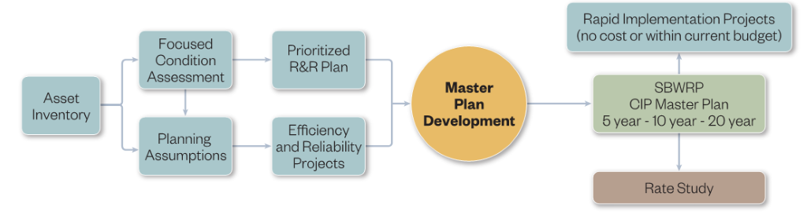
The Facilities Master Plan also includes an assessment of two important water quality parameters: total dissolved solids (TDS) and total inorganic nitrogen (TIN). TDS and TIN levels are increasing at the SBWRP primarily from changes in source water quality and decreasing per capita water usage as a result of water conservation. TDS and TIN concentrations are important to evaluate because elevated concentrations have the potential to impact wastewater treatment processes, infrastructure integrity, the use of recycled water, and the ability to practice environmental discharge. TDS and TIN concentrations are projected for the 2020 to 2040 planning horizon to support the Department’s planning and response to changing wastewater quality. The TDS and TIN Assessment Technical Memorandum (Hazen and Sawyer, 2020) is attached as Appendix A.

Facility Description
The SBWRP is located at 399 Chandler Place northeast of Interstate 215 (I-215) and I-10 at the confluence of East Twin Creek and the Santa Ana River. The SBWRP is situated on a site of approximately 60 acres that is bordered by Orange Show Road to the north; East Twin Creek to the east; the former San Bernardino Golf Club to the south/southwest; and developed industrial parcels to the west/northwest. Neighboring businesses include Durham School Bus Services and San Bernardino Animal Control. An aerial view of the existing facilities is shown on Figure 1-2 (below) and Exhibit 1 (attached).

Figure 1-2: SBWRP Facilities Aerial View Looking Northeast
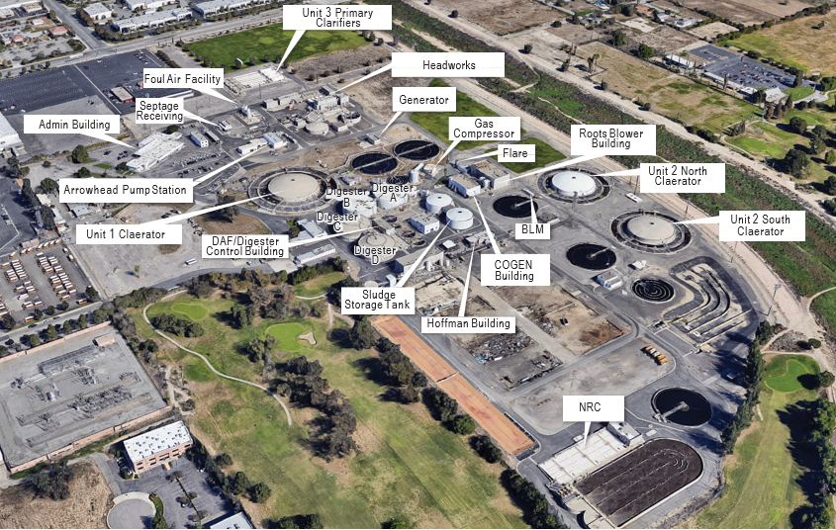

Plant Overview and Upgrade History
The SBWRP was originally constructed in 1958 to provide secondary treatment of wastewater prior to discharge to the Santa Ana River. The original plant consisted of a single primary clarifier surrounded by aeration basins divided into 10 cells, and a secondary clarifier. This system, called “Unit 1 Claerator,” had a capacity of 13 mgd. The original 1958 plant had two anaerobic digesters (Digester A and Digester B). To address hydraulic capacity issues, a second secondary clarifier was added to Unit 1 in 1987.
In 1968, the SBWRP was expanded by an additional 15 mgd for a total rated secondary treatment capacity of 28 mgd by constructing two more units, designated Units 2 North and South, and a 3 mgd tertiary treatment facility. Unit 2 North and Unit 2 South are like Unit 1, but smaller, each adding 7.5 mgd of treatment capacity.
Several solids handling projects in the 1980s added dissolved air floatation (DAF) thickeners, two more digesters and belt filter presses. Odor handling facilities and headworks facilities were also added in the 1980s.
The Primary Hydraulic Reliability Project was completed in the 1990s and included the Unit 3 Primary Clarifier. Two centrifuges were installed in 1997 and later replaced in 2013. To provide better treatment of the high ammonia recycle from the centrifuges, the Nitrogen Removal Carousel (NRC) was added, which consisted of a pre-anoxic tank followed by an oxidation ditch. Unit 1 was rehabilitated in 2014/2015.
The permitted treatment capacity of the SBWRP is currently 33 mgd; however, nutrient removal constraints are limiting capacity (see Section 8.5).

Existing Facilities
The SBWRP consists of five major systems: 1) preliminary processes; 2) primary treatment; 3) secondary treatment; 4) solids treatment; and 5) discharge. Raw influent wastewater passes through the headworks/preliminary processes, and then is split between Unit 1, Unit 2N, and Unit 2S primary clarifiers and aeration basin units as well as the NRC. The secondary treatment process includes concentric ring step-feed aeration basins, followed by secondary clarifiers.
The solid treatment stream includes managing both primary sludge and waste activated sludge (WAS). WAS is thickened through DAF thickeners and then pumped along with primary sludge to the anaerobic digesters. Digested sludge flows by gravity to storage tanks prior to dewatering by centrifuge units or belt presses, and then hauled off-site for composting.
The SBWRP does not disinfect secondary effluent. The secondary effluent is filtered and disinfected at the offsite Rapid Infiltration and Extraction (RIX) facility in Colton (see Section 5.2.1) which is jointly owned with the City of Colton and exclusively operated by the Department.
The SBWRP produces digester gas (DG) from the anaerobic digestion process and currently uses the gas beneficially as a fuel source for internal combustion engines, boilers, and cogeneration.
The major systems and components are summarized in Table 1-1 and a process flow diagram of the major systems is shown on Exhibit 2 attached.

Table 1-1: Major Systems and Components
System | Sub-system | Component
Preliminary Processes | Influent Lift Stations | Arrowhead Lift Station
Preliminary Processes | Influent Lift Stations | E Street Lift Station
Preliminary Processes | Influent Lift Stations | East Influent Lift Station
Preliminary Processes | Septage and Brine Receiving | Static Grinder Room
Preliminary Processes | Preliminary Treatment | Bar Screen
Preliminary Processes | Preliminary Treatment | Grit Chambers
Preliminary Processes | Preliminary Treatment | Screening Compaction / Grit Classifiers
Primary Treatment | Primary Clarifiers | Clarifier Tanks
Primary Treatment | Primary Clarifiers | Primary Sludge Pump
Primary Treatment | Primary Clarifiers | Scum Pump
Secondary Treatment | Secondary Aeration Basins | Basins
Secondary Treatment | Secondary Aeration System | Blower System
Secondary Treatment | Nitrogen Carousel | Aeration Basins
Secondary Treatment | Nitrogen Carousel | Clarifiers
Secondary Treatment | Nitrogen Carousel | RAS/WAS Pumping
Secondary Treatment | Secondary Pumping | RAS Pumps
Secondary Treatment | Secondary Pumping | WAS Pumps
Secondary Treatment | Secondary Clarifiers | Clarifier Tanks
Solids Treatment | Dissolved Air Flotation Thickener | Thickened Sludge Pumps
Solids Treatment | Dissolved Air Flotation Thickener | DAFT Tanks
Solids Treatment | Anaerobic Digesters | Digester Recirculation Pumps
Solids Treatment | Anaerobic Digesters | Digester Mixing Pumps
Solids Treatment | Anaerobic Digesters | Digester Heating System
Solids Treatment | Anaerobic Digesters | Digester Gas Collection System
Solids Treatment | Digested Sludge Storage | Storage Tanks
Solids Treatment | Digested Sludge Storage | Mixing Pumps
Solids Treatment | Dewatering | Belt Press Feed Pumps
Solids Treatment | Dewatering | Belt Press
Solids Treatment | Dewatering | Recycle Pumps
Solids Treatment | Dewatering | Centrifuge Feed Pump
Solids Treatment | Dewatering | Centrifuge
Solids Treatment | Dewatering | Polymer System
Solids Treatment | Truck Loading, Conveyors and Storage Silos | Silo
Solids Treatment | Truck Loading, Conveyors and Storage Silos | Truck Loading Bin
Solids Treatment | Truck Loading, Conveyors and Storage Silos | Conveyor and Belt
Discharge | Gravity Conveyance to RIX | Flow Metering and Sampling Station
Discharge | Chlorine Contact Basin | Basins

Preliminary Processes
The sources of wastewater for the SBMWD are as follows:
- SBMWD service area comprising most of the City of San Bernardino and some unincorporated areas in San Bernardino County, served by the three terminal lift stations (current average dry weather flow (ADWF) is approximately 13.4 mgd)
- EVWD service area comprising the City of Highland and the remaining portions of the City of San Bernardino, served by the East Influent Lift Station (current ADWF is approximately 6.0 mgd)
- City of Loma Linda, served by the E Street Lift Station (current ADWF is approximately 2.1 mgd)
- Former headworks near the historic Valley Truck Farm east of Twin Creek (relatively low flow).
Raw wastewater is conveyed to the SBWRP via two force mains and one gravity sewer that are metered independently. A fourth gravity sewer from the historic Valley Truck Farm area is not metered but is relatively low flow and is counted as part of the SBWRP drain flow. Wastewater that enters by gravity flow must be pumped via the East Influent Lift Station screw pumps to an influent channel where it combines with the other two influent lines. The combined influent is sampled, screened and de-gritted.

Influent Lift Stations
Wastewater from the west side of the service area is pumped by the Arrowhead Lift Station, which receives raw sewage via a 54-inch interceptor from the west side of the service area, recycled-plant drain flows, gravity line from the historic headworks/Valley Truck Farm area, and septage from the receiving station. The Arrowhead Lift Station consists of five variable speed pumps, one electric and four engine-driven pumps (two fueled by digester gas and two fueled by natural gas). The gas-driven engines are subject to South Coast Air Quality Management District (SCAQMD) Rule 1110.2 (see Section 7.3).
The electrically driven pump was installed in 2015 and has a 200 horsepower (hp) motor controlled with a variable frequency drive (VFD). The speed of each engine is controlled by a miltronics level sensor that allows the pumps to run at a maximum speed of 900 rpm. Under normal operation and headloss conditions, the approximate output capacity for each pump running alone is 13,500 gpm at 40 feet of head. The average daily flow through this lift station when its hydraulic capacity is reached is 31 mgd (based on a 2.0 peaking factor).
The E Street Lift Station pumps wastewater from the south side of the service area and from the Satellite Service Area of the City of Loma Linda. The E Street Lift Station houses three non-clog centrifugal pumps and the lift station control system determines the number of on-line pumps based on the liquid level in the wet well. Pumping capacity is adjusted using VFDs to accommodate the varying influent wastewater flow.
Both lift stations convey wastewater to the combined influent channel where it mixes with flows from the East Influent Lift Station, which conveys flow from the East Trunk Sewer. Influent lift station design information is summarized in Table 1-2.

Table 1-2: Influent Lift Station Design Information
Component | Equipment Description | Design Flow
Arrowhead Lift Station | Quantity: 5  Type: Variable Speed: 2 digester gas- driven, 2 natural gas-driven, 1 electric | Capacity: 13,500 gpm (ea.)
E Street Lift Station | Quantity: 3 (2 Duty)  Type: Non-clog Centrifugal with VFDs | Capacity: 4,500 gpm (ea.)
East Influent Lift Station | Quantity: 3 screw pumps  2 + 1 standby (2 Future)  Size: 66-inch | Each at 12,500 gpm  18 mgd (Average)  24 mgd (Peak Day)  36 mgd (Peak Hour)

East Hydraulic Structure
Wastewater collected by gravity from the eastern service area (eastern part of SBMWD Service Area and all of EVWD Service Area) flows through the East Hydraulic Structure via two 36-inch pipes where it combines to a 54-inch interceptor and flows to the East Influent Junction Box. The water surface elevation (WSE) in the East Influent Junction Box is controlled by WSE in the downstream influent screw pump influent channel. The East Influent Lift Station screw pumps lift the wastewater to the combined influent channel and headworks.

Influent Metering Station
The influent metering structure measures all influent wastewater entering the SBWRP from the Arrowhead Lift Station, E Street Lift Station, and East Hydraulic Structure except for the drain line from the historic Valley Truck Farm area mentioned in Section 1.5.1. Influent flow monitoring is required by the SWRCB. Flow measurements are used to determine chemical feeds and plant process pumping rates and are recorded for statistical and historical plant data.

Septage Receiving
Septage is hauled by permitted private waste haulers in trucks to the SBWRP and unloaded at the septage receiving station. Under normal conditions, septage flows through a motorized plug valve, a grinder, and another plug valve to a meter. After metering, the septage flows to the Arrowhead Lift Station influent pit where it intermixes with raw wastewater and is pumped to preliminary processes. The receiving station samples and monitors the septage to determine whether there are excessive amounts of grease or other harmful substances which may upset plant operations.

Bar Screens
Screening prevents large solids from entering the treatment process. The SBWRP utilizes three “climber-type” mechanically cleaned bar screens to provide influent screening and one manually cleaned bar screen, which is used for emergency bypass flow. The bar screens consist of vertically inclined stainless steel bars spaced at equal intervals across a channel through which raw influent wastewater flows. To prevent solids deposition, low pressure air is diffused into the influent wastewater in the bar screen inlet channel. The air lines are no longer in use. The bar screens are designed to meet design peak hour flow conditions with one unit out of service. Table 1-3 summarizes the bar screen design criteria.

Table 1-3: Bar Screen Design Information
Component | Equipment Description | Design Flow
Bar Screens | Quantity: 3  Mechanically Cleaned Climber-type  Channel Width: 6 feet  Clear Screen Velocity:  2.1 feet/sec. (Peak Day)  2.5 feet/sec. (Peak Hour) | 90 mgd (Peak Hour flow with one unit out of service)
Emergency Bypass | Quantity: 1  Manually Cleaned Bar Screen  Channel Width: 8 feet | N/A

Grit Removal
The grit removal system consists of aerated grit chambers with grit hoppers and grit slurry pumps to convey to the grit classifier and auger system, diffusers, and other ancillary system components located above the hopper. Screened wastewater enters each grit chamber through 48-inch by 60-inch openings equipped with a sluice gate for isolation. Four structurally identical grit chambers are available for removing grit from the wastewater. The degritted wastewater exits each grit chamber into the grit chamber collection channel through 84-inch by 48-inch bottom-opening sluice gates. Each grit chamber is dewatered through the grit slurry piping. Table 1-4 summarizes the grit removal system design criteria.

Table 1-4: Grit Removal Design Information
Component | Equipment Description | Design Flow
Grit Chambers | Quantity: 4 (3 + 1 Future)  Overflow Rate  Average: 17,900 gpd/sf  Peak Day: 23,800 gpd/sf  Peak Hour: 35,700 gpd/sf  Air Supply (only Chambers 1 – 3)  Maximum Air Flow: 5 cfm/LF of  basin length | Each Chamber  Average: 15 mgd  Peak Day: 20 mgd  Peak Hour: 30 mgd
Grit Slurry Pumps | Number: 5 (3 + 2 standby)  Type: Recessed Impeller | Hydraulic Capacity (ea.): 600 gpm  Fixed Capacity: 1,800 gpm
Grit Wash/Bin Loading | Number of Bays: 2 (1 for grit bin + 1 for screenings compactor and bin)  Overflow Rate: 12,000 gpd/sf  Weir Overflow Rate: 200,000 gpd/ft  Peak Hourly Grit Loading: 80 cf/hour  Number: 2 (1 + 1 standby)  Diameter: 16 inches  Screenings Conveyors  Number: 2  Type: 1 inclined sidewall, 1 flat  Screenings Loading: 0.06 cy/mgd | Hydraulic Capacity (ea.): 3,600 gpm

Primary and Secondary Treatment
Primary and secondary treatment is accomplished by the four parallel treatment units: Unit 1, Units 2N and 2S, and NRC. Each of these units has its own independent return activated sludge (RAS) system, so from the point of view of process biology, the four units function as individual treatment trains.

Primary Clarifiers
In the circular clarifiers, Unit 1 and Unit 2, the wastewater generally enters in the middle and flows towards the outside edge. Settled sludge is pushed to a hopper that is in the middle of the tank bottom. Floating material is removed by a surface skimmer connected to the sludge collector. The flow enters Unit 1 primary clarifier through a 42-inch gravity line from the headworks splitter box and Unit 2 through a 48-inch line from the headworks splitter box via a diversion box which splits the flow to the north or south clarifier. Flow passes through the clarifier over weirs in radial troughs and is collected in a circular effluent trough. The original dual inboard discharge weirs were replaced at Unit 1 with single outboard discharge weirs. A circular baffle wall extending a few inches above the water surface forces the entering wastewater to go down before it continues towards the peripheral discharge weir to reduce the possibility of “short-circuiting.” Back-up for the Unit 1 clarifier is provided by four rectangular clarifiers (Unit 3). Unit 3 primary effluent is directed to Unit 1 aeration system via PIPL. The Unit 3 clarifiers have not been used under normal operating conditions since 2015 but are currently being put back online so they can be rotated in and out of service with the Unit 1 primary clarifiers.
The estimated capacity is based on the surface overflow rate (SOR) as the critical hydraulic condition for treatment. Typical design SOR ranges from 600 to 1,000 gpd/ft² of surface area. The clarifier depth is determined by providing between 90 to 150 minutes of detention time for the total flow (including recycle streams) through the tank. Design criteria for the primary clarifiers is shown in Table 1-5.

Table 1-5: Primary Clarifier Design Information
Component | Equipment Description | Design Flow
Unit 1 Primary Clarifier | Quantity: 1  Diameter: 140 ft  Side Water Depth: 10 ft  Area: 15,400 ft²  Volume: 183,000 ft³  (1,370,000 gal)  Overflow: 1,000 gals/day-ft²  Detention time: 2.1 hours | Clarifier:  15.4 mgd  Total Unit 1 Clarifiers:  15.4 mgd
Unit 2 Primary Clarifiers | Quantity: 2  Diameter: 120 ft  Side Water Depth: 9 ft  Area (each) 11,300 ft²  Volume (each): 120,700 ft³  (902,650 gallons)  Overflow: 660 gal/day-ft²  Detention Time: 2.9 hours | Each Clarifier:  7.5 mgd  Total Unit 2 Clarifiers:  15 mgd
Unit 3 Primary Clarifiers  (Back-up for Unit 1 Clarifier) | Quantity: 4  Type: Rectangular  Side Water Depth: 10 ft  Width: 26 ft  Length: 162 ft  Area (each): 4,413 ft²  Volume (each): 297,000 gal  Overflow Rate 850 gal/day-ft²  Detention Time: 1.9 hours | Each Clarifier:  3.75 mgd  Total Unit 3 Clarifiers:  15 mgd

Primary Sludge Pumping
Primary sludge pumping is operated to maintain thin underflow and short sludge blanket retention times (i.e. “thin-sludge pumping mode”) to prevent fermentation of settled solids and to increase clarifier efficiency. The primary sludge is normally withdrawn automatically by the primary sludge pumps on a timed cycle to allow for sludge thickening to approximately 5% solids. In addition, the pumps operate in conjunction with the sludge grinder, which runs with the pump. There is a bypass for the grinder system in case of failure.
The primary sludge pumps at Unit 1 and Unit 2 Sludge Pump Station are currently duplex, piston-type positive displacement pumps each driven by a 15 hp electric motor. Some have been switched to Seepex progressive cavity pumps (Unit 1 #2 and Unit 2 #1) and replacement of the remaining pumps has been budgeted for this fiscal year. Floatable materials, such as shredded plastic and trash from the bar screen and other light material such as fats and grease, are usually called scum. Two pumps recirculate and convey the contents of the primary scum wet well directly to the digesters via the primary sludge pump discharge line. Table 1-6 summarizes primary sludge and scum pump design criteria.

Table 1-6: Primary Sludge and Scum Pumping Design Information
Component | Equipment Description | Design Flow
Primary Sludge Pumps and Scum Pumps – Unit 1 | Primary Sludge Pumps  Quantity: 2  Type: Duplex Plunger (#1); Seepex Progressive Cavity (#2)  Capacity (ea.): 90-250 gpm at 60 TDH  Motor (ea.): 15 hp  Scum Pumps  Quantity: 2  Type: Duplex Plunger  Capacity (ea.): 90 gpm at 60 TDH  Motor (ea.): 5 hp | Total Capacity: 500 gpm  Total Capacity: 180 gpm
Primary Sludge Pumps and Scum Pumps – Unit 2 | Primary Sludge Pumps  Quantity: 2  Type: Seepex Progressive Cavity (#1) and Duplex Plunger (#2)  Capacity (ea.): 90-250 gpm at 60 TDH  Motor (ea.): 15 hp, 50 rpm  Scum Pumps  Quantity: 1  Type: Simplex Piston-type Positive Displacement  Capacity (ea.): 75-130 gpm at 60 TDH  Motor (ea.): 15 hp, 50 rpm  Scum Grinder  Quantity: 1  Capacity (ea.): 3-160 gpm  Motor (ea.): 2 hp | Total Capacity: 500 gpm  Total Capacity: 130 gpm  Total Capacity: 320 gpm
Primary Sludge Pumps – Unit 3 | Primary Sludge Pumps  Quantity: 3  Type: Plunger duplex  Motor (ea.): 15 hp, 50 rpm  Scum Pumps  Quantity: 2  Type: Komline-Sanderson  Capacity (ea.): 130 gpm  Motor (ea.): 15 hp | Capacity (ea.): 250 gpm

Secondary Treatment
Secondary treatment uses an activated sludge process to stabilize the soluble and dissolved organic matter by biological oxidation. The system produces a settleable floc that is separated from the secondary effluent through settling. The secondary process includes activated sludge bioreactors, secondary clarifiers, and the NRC. The activated sludge system consists of one large Claerator (Unit 1) and two smaller Claerators (Unit 2N and 2S). The Unit 1 Claerator includes two concentric-rings of 18 step-feed aeration basins and two secondary clarifiers (East and West). Unit 2 consists of two Claerators (Units 2N and 2S) each including a circular primary clarifier and two concentric-rings of ten step-feed aeration basins followed by one circular secondary clarifier each. The rated design flow of the Unit 1 Claerator is 15 mgd and the design flow for each Unit 2 Claerator is 7.5 mgd. Table 1-7 summarizes the aeration basin design criteria.

Table 1-7: Aeration Basin Design Information
Component | Equipment Description | Design Flow
Unit 1 Aeration Basins | Quantity: 1  Type: Circular  HRT (@125% flow): 5 hours  Side Water Depth: 14 ft  Inside Bays: 334,300 gallons  Outside Bays: 447,500 gallons  Total Volume: 3,910,000 gallons | 15 mgd
Unit 2 Aeration Basins  -Unit 2 North  -Unit 2 South | Quantity: 2  Type: Circular  HRT (@125% flow): 6 hours  Side Water Depth: 14 ft  Inside Bays: 200,000 gallons  Outside Bays: 268,000 gallons  Total Volume (ea.): 2,340,000 gallons | 7.5 mgd (each)
Secondary clarifiers are very similar in structure to primary clarifiers and are equipped with similar mechanical equipment. Loading and sludge settling characteristics are the most important factors affecting their operation. The settling characteristics of the solids are developed in the aeration tank and are affected by mixed liquor suspended solids (MLSS) concentration. The settling properties of the solids are measured by the sludge volume index (SVI) or by settleometer. The capacity presented uses the surface overflow rate (SOR) and weir overflow rate as the critical hydraulic condition for treatment. Table 1-8 summarizes the secondary clarifier design criteria.

Table 1-8: Secondary Clarifier Design Information
Component | Equipment Description | Design Flow
Unit 1 Secondary Clarifiers  -Unit 1 East  -Unit 1 West | Quantity: 2  Diameter: 140 ft  Side Water Depth: 10 ft  Area: 15,394 ft²  Volume (each): 1,151,471 gallons  Surface Overloading Rate (each)  440 gpd/sf (average)  705 gpd/sf (peak)  Solids Loading (each):  36.7 lbs./day/sf (average)  58.7 lbs./day/sf (peak)  Weir loading  5,045 gpd/sf  Detention Time at Average: 4.2 hours  RAS Recycle: 25% - 80% | 15 mgd
Unit 2 Secondary Clarifiers  Unit 2 North and Unit 2 South | Quantity: 2  Diameter: 125 ft  Side Water Depth: 12 ft  Area: 12,250 ft²  Volume (each): 1,260,350 gallons  Surface Overloading Rate (each):  610 gpd/sq. ft. (average)  978 gpd/sq. ft. (peak)  Solids Loading (each):  51.0 lbs./day/sq. ft. (average)  81.6 lbs./day/sq. ft. (peak)  Detention Time at Average: 4.0 hours  RAS Recycle: 25%-80% | Each 11.9 mgd  (based on SOR Peak)  Total Capacity for Unit 2:  23.8 mgd
The secondary aeration system consists of fine-bubble membrane diffusers and four blowers currently located in the Roots Blower Building (north side of secondary clarifier 2N). Each aerated zone air piping header has a flow meter and butterfly valve. Some of the installed diffusers and headers have been blanked to allow for additional diffusers to be installed in the future as required. Secondary aeration system capacities are summarized in Table 1-9.

Table 1-9: Secondary Aeration System Design Information
Component | Equipment Description | Design Flow
Blower System | Internal Combustion Engine (ICE)  Quantity: 2  Type: Rotary Lobe Displacement,  Engine-driven  Horsepower: 750 hp  Electric Powered Blowers  Quantity: 2  Type: Rotary Lobe Displacement  Capacity:16,400 scfm (each)  Horsepower: 750 hp | Capacity:16,400 scfm (each)  32,800 scfm (total)  Capacity:16,400 scfm (each)  32,800 scfm (total)
Aeration System | Unit 1  Type: Fine-bubble Membrane Disc  No. of Diffusers in Bays 1 to 5: 7,087  No. of Diffusers in Bays 6 to 10: 8,527  Unit 2  Type: Fine-bubble Membrane Disc  No. of Diffusers in Bays 1 to 5: 4,143  No. of Diffusers in Bays 6 to 10: 4,410 | N/A
Of the four existing blowers, two are electric-powered and two are engine-driven using digester gas. The Department plans to cease operation of the engine-driven blowers by September 1, 2021 as part of a larger Digester Gas Beneficial Use (DGBU) Program. Under the new program, five electric turbo blowers (4 + 1) at 6,000 scfm each will be installed in a new Unit 1 blower building that is currently under design, and the two existing electric blowers at the Roots Blower Building will supply air to Unit 2. These projects are being performed in response to SCAQMD Amended Rule 1110.2 (see Section 7.3).

RAS Pumping Systems
The mixed liquor solids concentration in the aeration basins is controlled by return activated sludge (RAS) pumps to assure proper operations of the activated sludge process. Excess solids not needed for treatment and settled out in the secondary clarifiers are wasted to the DAF thickeners by the waste activated sludge (WAS) pumps. The Unit 1 RAS/WAS Pump Station has three (3) RAS pumps, two (2) WAS pumps, and one (1) scum pump. Separate return sludge lines from each of the two secondary clarifiers enter the pump station and then merge into a common header. The suction piping is arranged in such a way that sludge can be drawn by any one RAS pump.
The RAS pumps at Unit 1 and Unit 2 pump station are mixed-flow type pumps and non-clog centrifugal pump, respectively. Each is provided with VFD and driven by a 100 hp (Unit 1) and 60 hp (Unit 2) electric motors. Pump operation can be controlled automatically via SCADA. RAS pumping capacity information is summarized in Table 1-10.

Table 1-10: RAS Pumping Design Information
Component | Equipment Description | Design Flow
Unit 1 RAS Pumps | Quantity: 3 (2+1 standby)  Type: Mixed-flow  TDH: 18 ft  Motor (ea.): 100 hp, 1200 rpm | Each: 2,700 gpm
Unit 2 RAS Pumps | Quantity: 3 (2+1 standby)  Type: Non-clog Centrifugal  TDH: 40 ft  Motor (ea.): 60 hp | Each: 3,150 gpm

WAS Pumping Systems
From the WAS withdrawal system, waste sludge is transported to the DAF thickener by non-clog, centrifugal pumps. Each pump is provided with VFD drives and is driven by a 7.5 hp (Unit 1) and 10 hp (Unit 2) electric motor. A 4-inch magnetic flowmeter is mounted on the WAS discharge line from Unit 1, Unit 2N and Unit 2S secondary clarifiers, inside the Sludge Pump Building. The flowmeter provides flow control and it also indicates, records, and totalizes the waste sludge flow in the Operation Building. Design criteria for secondary sludge and scum pumping is summarized in Table 1-11.

Table 1-11: WAS Pumping Design Information
Component | Equipment Description | Design Flow
Unit 1 WAS Pumps | Quantity: 2 (1+1 standby)  Capacity (total): 5 - 385 gpm  TDH: –12.6 feet  Motor (ea.): 7.5 hp, 1200 rpm | Combined: Up to 400 gpm (per SBMWD)
Unit 2 WAS Pumps | Quantity: 3 (2+1 standby)  Capacity (ea.): 400 gpm  TDH: 14 ft  Motor (ea.): 5 hp | Each: 400 gpm

Nitrogen Removal Carousel
The NRC consists of an influent junction structure, equalization basin for belt press filtrate, anoxic basins, oxidation ditch for nitrification and denitrification, secondary clarification and auxiliary systems. The purpose of the NRC with pre-anoxic stages is to treat 3 mgd of raw wastewater and 0.2 to 0.6 mgd of belt press filtrate and centrate from the centrifuges, which has a high ammonia content. Nitrogen removal is accomplished through the stepwise process of decomposition of organic material to ammonia, nitrification of ammonia to nitrate, and denitrification of nitrate to nitrogen gas. The carousel oxidation ditch with pre-anoxic stages uses the influent wastewater as an organic carbon source for denitrification and alternating aerobic/anoxic stages for a complete nitrogen removal. Mixed influent is conveyed to the NRC with 3 screw lift pumps and enters the oxidation ditch where it is aerated to raise the dissolved oxygen (DO) level to 2 mg/L. To increase detention time for efficient nitrogen removal, the flow is recycled internally at a rate of 2:1 to 4:1 (recycle:NRC influent). RAS is used to maintain a high microorganism concentration. The rated design capacity of the NRC is approximately 3 mgd. The NRC design criteria is summarized in Table 1-12.

Table 1-12: NRC Design Information
Component | Equipment Description | Design Flow
Nitrogen Removal Carousel | SRT (Overall/Nitrification): 20/10  MLSS: 4,000  Temperature 15 deg C to 25 deg C | 3.6 mgd  (3 mgd raw WW + 0.6 mgd filtrate/centrate)
NRC Secondary Clarifier | Diameter: 110 ft  Side Water Depth: 15.3 ft  Maximum Overflow Rate: 400 gpd/sf | 3.8 mgd (based on SOR)
NRC RAS Pumping | Quantity: 3  Motor (variable speed): 25 hp | Capacity (ea.): 1,250 gpm
NRC WAS Pumping | Quantity: 2  Motor (variable speed): 5 hp | Capacity (ea.): 250 gpm

Solids Handling

Solids Thickening
The solids thickening process consists of a thickener basin and mechanisms, pressurization systems, air supply systems, thickened sludge pumping system and polymer feed system. The DAF thickeners use recycle pressurization for dissolving air into the recycle stream. Recycle ratio ranges from two to four times the WAS influent. Design criteria for the DAF thickening system is summarized in Table 1-13.

Table 1-13: Solids Thickening Design Information
Component | Equipment Description | Design Flow
DAF Tanks | Quantity: 4 (3 in service)  Diameter:  DAF 1, 2 and 4: 35 ft  DAF 3 (not operational): 25 ft  Effective Surface Area:  25-ft. Diameter: 440 sf.  35-ft. Diameter: 880 sf.  Side Water Depth: 8.125 ft  Loading Rate:  Solid: 1.0 lb./sf/hr.  Hydraulic: 1.0 gpm/sf.  Solids Capture Rate:  With Chemical: 95%  Without Chemical: 90% | 3.80 mgd  (based on Hydraulic Loading rate)
TWAS Pumps | Quantity: 2 (1+1 standby)  Capacity (each): 400 gpm  TDH: 14 ft  Motor (each): 5 hp | 100 gpm

Anaerobic Digestion
There are four anaerobic digester tanks (Digesters A - D) that are fed continuously and overflow to digested sludge storage tanks. The digesters are mixed with pumps and nozzles to recirculate flows within the tanks. The digester feed solids are heated by spiral heat exchangers before entering the digester tanks.
Digesters A and B were constructed in 1958 and were upgraded in 1983-84 and 1989-90. The dimensions of these are 90-foot diameter and approximately 33.5-foot sidewall with 10-foot deep cone section. Digesters A and B are concrete tanks with insulated metal lids with approximately 1.7 million gallons (MG) of liquid storage and an estimated 30,000 standard cubic feet (SCF) of DG storage in each digester. Digester B is currently out of service because the concrete is damaged which prevents pressurized operation and anaerobic conditions. At the time of this Master Plan, the Department was in the process of preparing an RFP to replace Digester B.
Digesters C and D are the newer tanks built in the late 1980s with 90-foot diameter and approximately 36.5-foot sidewall and 10-foot deep cone section. These are concrete tanks with concrete lids. Digesters C and D have approximately 1.8 MG of liquid storage and 35,000 SCF of DG storage in each digester. Design criteria for anaerobic digestion is summarized in Table 1-14.

Table 1-14: Anaerobic Digestion Design Information
Major Component | Description | Design Flow
Anaerobic Digesters | Quantity: 4 (3 in service)  Diameter: 90 ft  Effective Digester Volume:  Digester A: 156,000 ft³  Digester C: 169,000 ft³  Digester D: 169,000 ft³  Total: 494,000 ft³  Solids Loading:  0.07 lb.-VSS/cu ft/day (average)  0.09 lb.-VSS/cu ft/day (peak)  Hydraulic Retention Time:  24.4 days (Average)  19.0 days (Peak)  Digester B: 169,000 ft³ (Abandoned in  Place; RFP for replacement in progress) | 246,340 gpd sludge flow  (based on HRT of 15 days)
Digester Mixing Pumps | Quantity: 1 per digester  Capacity (each): 8,000 gpm  Motor (each): 60 hp | Each: 8,000 gpm

Digester Gas Management
The existing DG management system includes four anaerobic digester tanks, a low-pressure holding tank, a high-pressure holding tank, gas compressors, gas cleaning units, and a flare. DG is currently used to power digester gas-driven engines for pumps at the Arrowhead Pump Station, blowers, cogeneration, and boiler heating as shown in Figure 1-3. In the future, DG will be used to the fullest extent under the DGBU program, which is currently in design. Under the DGBU, DG will be used in a Fuel Cell system and excess not used by the boilers will be flared by an Ultra-Low Emissions (ULE) flare (see Section 7.3).

Figure 1-3: Digester Gas Management
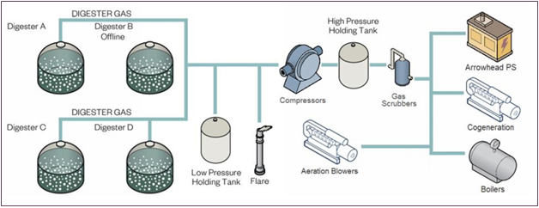

Sludge Dewatering
The sludge to be dewatered at SBWRP normally consists of a combination of anaerobically digested primary sludge, WAS from activated sludge tanks, and WAS from the NRC at a ratio of 60% primary to 40% TWAS. In 2014, two centrifuges were installed in the dewatering building and are the primary dewatering method, with belt presses as back-ups. The belt press system consists of a continuous belt filter press, belt wash system, sludge feed pump, and filtrate pump system. Each press operates identically and is designed to treat digested sludge with an average inlet solids concentration of approximately 2.5%. Design criteria for the dewatering system is summarized in Table 1-15.

Table 1-15: Dewatering Design Information
Major Component | Description | Design Flow
Digested Sludge Storage Tanks  (North and South) | Quantity: 2  Diameter: 70 feet  Side Water Depth:12 feet  Active Volume: 350,000 gallons | N/A
Centrifuge (Primary) | Quantity: 2 | The feed solids range from 1.6-2.2 TS% the average cake solids range from 22-24%. The Centrifuges are designed for aa feed flow of 20 gpm, but we typically do not go over 180 gpm.
Belt Press (Back-up) | Quantity: 3  Belt Width (each): 2 meters (approx. 6 feet)  Feed Solids: 2-3 %  Cake Solids: 22%  Solids Capture: 90%  Belt Wash Pressure: 90 psig  Belt Wash Flow Rate: 125 gpm  Belt Material: Monofilament, Polyester | 135 gpm (ea.)

Solids Storage
The solids storage and handling include solids storage bin, truck loading bin and belt conveyors which convey the dewatered sludge to these facilities. The purpose of these facilities is to minimize truck loading times, maximize truck payload, and allow flexibility for dewatering and transportation. Design criteria for the solids storage facility is summarized in Table 1-16.

Table 1-16: Solids Storage Design Information
Major Component | Description | Design Flow
Solids Storage Facility | Quantity: 1  Solids Loading Rate:  36,850 lbs. dry solids/day  Retention Time: 3 days | 350 cubic yards
Truck Loading Storage | Storage in Bins | 40 cubic yards

Disinfection
The chlorine contact basins and lagoon are designed for disinfection purposes. Currently, these units are not in operation. Disinfection through chlorination is only required if secondary effluent is discharged to the Santa Ana River, only as permitted during a 20:1 dilution, which is not how SBWRP is currently operated. SBWRP effluent currently passes through the chlorine contact basin to the Rapid Infiltration Extraction (RIX) facility for groundwater infiltration.
Original design criteria for the chlorine disinfection units is summarized in Table 1-17.

Table 1-17: Chlorine Disinfection Design Information
Major Component | Description | Design Flow
Chlorine Contact Basin  Unit 1 | Diameter: 60 ft  Volume: 159,000 gallons  Side Water Depth: 7.5 ft  Contact Time (13 mgd): 29 minutes | 13 mgd (average flow)
Chlorine Contact Basin  Unit 2 | Diameter: 100 ft  Volume: 543,000 gallons  Side Water Depth: 10 ft  Contact Time (15 mgd): 52 minutes | 15 mgd (average flow)
Chlorine Contact Lagoon | Volume: 1,260,000 gallons  Contact Time (28 mgd): 65 minutes | 28 mgd (average flow)

Odor Control
The SBWRP currently operates 5 foul air scrubbers with 2 packed bed scrubbers, each with 25,000 cfm capacity, dedicated to the Headworks Building; 2 caustic scrubbers, each with 25,000 cfm capacity, dedicated to the belt filter presses; and one dedicated to the digested sludge storage tanks.

Asset Inventory

Introduction
SBMWD elected to incorporate elements of asset management into the development of the SBWRP Facilities Assessment and Master Plan. Some of the benefits being:
- Asset inventory that can serve as a data source for the new Enterprise Asset Management (EAM) System, which will include as one component a Computerized Maintenance Management System (CMMS) to be used Department wide.
- Rehabilitation and Replacement decisions based on condition versus age.
- Better able to manage SBMWD’s business risk exposure
- Minimize life-cycle costs
- Better project long range funding requirements
Determination of the current state of the SBWRP’s assets requires knowledge of the assets owned and managed by SBMWD, so the first phase consisted of populating the asset register for the SBWRP. Figure 2-1 provides an aerial view of the SBWRP. While this project only populated the asset register with SBWRP assets, the asset register framework was developed so that it could also be expanded and applied to other Departments in the future.

Figure 2-1: SBMWD Water Reclamation Facility (Scope Area)
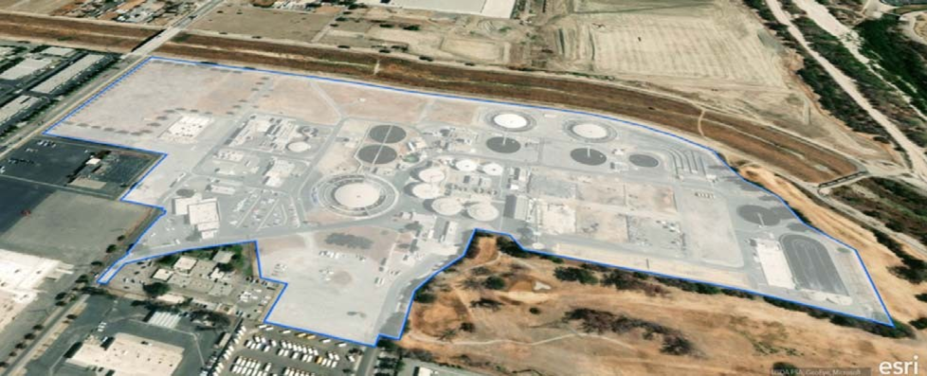

Data Collection
The first step of the WRP Facilities Assessment was the identification of all assets associated with the WRP into a consolidated database referred to as an asset register. Using data from SBMWD’s existing sources such as Record Drawings, electronic O&M manuals (EOM) and institutional knowledge of staff, a preliminary asset register of SBWRP above-ground and yard piping assets was developed.

Above-Ground Assets
The preliminary asset register of above-ground assets was further developed during the field inventory, condition assessment and further gap closure activities after the field inventory as shown in Table 2-1.

Table 2-1: Sources of Information
Data Collection Methods | Percentage of Total Asset Count | Count of Assets
Record Drawings, Electronic O&M Manuals, Staff | 57% | 1,804
Added Onsite | 42% | 1,335
After Onsite | 1% | 40
TOTALS | 100% | 3,179
Figure 2-2 lists the count of above-ground assets by process.

Figure 2-2: SBWRP Count of Above-Ground Assets by Process

Yard Piping
The preliminary asset register for WRP yard piping was developed using a combination of AutoCAD, ArcGIS and Excel. The source files consisted of pipe layers in AutoCAD, a grid shapefile in ArcGIS and record plant drawings. The source CAD file was processed for geolocation and cleaned for transfer into GIS. ArcGIS was used to parse and compile pertinent data from the processed CAD file and to geo- process layers for information such as pipe length and grid location. All layers were then compiled into one layer and attribute table, which served as the basis of the asset register. This table was transferred into Excel for final cleaning and processing. Using record drawings, approximate pipe ages were added to the spreadsheet based on the year of construction for each function. Approximate available useful life, derived by function, was also added to the yard piping asset register. Figure 2-3 illustrates the resultant yard pipes captured in the asset register, colored by function.

Figure 2-3: SBWRP Yard Piping
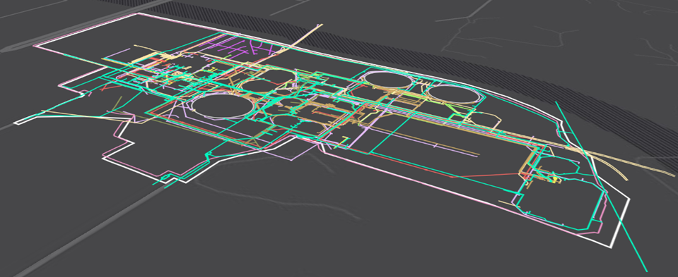
Figure 2-4 illustrates the resultant yard piping lengths by function and Figure 2-5 presents the yard piping function hierarchy.

Figure 2-4: SBWRP Yard Piping Length by Function

*IDS lines represent the SBMWD WRP Security System

Figure 2-5: SBWRP Yard Piping Function-Based Hierarchy

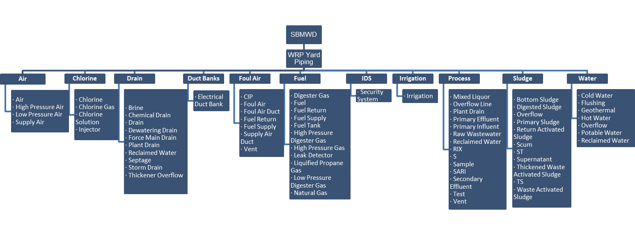

Data Attributes
A data attribute is a characteristic that sets it apart from other data and is key to performing condition and risk assessment. Table 2-2 shows the typical relevant asset attributes associated with each above-ground and yard pipe asset within the SBWRP asset register.

Table 2-2: Typical Asset Attributes for Water and Wastewater Treatment Facilities
Physical/Attributes | Groupings | Remaining Useful Life | Valuation | Risk
Size | Class | Condition Score | Unit Cost | Probability of Failure
Size Unit | Type | Useful Life | Replacement Cost | Consequence of Failure
Material | Discipline | Remaining Useful Life |  | Risk Score
Manufacturer |  | Rehab Year
Serial Number |  | Rehab Description
Tag ID
Model
Asset Description
Prior to the field inventory of above-ground assets at WRP, gaps in attributes such as install year and major rehabilitation history were closed during the gap closure workshops with the Department. This allowed for derivation of remaining useful life, probability of failure (PoF) and consequence of failure (CoF) to develop a list of assets for a focused condition assessment. Any remaining gaps in physical attributes such as Manufacturer, Model, Serial Number and Size were closed during the field inventory. Furthermore, about 1,300 additional assets, not identified during the development of the preliminary asset register, were added to the asset register during the field inventory while attribute information for the existing assets were verified and updated as needed.
Fields such as Material, Condition and Status are currently gaps in the yard piping asset register. Other minor gaps in the asset register are length (ft) at 6% of the dataset and diameter (in) at 18% of the dataset.

Asset Register Framework
An asset register is the systematic recording of all assets within the WRP that SBMWD owns or is responsible for their operations and maintenance. An asset hierarchy provides a structured framework for organizing assets in the asset register. A hierarchy enables SBMWD staff to easily locate an asset and obtain data (e.g., valuation, risk, remaining useful life) required to support asset management decisions.
An asset register forms links between all asset-related applications or information systems and enables the assessment of the assets as individual components, composite assets, or groups of assets. Along with establishing the asset register hierarchy as shown in Figure 2-6, developing an asset register includes the following components:
- Asset Definition. Developing a definition for an asset that can be used across SBMWD by the Finance and Water Reclamations Divisions, and Engineering Section.
- Asset Classification. An asset class can be defined as a group of assets with similar type, function, useful life, and pricing attributes (e.g., size, material, power).
- Data Standards. Data standards identify data attributes required to support asset management decisions. There are common attributes (e.g., year of install, replacement cost, asset naming/numbering) and specific attributes (e.g., type, power, size, length, and material) for each asset class.

Figure 2-6: Asset Register Hierarchy Parent-Child Relationship
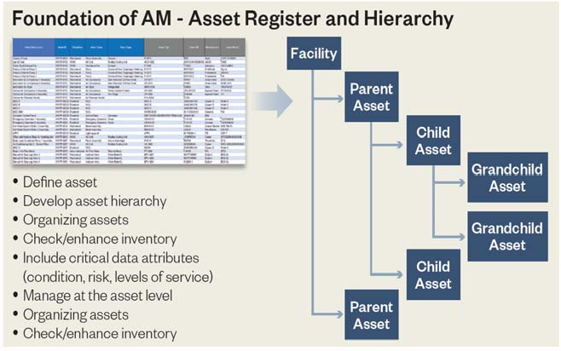
The asset register for SBMWD was set up using a “process-based” hierarchy as shown in Figure 2-7 and Figure 2-8. There are five levels of hierarchy captured for the SBWRP in the asset register. The hierarchy divides into facility and major process first and then location, which is further broken down into assembly/systems.

Figure 2-7: Five Levels of Hierarchy for Drilling Down and Rolling Up
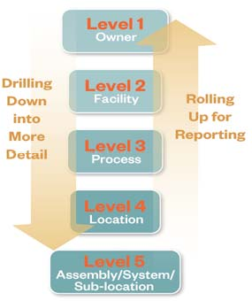

Figure 2-8: Process-Based Hierarchy

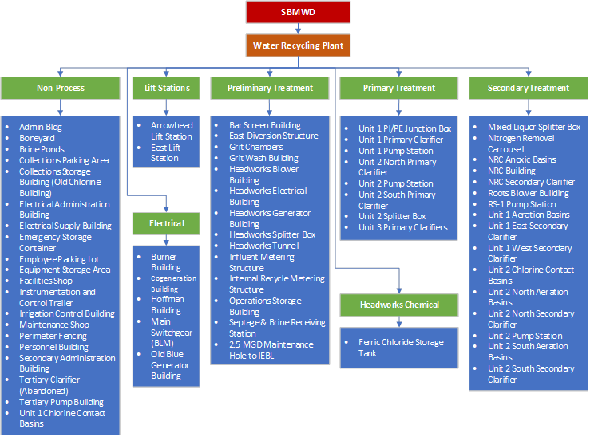

Asset Identification and Asset Tagging System
Each asset in the asset register was assigned a unique “Asset ID” starting with the number 1 and continuing sequentially as assets are added to the asset register.
Along with assigning an Asset ID, Hazen collaborated with SBMWD staff to refine their Tagging ID System which consists of:
Owner / Site / Location / Process / Type / Number
An example is:
Arrowhead Influent Flow Meter Tube SBMWD.WRP.B223.81.FE.010
Table 2-3 provides the Tag ID System elements and a description of the example above.

Table 2-3: Typical Asset Attributes for Water and Wastewater Treatment Facilities
Tag ID System Elements | Example Description
Owner | SBMWD (San Bernardino Municipal Water Department)
Site | WRP (Water Reclamation Plant)
Location | B223 (Grid B2, Influent Area 23)
Process | 81 (Process Instrument)
Type | FE (Flow Element)
Number | 010 (Number assigned to flow element. There are three flow elements with the flow metering structure and numbers would be assigned accordingly: 010, 020, 030)
A Tag ID was assigned to each asset and incorporated into the asset register.

Summary
Once populated, the asset register is used to identify the assets for the risk assessment that identified the assets for the focused condition assessment. During the field condition assessment, data in the SBWRP asset register was verified and information, such as asset photos, asset performance, nameplate data, manufacturer, model, and asset condition for assets ranked high risk were added to the asset register.
The asset register serves as the foundation of a future asset management program for SBMWD and as a data source for a new computerized maintenance management system.

Condition Assessment

Condition Assessment

Introduction
Each organization is unique, and no condition assessment framework will work universally. However, each organization’s condition assessment framework should be built on the same basic framework or foundation and should incorporate the same fundamental concepts. This section describes the basics of a focused condition assessment that was developed for SBMWD’s SBWRP to meet the short-term needs of SBMWD and provide a framework for continuing with the facility condition assessment over the next several years.
The objective of condition assessment is to estimate asset failure or the rate of deterioration of an asset and adjust asset management plans accordingly. This includes adjusting remaining useful life, revising maintenance schedules, and updating total asset management costs and funding needs. The probability of an asset failing is most dependent upon the condition of the asset. As the condition of an asset deteriorates, the probability of failure increases. Ultimately, the goal of any condition assessment protocol is to acquire a more accurate knowledge of the timing to asset failure. Having more confidence in asset failures and renewal needs will lead to more efficient and effective use of SBMWD’s staff, resources, and funds.
The condition assessment for this project included three components: 1) desktop evaluation of each asset; 2) desktop evaluation of underground assets; and 3) a focused field condition assessment of assets identified as high risk.

Focused Condition Assessment
A desktop assessment of the 3,184 above-ground assets in the preliminary asset register and a ranking of the criticality of processes was determined in workshops with SBMWD staff to identify assets for the Level 1 visual condition assessment. Figure 3-1 shows a breakdown of assets by process.

Figure 3-1: Assets in the Preliminary Register by Process
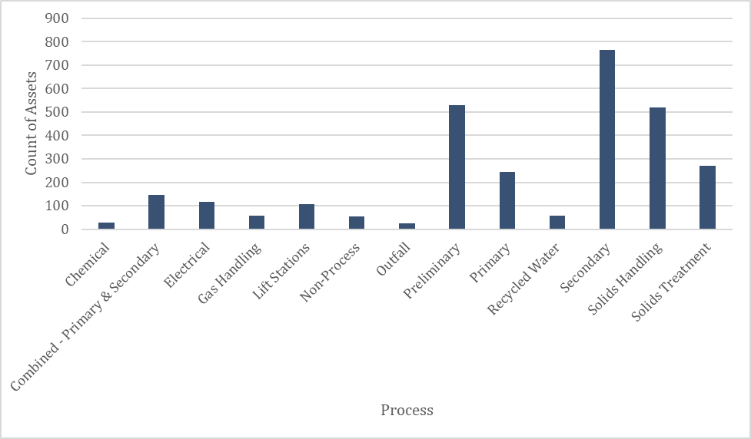
Hazen developed a risk-based approach for the level 1 focused field condition assessment by prioritizing the assets with the highest risk based on determining the remaining useful life (RUL) and consequence of failure (CoF).
RUL was used as an indicator of likelihood of failure within the next 5 years or less or the next 6 to 10 years. Assets in the preliminary asset register were assessed to determine the RUL based on the age of each asset and the expected useful life for each asset class.
The CoF evaluates the direct and indirect impacts of a failure. The CoF was determined for each process within the SBWRP through collaborative workshops with SBMWD staff.
Using the methodology shown in Figure 3-2, a combination of remaining useful life and CoF scores were used to determine the assets on which to conduct the Focused Condition Assessment and the assets on which to conduct Complete Condition Assessment later. Assets that had been identified by SBMWD to be abandoned or planned to be rehabilitated or replaced within the next 5 years were not considered for the field condition assessment.

Figure 3-2: Focused Condition Assessment Methodology

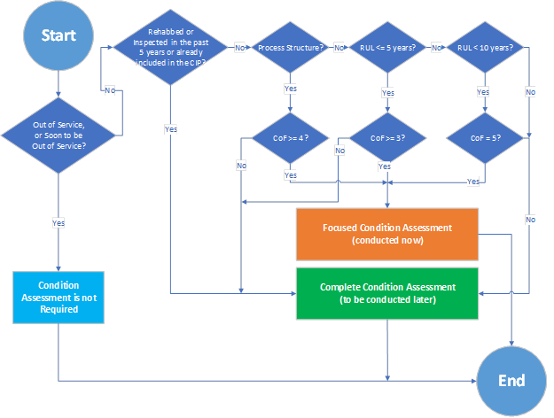

Remaining Useful Life
The expected useful life of an asset is a key factor in assessing a replacement timeframe. A predetermined useful life for each type of asset class was assigned and the year of installation of each asset was used to determine the current age of the asset. The expected useful lives are based on industry best practices and knowledge from local and similar projects. The estimated useful life table developed for SBMWD can be found in Appendix B.
The expected useful life for each asset along with the determined age were used to assess remaining useful life (RUL) of each of SBMWD’s assets in the preliminary asset register using the equation as follows:
RUL=Expected Useful Life (years)-Age (years)
Where: RUL = Remaining Useful Life (years)
Age (years) = Current Year – Year Installed
As shown in Figure 3-3, 1,956 (approximately 60%) of assets in the preliminary asset register were determined to be reaching the end of their useful life within the next 10 years.

Figure 3-3: RUL – Asset Count by Year (Age-Based)

Consequence of Failure
To determine the CoF of each asset, a multi-parameter weighted consequence of failure (CoF) score (ranging from 1 to 5) was determined for each asset at the process level as presented in Table 3-1. The Hazen team utilized SBMWD operations staff’s knowledge of processes in critical condition and workshops were conducted with a broader range of SBMWD staff to gain further input. The results of the preliminary CoF analysis are shown in Figure 3-4.

Table 3-1: CoF Description and Related Score
CoF Range | Description | CoF Score
Lowest | Lowest impact on the main functionality of the process/facility | 1
Lower | Lower impact on the main functionality of the process/facility | 2
High | High impact on the main functionality of the process/facility | 3
Higher | Higher impact on the main functionality of the process/facility | 4
Highest | Highest impact on the main functionality of the process/facility | 5

Figure 3-4: Preliminary CoF Results
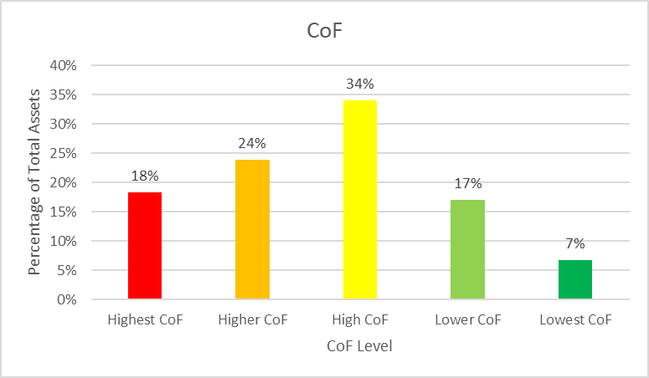

Assets Identified for Field Condition Assessment
The results of remaining useful life analysis and consequence of failure were combined to identify the critical assets that are reaching the end of their useful life (Figure 3-5). Following the decision tree presented in Figure 3-2, 850 assets (approximately 30%) were identified for the focused condition assessment. Figure 3-6 presents the count of those assets at each process.

Figure 3-5: Remaining Useful Life Combined with CoF Results
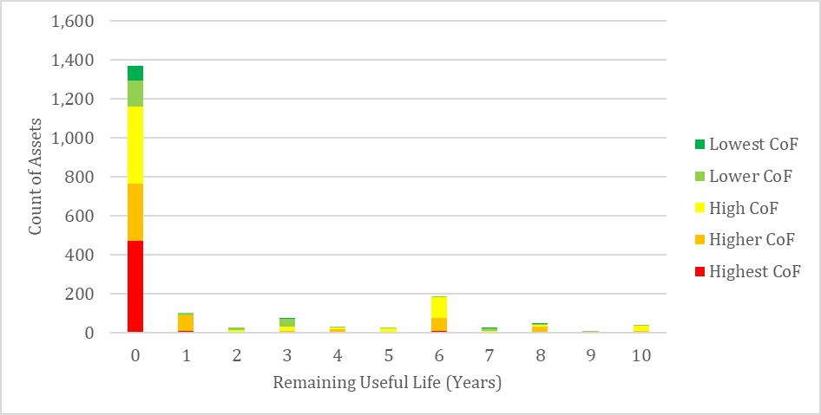

Figure 3-6: Assets Selected for the Focused Condition Assessment

Field Condition Assessment Approach
A field inventory to close data gaps in the preliminary asset register and a Level 1 visual condition assessment of approximately 30% of the WRP assets was conducted. Condition assessment is a combination of field performance and design assessments of assets followed by implementation of the condition scoring process to assign a condition grade to each asset.
Hazen performed an inventory of all assets and a focused condition assessment of about 30% of the assets within the SBWRP. A Level 1 (visual) condition assessment was conducted to assess the mechanical, electrical and structural conditions of assets at WRP. The condition of assets, system redundancies, installation years, quantities, and O&M assessment/needs were identified during the on-site focused facility condition assessment. Additionally, inputs from SBMWD staff as to when the asset was last serviced were used to complete the focused condition assessment.
Asset condition was determined via visual inspection. Field observations were recorded by analysts on mobile devices utilizing customized condition assessment forms. The condition scoring system and mobile devices with electronic forms are presented in Figure 3-7. This system uses a rating range from 1 (Excellent condition) to 5 (Poor condition). Descriptions for each rating enable analysts to assign ratings consistently to assets. The data collected for each asset, including photographs of the assets, notes taken during the condition assessment, condition scores for specific attributes, inspection checklists, etc., were stored digitally. Figure 3-8 shows a portion of the inspection checklists for Mechanical, Electrical, Instrumentation and Structural assets. The complete checklist for each discipline can be found in Appendix B.

Figure 3-7: Mobile Data Collection Tools and Scoring Guide
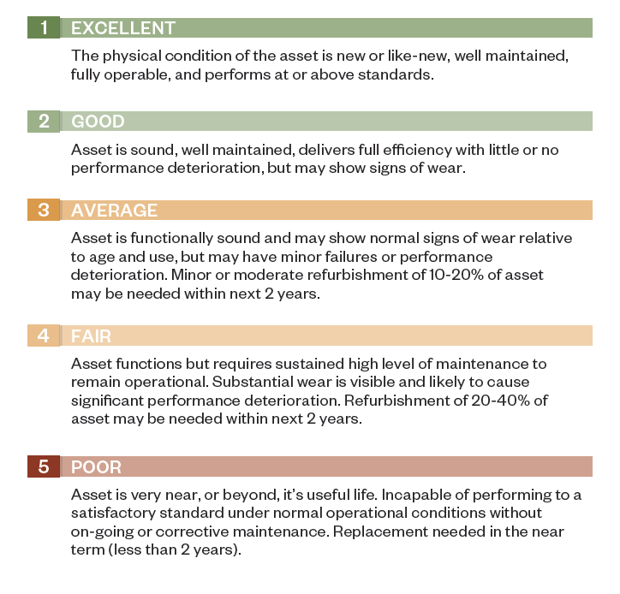
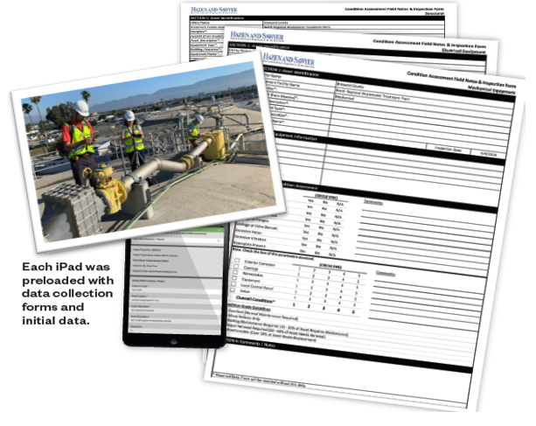

Figure 3-8: Inspection Checklists for Mechanical, Electrical, Instrumentation and Structural Assets
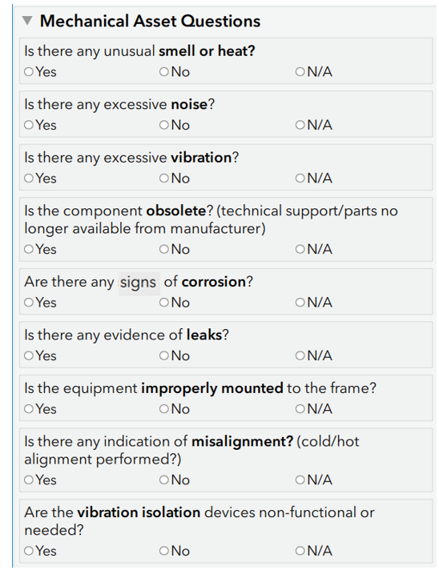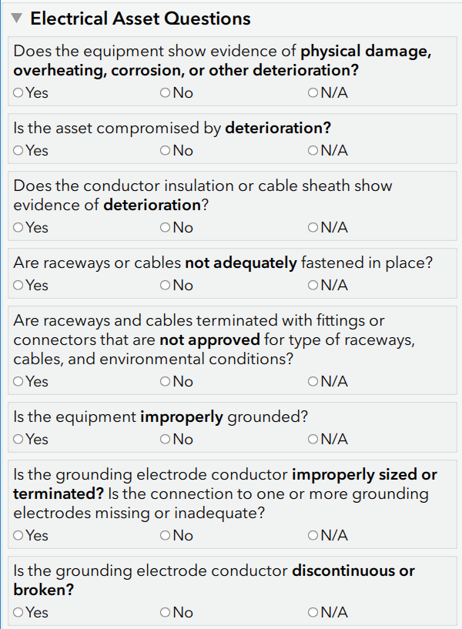

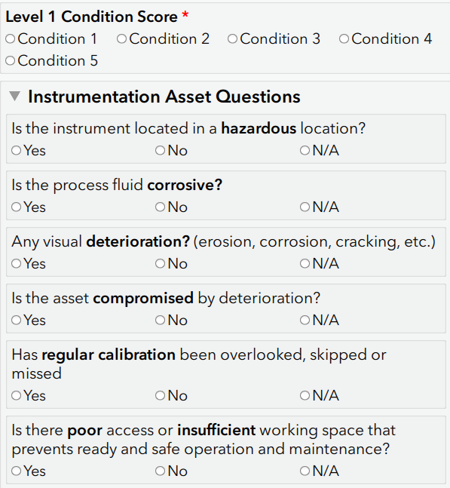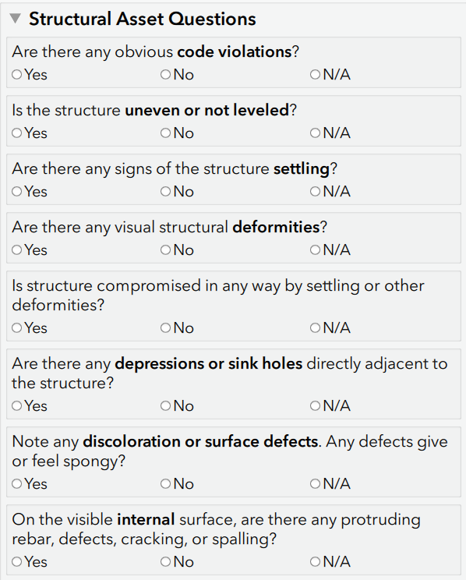
All data collected for each asset, including photographs of facility assets, the inspectors’ notes, condition scores, inspection checklists, etc., were stored digitally and can be exported in a variety of formats. The Hazen Facilities Inspection forms were provided as a deliverable to SBMWD enabling staff to easily continue to periodically collect condition information and update the asset inventory.

Field Condition Assessment Results
A total of 2,995 assets were inspected and assigned a condition score. This included 850 assets identified during the desktop and workshop analysis and another 2,145 identified in the field for inspection based on the criteria described in Figure 3-2. Figure 3-9 provides a summary of the condition assessment results.

Figure 3-9: Summary of Condition Assessment Results

As shown in Figure 3-9, the majority of assets inspected were found to be in “Average”, “Good” or “Excellent” condition.
A total of 204 assets were found to be in “Fair” condition. Table 3-2 and Figure 3-10 and Table 3-34 provide the count of assets in Fair condition by location.
As shown in Table 3-23 and Figure 3-11, a total of 97 assets were found to be in need of rehabilitation or replacement (condition score 5).

Table 3-2: Location of Assets with Condition Score 4
Location of Assets with Condition Score 4 | Count of Assets
Dewatering & Thickening (D&T) Building | 30
Unit 3 Primary Clarifiers | 25
Unit 2 Pump Station | 23
Arrowhead Lift Station | 19
Boiler Building | 12
Dewatering Building & Conveyors 1 & 2 | 11
Unit 1 Aeration Basins | 8
NRC Anoxic Basins | 6
RS-1 Pump Station | 5
Nitrogen Removal Carousel | 5
North Outfall Structure | 4
Headworks Splitter Box | 4
Digester D | 3
Dissolved Air Flotation Thickener (DAFT) 1 | 3
Secondary Administration Building | 3
Sludge Storage Odor Scrubber | 3
Burner Building | 3
Grit Chambers | 3
Bar Screen Building | 3
Digester A | 2
East Influent Lift Station | 2
Headworks Tunnel | 2
NRC Building | 2
South Outfall Structure | 2
Old Blue Generator Building | 2
Digester C | 2
Dissolved Air Flotation Thickener (DAFT) 2 | 2
Admin Bldg | 2
Ferric Chloride Storage Tank | 1
Unit 2 South Primary Clarifier | 1
Unit 2 North Aeration Basins | 1
Bio-Solids Storage Beds | 1
Manual Biosolids Loading Bed | 1
Century Well | 1
Unit 2 Chlorine Contact Basins | 1
Existing 0.06 Flare | 1
Chlorine Contact Lagoon | 1
Internal Recycle Metering Structure | 1
Irrigation Control Building | 1
Headworks Electrical Building | 1
Headworks Odor Scrubber | 1

Figure 3-10: Count of Assets with Condition Score of 4 (based on level 4 of hierarchy)
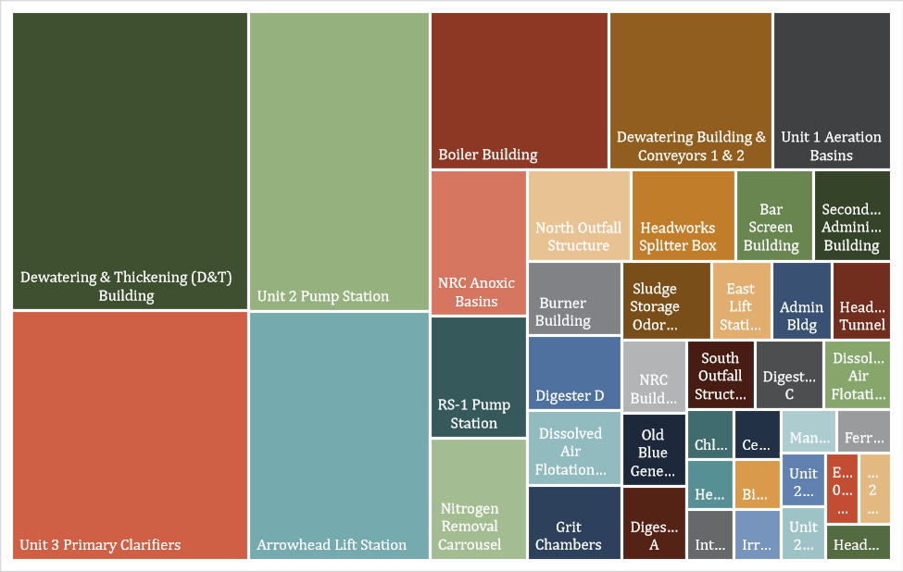

Table 3-3: Location of Assets with Condition Score 5
Location of Assets with Condition Score 5 | Count of Assets
Boiler Building | 16
Unit 2 Pump Station | 11
Digester C | 8
RS-1 Pump Station | 7
NRC Anoxic Basins | 5
Gas Compression Area | 5
Nitrogen Removal Carousel | 4
Digester A | 3
Sludge Storage Odor Scrubber | 3
Unit 1 Pump Station | 3
Grit Chambers | 3
Arrowhead Lift Station | 3
Unit 1 Chlorine Contact Basins | 2
Bar Screen Building | 2
Old Blue Generator Building | 2
Unit 2 South Primary Clarifier | 2
Unit 3 Primary Clarifiers | 1
Headworks Blower Building | 1
Digester B | 1
Internal Recycle Metering Structure | 1
Unit 2 North Primary Clarifier | 1
Low Pressure Holding Tank (LPHT) | 1
Hazardous Materials Storage Area | 1
Collections Storage Building (Old Chlorine Building) | 1
South Digested Sludge Storage Tank | 1
North Outfall Structure | 1
Burner Building | 1
Century Well | 1
Unit 2 North Secondary Clarifier | 1
Cogeneration Building | 1
Grit Dewatering Bed | 1
Combination Truck Unloading Bed | 1
NRC Secondary Clarifier | 1
Influent Metering Structure | 1

Figure 3-11: Count of Assets with Condition Score of 5 (based on level 4 of hierarchy)
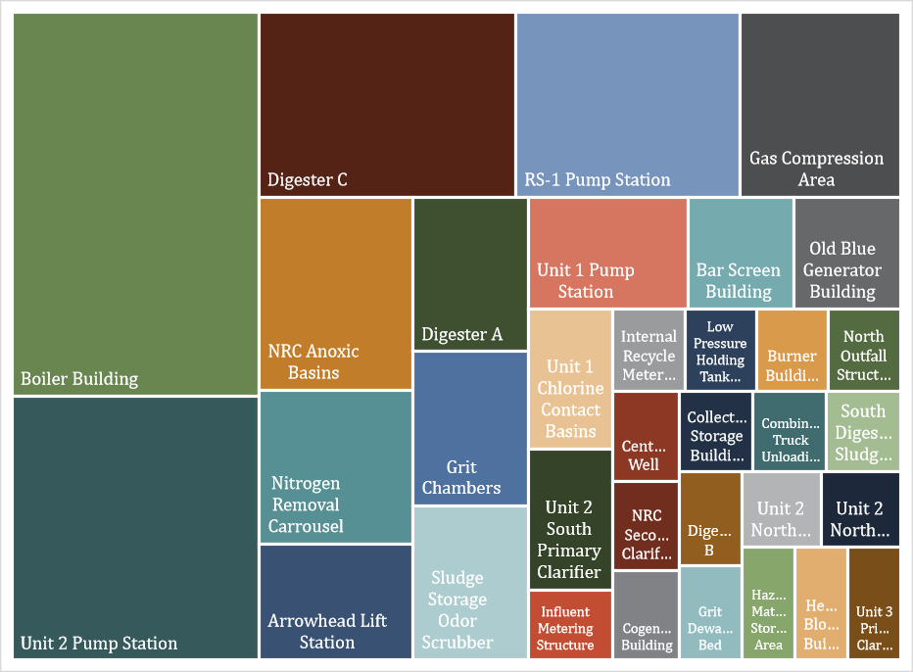
Figure 3-12 presents photos of a sample of assets with condition score 5.

Figure 3-12: Sample of Assets in Need of Rehabilitation or Replacement
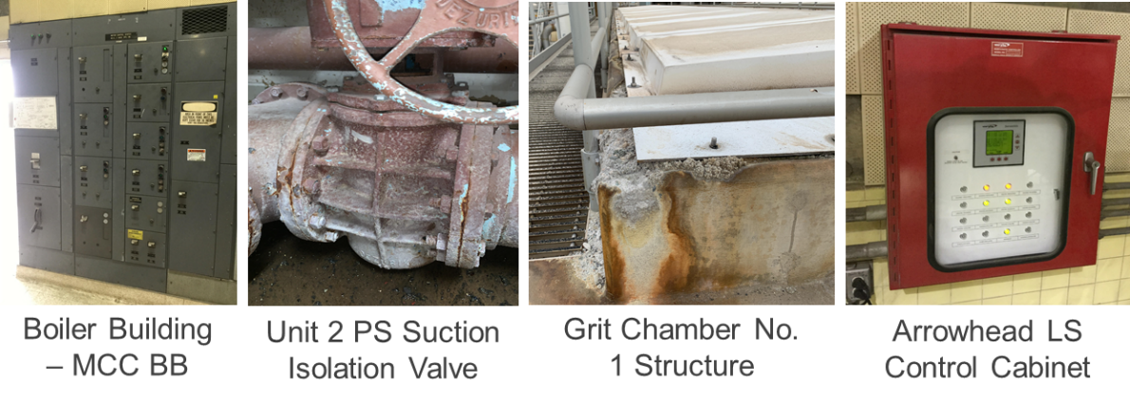

Updated Remaining Useful Life
The preliminary asset register was updated with new assets identified in the field (1,335 assets) and condition scores and remaining useful life were updated for those assets for which a visual condition assessment was performed. Figure 3-13 shows the updated remaining useful lives based on the results of the condition assessment. A total of 1,179 assets (approximately 37%) were identified as reaching the end of their useful lives within the next 10 years. The results of the remaining useful life analysis are utilized to identify assets for rehabilitation or replacement within the next 10 years.

Figure 3-13: Condition-Based RUL by Asset Count

Summary of Findings
The focused condition assessment consisted of Hazen engineers conducting visual inspections of approximately 30% of the most critical assets on the SBWRP. Assets that had been inspected or rehabilitated within the past five years were not included.
Of the 2,995 assets with condition scores, the results indicated that the majority of assets (2,694) inspected were found to be in “Average”, “Good” or “Excellent” condition.
A total of 204 assets were found to be in “Fair” condition and total of 97 assets were found to have reached the end of their useful life and be in need of rehabilitation or replacement.
Based on condition and age, a total of 1,179 assets (approximately 37%) were identified as reaching the end of their useful lives within the next 10 years. The results of the remaining useful life analysis were utilized to identify assets for rehabilitation or replacement within the next 10 years.

Risk Assessment

Business Risk Exposure Methodology
A business risk is the threat that an event, action or inaction will adversely affect an organization’s ability to achieve its business objectives and execute its strategies successfully. An analysis of risk commonly identifies the risk of an event, analyzes the probability of failure and the consequence of failure, calculates a risk score, ranks assets based on their risk scores, and develops risk mitigation strategies if required.
Business Risk Exposure (BRE) is the term used to describe and quantify the risks associated with the management of assets. It can be assessed at an asset level and/or at the system level. Business risk exposure is comprised of three major components: probability of failure, consequence of failure, and redundancy. The probability of failure measures an asset’s likelihood of or timing to failure. The consequence of failure evaluates the direct and indirect impacts of a failure. Redundancy, the presence of backup equipment, helps to decrease the overall risks of a failure. A BRE score is assigned to each asset in the asset register to help prioritize the needs under limited resources. BRE scoring results are used to help prioritize investments in inspection, maintenance, rehabilitation, and replacement activities, informing the prioritization of near-term actions needed to mitigate asset risk and/or help meet level of service goals.

Figure 4-1: Business Risk Exposure Methodology
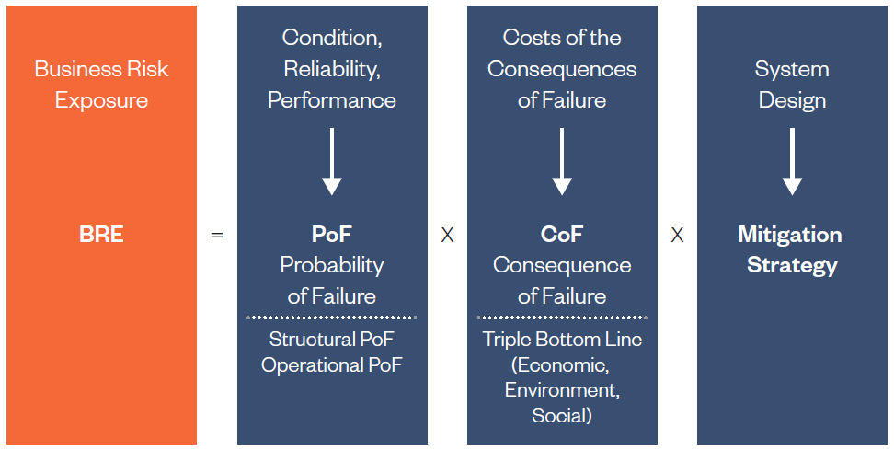
One of the fundamental questions that must be answered in prioritizing assets for maintenance, renewal, and replacement is: “Which assets pose high risk to sustained performance?”
Not all assets are equally important to the system’s operation (see Figure 4-2). Some assets are highly critical to operations (e.g., failure of a chlorine container resulting in potential injury or death of onsite personnel) and others are less critical. Furthermore, critical assets are system specific. Certain assets or types of assets may be critical in one location but not critical in another. For example, within one system, a sludge dewatering press may be a critical asset due to the lack of redundancy and poor condition. In another system, the sludge dewatering press may not be a critical asset because redundant equipment is available that is in good condition. So, an asset-level and process level assessment of probability of failure and consequence of failure is key to evaluate the risk associated with each asset.

Figure 4-2: Consequences of Failure Are Not All the Same
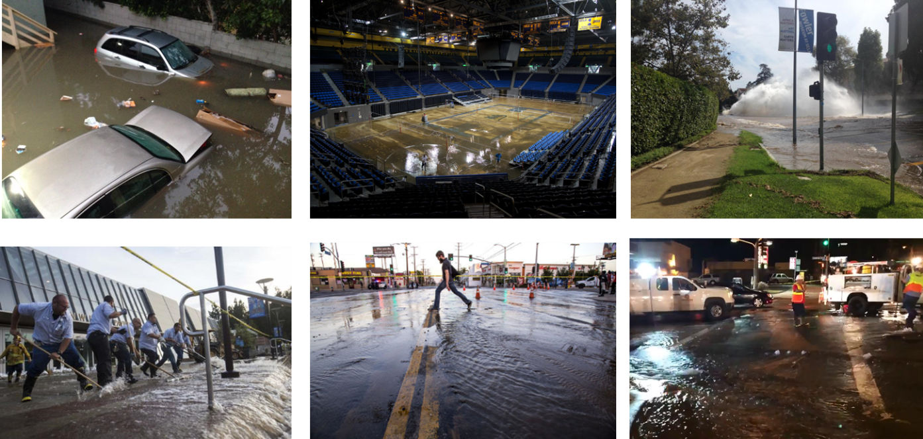

Probability of Failure
Probability of Failure (PoF) measures an asset’s likelihood of failure. A condition-based approach has been followed to calculate the PoF. Condition is the most important factor in determining the probability of an asset failing. As the condition of an asset deteriorates, it will become more likely to fail. Condition of the SBWRP assets was determined via visual inspection of the equipment, along with interviews with Department operations and maintenance staff to determine a condition score as described in the following sections.
Based upon the findings of the field observations (level 1 visual assessment) and interviews, an overall condition score was assigned to each asset. Condition assessment is a combination of field and design assessments of assets followed by implementation of the condition scoring process to assign a condition grade to each asset. The scoring system was developed by Hazen in conjunction with SBMWD staff. The condition scoring system utilized is presented in Table 4-1. This system uses a rating range from 1 (Excellent condition) to 5 (Poor condition). Descriptions for each rating enable analysts to assign ratings to assets. The results of the field investigation were also used to determine the estimated remaining useful life.

Table 4-1: Asset Condition Rating Guidelines
Condition/ Scale | Asset Condition | Definition
1 | Excellent | The physical condition of the asset is as new, e.g., new equipment.
2 | Good | Asset has minor integrity issues. Not new but in very good condition
3 | Average | Asset does not operate efficiently but does not significantly hamper normal operations.  Corroded parts on an asset that do not affect operation.
4 | Fair | Asset has significant structure or integrity issues that have the potential to develop into major operational problems. Significant leaks, damaged electrical cables
5 | Poor | Asset incapable of performing to a satisfactory standard under normal operational conditions  Corroded electrical cabinet which is not sealed

Consequence of Failure
When assets fail, the consequences depend on the failure mode and level of redundancy. Consequences of failure can range from a minor inconvenience to a major disruption of customer service, inability to comply with operating permit, and possible endangerment of public health.
The consequence of failure measures the direct and indirect impacts of an asset failure from triple bottom line perspectives of economic, environment and social factors. The consequence of failure was assessed at both the process-location-level and asset-level as show in Figure 4-3.

Figure 4-3: Consequence of Failure: Multiple Levels
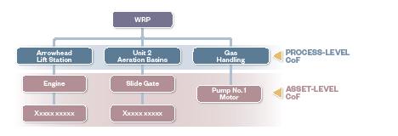
To objectively measure the criticality of each process, an assessment was conducted at a WRP-wide level, considering all processes managed by the SBMWD. Four parameters were identified by the SBMWD to measure the consequence of failure at the process-level:
- Fatalities/Serious Injuries or Sickness
- Cost to Remediate/Economic Loss
- Environmental Damage
- Public Perception
Each process was assigned a score of 1 to 5 under each consequence of failure parameter to describe the impact of failure from no impact to high impact. Table 4-2 presents the process-level guideline for scoring each consequence of failure parameter from 1 to 5.

Table 4-2: Process/Location-Level Scoring Guide
CoF Range | Description | CoF Score
Lowest | Lowest impact on the main functionality of the process/facility | 1
Lower | Lower impact on the main functionality of the process/facility | 2
High | High impact on the main functionality of the process/facility | 3
Higher | Higher impact on the main functionality of the process/facility | 4
Highest | Highest impact on the main functionality of the process/facility | 5
Additionally, each parameter was assigned a weighting factor that defines the relative importance of each parameter. The weight for each factor is shown in Table 4-3.

Table 4-3: Process/Location Level Weighting Factors
Process Level CoF Criteria | Weighting Factor (%)
Fatalities/Serious Injury or Sickness | 35
Cost to Remediation/Economic Loss | 25
Environmental Damage | 20
Public Perception | 20
At the asset-level, the impact was measured by the impact of the asset failure on the process. Table 4-4 presents the Asset-level scoring guideline for scoring each consequence of failure parameter from Catastrophic (score of 5) to No impact (score of 1).

Table 4-4: Asset Level CoF Scoring Guide
CoF Level | Description | Examples
5 - Highest | Highest impact on the main functionality of the process/facility | Automatic Transfer Switch, Blowers, Flame Arrester, Gas Detector, Emergency Generator, MCC, Eyewash Station
4 - Higher | Higher impact on the main functionality of the process/facility | Flow Meter, Pumps, Mixer, Belt Press, Gas Meters, Grinder, Motor, Conveyors, Valves
3 - High | High impact on the main functionality of the process/facility | Air Compressor, Air Dryer, Boiler, Crane Assembly, Fuel Tank, Sampler, Skimmer, Process Structure, Ventilation Fan, Weir Structure
2 - Lower | Lower impact on the main functionality of the process/facility | Access Cover, Louver, Spray System, Air Receiver, Water Softener
1 - Lowest | Lowest impact on the main functionality of the process/facility | Concrete Pad, Exhauster, Paving, Fence, Roof, Trailer, Walkway

Risk Results

Probability of Failure Summary Results
- The Probability of Failure (PoF) was generated for each WRP asset based on one of two following approaches.
- Condition score for approximately 30% of the WRP’s assets generated during the focused field condition assessment.
- Desktop assessment of approximately 70% of the WRP’s assets based on:
- Age
- Institutional knowledge
- Desktop review of the WRP performance data
Table 4-5 shows an example of how assets with a condition score had the Percentage (%) Consumed used to calculate PoF and for assets without a condition score Remaining Useful Life was used to determine PoF. For example, the age of Motor No. 2 is beyond its expected useful life, however the percent consumed based on the condition score of 4 shows that the asset is in Fair condition and therefore has a percent consumed of 84% which results in a remaining useful life of 3 years.

Table 4-5: Calculation of PoF Example
Asset | Age | Condition | % Consumed | Expected Useful Life | Remaining Useful Life | PoF (%)
Concrete Vault | 65 | - | - | 100 | 35 | 65
Motor No. 1 | 12 | - | - | 20 | 8 | 60
Motor No. 2 | 34 | 4 | 84 | 20 | 3 | 84
Ball Valve | 36 | 5 | 100 | 30 | 0 | 100
MCC Cabinet | 27 | 3 | 65 | 20 | 7 | 65
VFD | 2 | 1 | 0 | 15 | 15 | 0
PoF thresholds for high, medium, low, and negligible categories were established as shown in Table 4-6 and the PoF was calculated for each category.

Table 4-6: PoF Thresholds
PoF | Threshold Values
High | Greater than 75%
Medium | Between 50% and 75% (including 75%)
Low | 25% to 50% (including 25% and 50%)
Negligible | Less than 25%
Location-based results of the PoF assessment are shown on a map of the WRP in Figure 4-4 and Figure 4-5. The results indicated a majority of the WRP assets with “Medium” or “High” PoF scores are scattered throughout the WRP versus being concentrated in one area.

Figure 4-4: Summary of PoF Results (Colored Map)
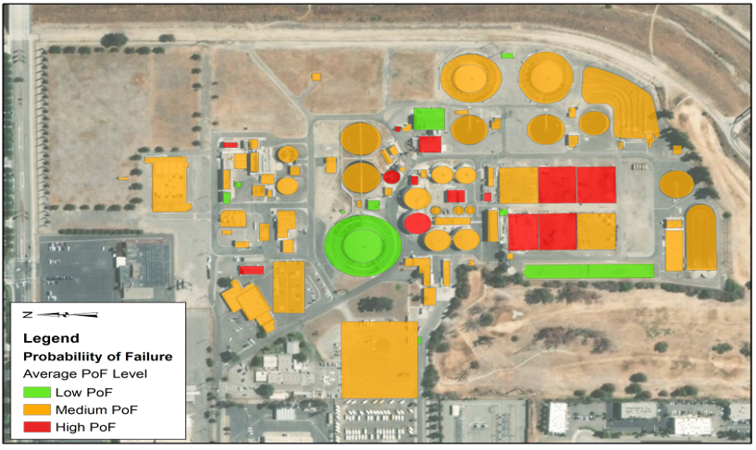

Figure 4-5: Summary of PoF Results (Grayscale Map)
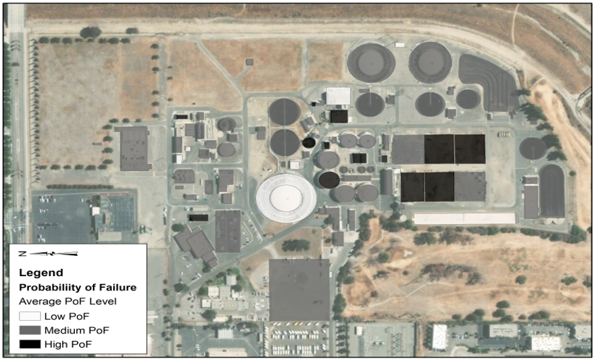
Figure 4-6 presents examples of assets that are reaching the end of their useful life and have the highest PoF score.

Figure 4-6: Examples of Assets with Highest PoF
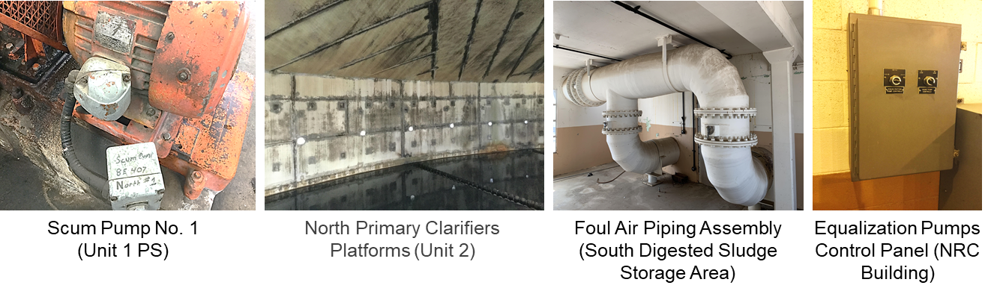
Table 4-7 presents the number of assets with high PoF at each of the different plant processes. A list of high PoF assets can be found in Appendix C.

Table 4-7: High PoF Assets per Process
Process | No. of Assets with High PoF | Percentage of Assets with High PoF
Headworks Chemical | 1 | 13
Solids Chemical | 1 | 7
Recycled Water | 3 | 6
Electrical | 7 | 14
Odor Scrubber Chemical | 7 | 9
Outfall | 8 | 21
Lift Stations | 10 | 9
Non-Process | 13 | 14
Preliminary | 28 | 7
Solids Treatment | 46 | 24
Solids Handling | 48 | 11
Primary | 50 | 17
Secondary | 104 | 12
Total | 326 | 12
Figure 4-7 summarizes the findings of PoF risk scores by showing the probability of failure and number of assets.

Figure 4-7: Summary of PoF Results
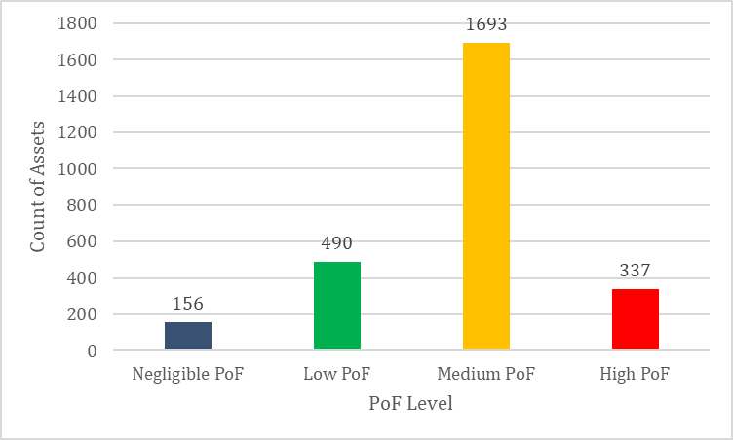

Consequence of Failure Summary Results
The process level and asset level CoF scores were combined using the formula presented in Figure 4-8 to come up with an overall CoF score. The product of Process-Level CoF and Asset-Level CoF were divided by 2.5 to adjust the final CoF score from 1-25 to 1-10. Table 4-8 presents the process/location level CoF results.

Figure 4-8: Final CoF Formula

Table 4-8: Process/Location Level CoF
Process | Location | CoF
Electrical | Burner Building | 5
Electrical | Cogeneration Building | 5
Electrical | Hoffman Building | 5
Electrical | Main Switchgear (BLM) | 5
Electrical | Old Blue Generator Building | 5
Gas Handling | Existing 0.06 Flare | 5
Gas Handling | Gas Compression Area | 5
Gas Handling | High Pressure Storage Tank (HPST) | 5
Gas Handling | Low Pressure Holding Tank (LPHT) | 3
Headworks Chemical | Ferric Chloride Storage Tank | 2
Lift Stations | Arrowhead Lift Station | 5
Lift Stations | East Influent Lift Station | 5
Non-Process | Emergency Storage Container | 5
Non-Process | Unit 1 Chlorine Contact Basins | 5
Non-Process | Unit 2 Chlorine Contact Basins | 5
Non-Process | Admin Bldg | 2
Non-Process | Boneyard | 1
Non-Process | Brine Ponds | 1
Non-Process | Collections Parking Area | 1
Non-Process | Collections Storage Building (Old Chlorine Building) | 1
Non-Process | Electrical Administration Building | 1
Non-Process | Electrical Supply Building | 1
Non-Process | Employee Parking Lot | 1
Non-Process | Equipment Storage Area | 1
Non-Process | Facilities Shop | 1
Non-Process | Instrumentation and Control Trailer | 1
Non-Process | Irrigation Control Building | 1
Non-Process | Maintenance Shop | 1
Non-Process | Perimeter Fencing | 1
Non-Process | Personnel Building | 1
Non-Process | Secondary Administration Building | 1
Non-Process | Tertiary Clarifier (Abandoned) | 1
Non-Process | Tertiary Pump Building | 1
Odor Scrubber Chemical | Sludge Storage Odor Scrubber | 4
Odor Scrubber Chemical | Headworks Odor Scrubber | 3
Outfall | North Outfall Structure | 5
Outfall | Outfall Sampling Station | 5
Outfall | South Outfall Structure | 5
Outfall | Chlorine Contact Lagoon | 1
Outfall | Outfall Bleach Tank | 1
Preliminary | Bar Screen Building | 5
Preliminary | Headworks Electrical Building | 5
Preliminary | Headworks Generator Building | 5
Preliminary | Influent Metering Structure | 5
Preliminary | Internal Recycle Metering Structure | 5
Preliminary | East Diversion Structure | 4
Preliminary | Grit Chambers | 4
Preliminary | Headworks Blower Building | 3
Preliminary | Headworks Tunnel | 3
Preliminary | 2.5 MGD Maintenance Hole to IEBL | 2
Preliminary | Grit Wash Building | 2
Preliminary | Headworks Splitter Box | 2
Preliminary | Septage & Brine Receiving Station | 2
Preliminary | Operations Storage Building | 1
Primary | Unit 2 North Primary Clarifier | 4
Primary | Unit 2 Pump Station | 4
Primary | Unit 2 South Primary Clarifier | 4
Primary | Headworks Tunnel | 3
Primary | Unit 1 PI/PE Junction Box | 2
Primary | Unit 1 Primary Clarifier | 2
Primary | Unit 1 Pump Station | 2
Primary | Unit 2 Splitter Box | 2
Primary | Unit 3 Primary Clarifiers | 2
Recycled Water | Alternate 6-inch Potable Water Connection | 2
Recycled Water | Century Well | 2
Recycled Water | Chandler Well | 2
Recycled Water | Golf Course and Caltrans Irrigation Meters | 2
Recycled Water | Main Potable Water Feed Source | 2
Recycled Water | Orange Show Well | 2
Recycled Water | Tertiary Reservoir | 2
Solids Chemical | Polymer Storage Area | 3
Solids Chemical | Hazardous Materials Storage Area | 2
Solids Handling | Dewatering & Thickening (D&T) Building | 4
Solids Handling | Dewatering Building & Conveyors 1 & 2 | 4
Solids Handling | Truck Loading, Conveyors 3-5, & Storage Silo | 2
Solids Handling | Bio-Solids Storage Beds | 1
Solids Handling | Combination Truck Unloading Bed | 1
Solids Handling | Grit Dewatering Bed | 1
Solids Handling | Manual Biosolids Loading Bed | 1
Solids Treatment | Boiler Building | 5
Solids Treatment | Digester A | 4
Solids Treatment | Digester C | 4
Solids Treatment | Digester C&D Common Valve Vault | 4
Solids Treatment | Digester D | 4
Solids Treatment | Dissolved Air Flotation Thickener (DAFT) 1 | 3
Solids Treatment | Dissolved Air Flotation Thickener (DAFT) 2 | 3
Solids Treatment | Dissolved Air Flotation Thickener (DAFT) 4 | 3
Solids Treatment | North Digested Sludge Storage Tank | 2
Solids Treatment | South Digested Sludge Storage Tank | 2
Solids Treatment | Digester B | 1
Secondary | Roots Blower Building | 5
Secondary | Unit 2 Chlorine Contact Basins | 5
Secondary | RS-1 Pump Station | 4
Secondary | Unit 1 Aeration Basins | 4
Secondary | Unit 1 East Secondary Clarifier | 4
Secondary | Unit 1 West Secondary Clarifier | 4
Secondary | Unit 2 North Aeration Basins | 4
Secondary | Unit 2 North Secondary Clarifier | 4
Secondary | Unit 2 Pump Station | 4
Secondary | Unit 2 South Aeration Basins | 4
Secondary | Unit 2 South Secondary Clarifier | 4
Secondary | Nitrogen Removal Carousel | 3
Secondary | NRC Anoxic Basins | 3
Secondary | NRC Building | 3
Secondary | NRC Secondary Clarifier | 3
Secondary | Mixed Liquor Splitter Box | 2
Figure 4-9 summarizes the findings of CoF risk scores by showing the consequence of failure and number of assets.

Figure 4-9: Summary of Final CoF Scores
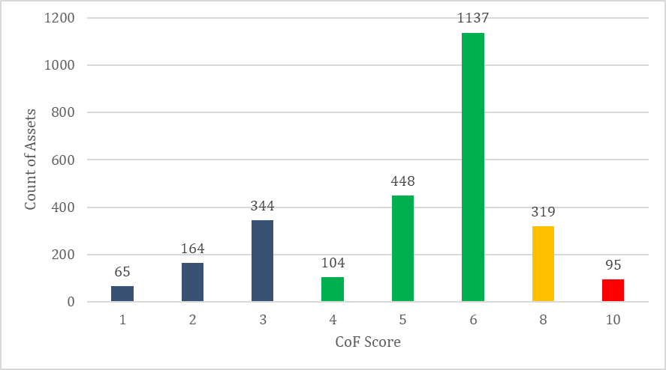
Process level results of the CoF assessment are shown on a map of the WRP in Figure 4-10 and Figure 4-11. The results indicated the assets judged to have a higher consequence of failure are primarily associated with the primary, secondary and gas handling processes.

Figure 4-10: Process Level CoF Results (Colored Map)
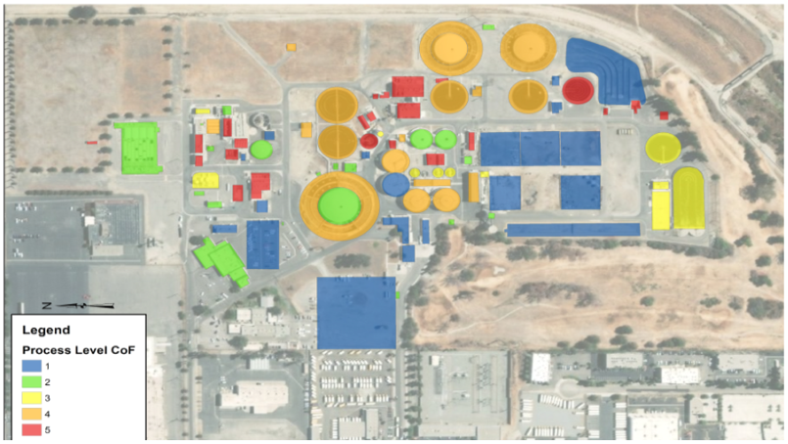

Figure 4-11: Process Level CoF Results (Grayscale Map)
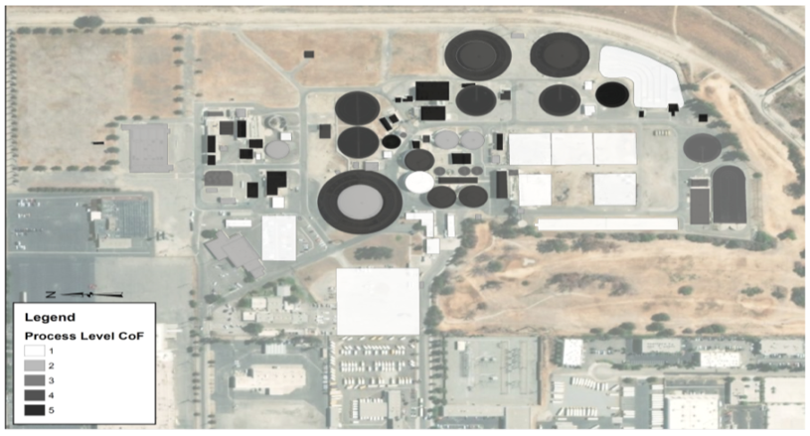
Figure 4-12 presents examples of assets with a high level CoF.

Figure 4-12: Examples of Assets with High CoF
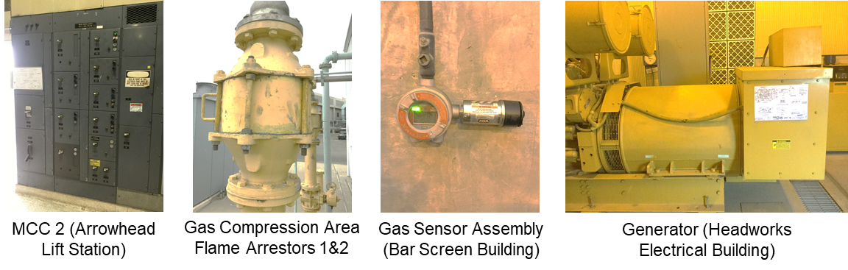
Table 4-9 presents the number of assets with high CoF at each of the different plant processes. A list of high CoF assets is presented in Appendix C.

Table 4-9: High CoF Assets
Process | No. of Assets with High CoF | Percentage of Assets with High CoF
Solids Treatment | 1 | <1
Outfall | 2 | 5
Primary | 2 | <1
Solids Handling | 2 | <1
Lift Stations | 7 | 6
Gas Handling | 2 | 3
Secondary | 13 | 2
Preliminary | 22 | 6
Electrical | 30 | 58
Total | 81 | 3

Business Risk Exposure Summary Results
Through a workshop, the Hazen team worked with SBMWD staff to determine the appropriate risk assessment methodology to calculate the risk score for each asset.
Business Risk Exposure (BRE) is a component of both the probability of failure and consequence of failure based on the formula presented in Figure 4-13.

Figure 4-13: Business Risk Exposure Formula
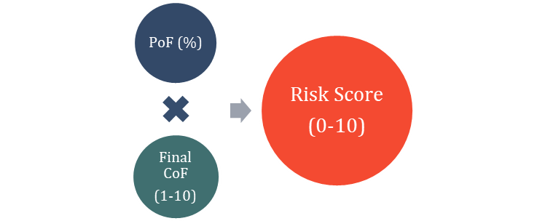
Mapping the risk results on a matrix is a powerful tool to visualize how each asset is scored against the main constituents of the risk (PoF and CoF). The risk matrix, presented in Figure 4-14, demonstrates the probability of failure on the vertical axis and consequence of failure on the horizontal axis. The numbers inside the individual cells denote the number of assets identified in that risk level.

Figure 4-14: Risk Matrix
Assets within the WRP were mapped on the risk matrix based on their categories (i.e., High, Medium, and Low). The risk matrix was categorized and color-coded into high, medium, and low risk zones (red, orange, and green respectively). Assets located on the top-right corner of the risk matrix are considered high risk and assets located on the bottom-left of the risk matrix are considered low risk assets. Here is a summary of the logics set up to categorize assets into high, medium, and low risk zones:
- For assets with High PoF:
- If the CoF is Medium or High, the asset is considered High Risk
- If the CoF is Low or Negligible, the asset is considered Medium Risk
- For assets with Medium PoF:
- If the CoF is High, the asset is considered High Risk
- If the CoF is Low or Medium, the asset is considered Medium Risk
- If the CoF is Negligible, the asset is considered Low Risk
- For assets with Low PoF:
- If the CoF is Medium or High, the asset is considered Medium Risk
- If the CoF is Negligible or Low, the asset is considered Low Risk
- For assets with Negligible PoF:
- Regardless of the CoF score, the asset is considered Low Risk
Table 4-10 presents the number of assets with high risk BRE scores at each of the different plant processes. A list of high risk BRE assets is shown in Appendix C.

Table 4-10: High Risk Assets
Process | No. of Assets with High CoF | Percentage of Assets with High CoF
Solids Handling | 2 | <1
Primary | 3 | 1
Outfall | 7 | 18
Lift Stations | 9 | 8
Secondary | 10 | 1
Solids Treatment | 14 | 8
Electrical | 29 | 29
Preliminary | 29 | 7
Total | 103 | 4
Figure 4-15 and Figure 4-16 show location-based BRE results.

Figure 4-15: Location-Based BRE Results (Colored Map)
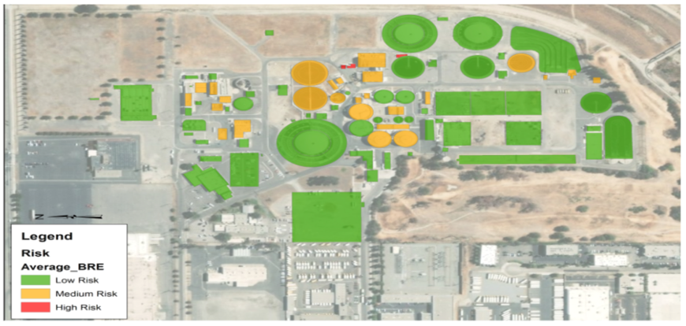

Figure 4-16: Location-Based BRE Results (Grayscale Map)
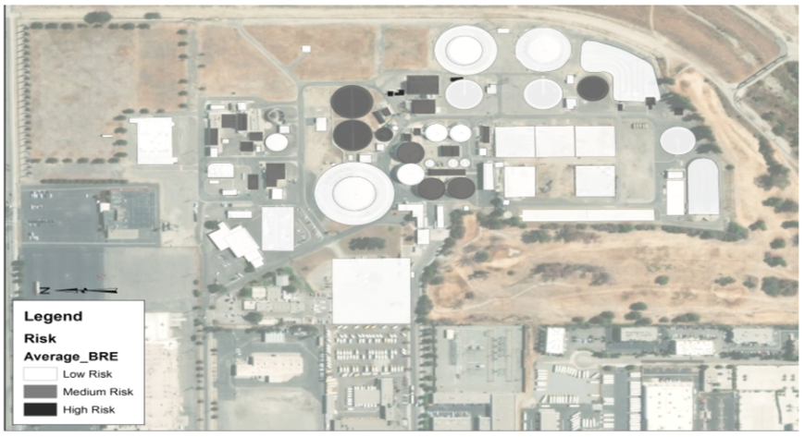
Figure 4-17 presents the count of assets for each BRE score of 0 through 10.

Figure 4-17: Asset Count by BRE Score
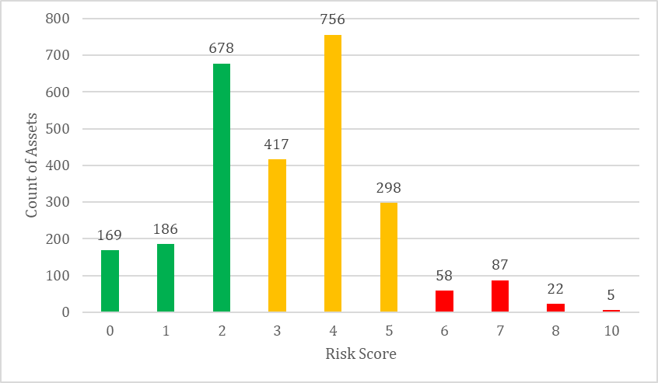
The results of the risk assessment are combined with the results of the remaining useful life analysis in order to prioritize the replacement of the assets. Figure 4-18 exhibits a risk-based prioritization of assets by categorizing the assets that are reaching the end of their useful lives in the next 20 years into high risk, medium risk, and low risk. This will help SBMWD to prioritize the rehabilitation and replacement investments by focusing on assets with higher business risk exposure.

Figure 4-18: Risk-Based Prioritization of Assets
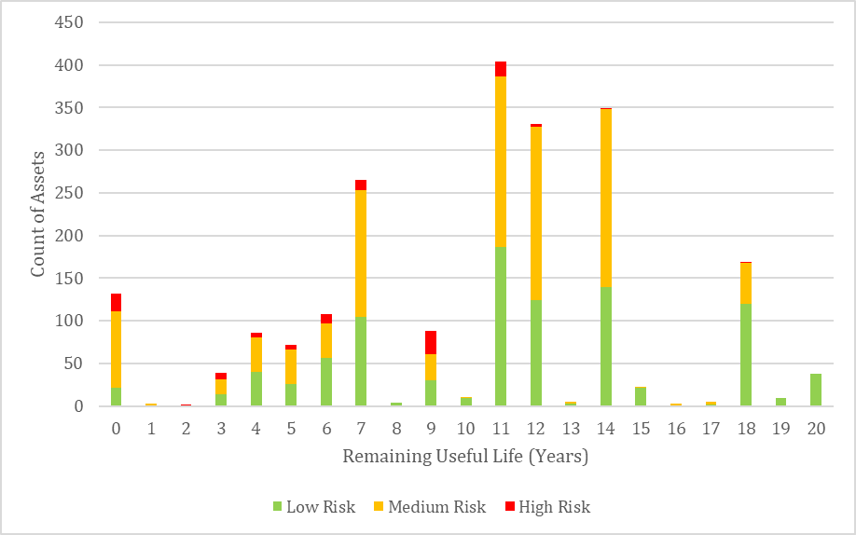
The results show approximately 132 assets have reached the end of their useful life. The list of assets at the end of their useful life that are high and medium risk can be found in Appendix C.

Facility Planning Assumptions
Facilities master planning for the SBWRP addresses numerous water resource considerations such as stormwater management, liquefaction and flooding potential, and planned water recycling projects at the site. In addition to these site-specific concerns, there are offsite projects with impacts to the SBWRP: the future East Valley Water District (EVWD) Sterling Natural Resource Center (SNRC) in the City of Highland that will reduce wastewater flow to the SBWRP; and the Santa Ana River discharge requirements from the Rapid Infiltration Extraction (RIX) facility that may impact the volume of water that can be recycled at the SBWRP. This Section discusses how these water resource considerations impact facility planning for the SBWRP.
Figure 5-1 presents the setting for many of the planning assumptions. The shaded areas represent the current service areas for the SBWRP, including the City of San Bernardino Municipal Water Department, the East Valley Water District, and the City of Loma Linda. At the RIX facility in the City of Colton, secondary treated wastewater from SBWRP’s service area combines with flows from outside its service area, including the City of Colton and the satellite collection system of the City of Grand Terrace. The secondary-treated wastewater is further combined with extracted groundwater and undergoes tertiary treatment at RIX before it is discharged to the Santa Ana River.

Figure 5-1: Planning Assumption Setting
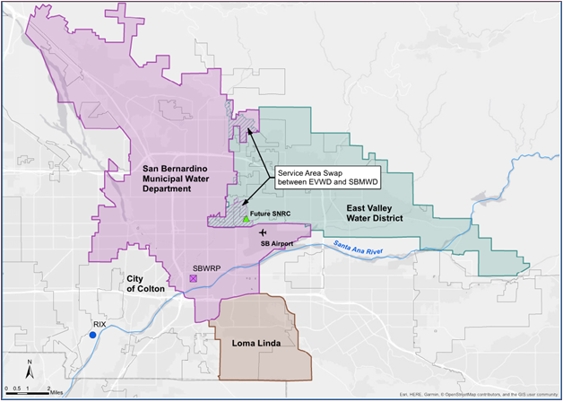

Current Projects with Potential Impacts to the Facilities Master Plan

East Valley Water District Sterling Natural Resource Center
Wastewater produced in East Valley Water District (EVWD) is currently treated at the SBWRP. GIS analysis shows that approximately 13% of San Bernardino’s land area is contained within EVWD’s service area. Flow from the EVWD combines with flow from the SBWRP service area and enters the plant through the East Trunk Sewer. The flow contribution from EVWD is approximately 6 mgd or 28% of the current SBWRP flow.
EVWD is building a new water recycling plant called the Sterling Natural Resources Center (SNRC) that, when complete, will divert EVWD’s wastewater flow from the SBWRP to a new reclamation facility in Highland (Figure 5-1). The SNRC will produce Title 22 disinfected tertiary recycled water to recharge the Bunker Hill Groundwater Basin and meet environmental commitments to the Santa Ana River. The SNRC is under construction and anticipated to be completed in October/November 2021. When the SNRC starts up, an estimated 6 mgd of flow will cease to flow to the SBWRP. As shown on Figure 5-2, anticipated growth in the SBWRP service area from 2023 to 2040 will make up a portion of the loss of flow from EVWD; however, growth will not likely fully recover the loss of 6 mgd of EVWD flow by the year 2040.

Figure 5-2: Projected Wastewater Flow
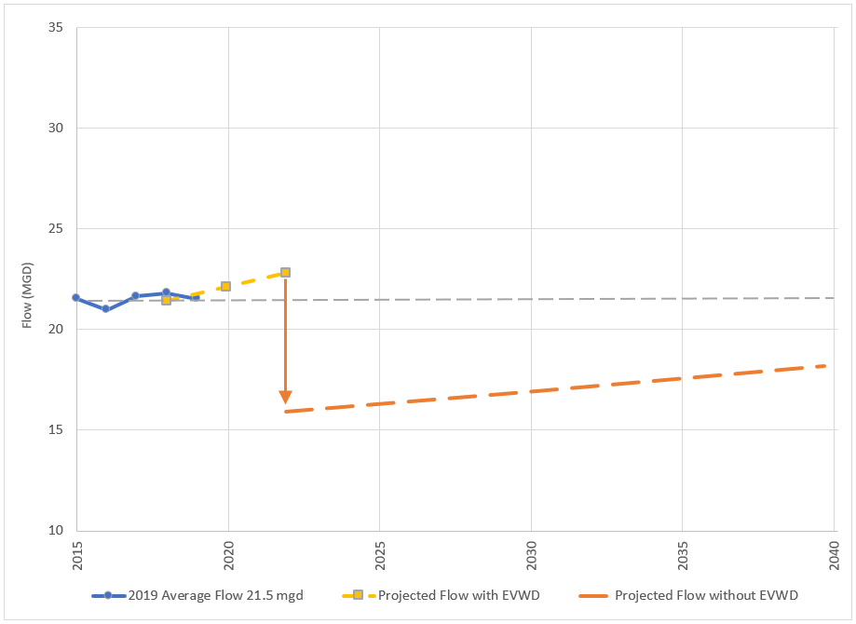
The net flow decrease from the EVWD will have multiple impacts to operation of the SBWRP, including a loss of approximately 28% of the total flow into the plant. Because the cost structure for the SBWRP is a combination of costs that are fixed (not flow-dependent) and variable (flow-dependent), the corresponding operational savings from the future flow reduction is estimated at less than 10% (Section 10.2.2). Without options to divert wastewater from other sources, the Department must make changes to minimize the impact to rates within the SBWRP service areas.

East Valley Water District Sewer Exchange Flow Agreement
A small portion of flow from EVWD will be diverted to SBWRP as part of a sewer exchange flow Agreement. The sewer exchange flow Agreement between EVWD and SBMWD stipulates that 398,500 gpd from EVWD service area will be diverted to the SBWRP and 355,746 gpd from SBWRP will be directed to the SNRC. The sewer exchange areas are shown on Figure 5-1.

Clean Water Factory
The SBMWD is planning a recycled water project called the Clean Water Factory (CWF) which will be a Title 22-compliant tertiary treatment facility that will supply recycled water for:
- Operational needs within the plant, eliminating in-plant use of groundwater and onsite groundwater storage
- Groundwater recharge of the Bunker Hill Groundwater Basin, which is SBMWD’s sole source of water supply
- Supplying potential future recycled water customers.
The CWF is currently in the preliminary design phase and is expected to be operational in 2021. Based on the preliminary design, the CWF is sited on the former site of the pre-aerator structure, a currently unused area, east of the Unit 1 secondary clarifiers as shown in Figure 5-3. The design includes a new pump station and pipelines to convey secondary effluent to new filtration and disinfection processes. After treatment, the tertiary recycled water will be stored in an existing reservoir that will be rehabilitated and modified to store tertiary effluent (existing reservoir currently stores groundwater). Production of tertiary disinfected recycled water from the CWF will be phased with provisions to allow future expansion of up to 5 mgd (AECOM, 2019) and will only occur in the volume that exceeds discharge commitments to the SAR from the RIX.
The CWF has been approved for funding through the San Bernardino Valley Municipal Water District (Valley District) Local Resource Investment Program (LRIP). The LRIP has a target of investing in 15,000 acre-feet of locally supplied water in the region. The Valley District Board of Directors approved the Clean Water Factory for funding of approximately $970,000 per year for 20 years once the project comes online in 2021 (based on a production rate of 5,600 AF (5 mgd) of recycled water).
The CWF presents implications to the Facilities Master Plan and future operation of the SBWRP. Space needs to be reserved and power requirements and other interfacing issues need to be considered. The CWF will require consistent influent water quality from the SBWRP. There are also minimum discharge requirements to the Santa Ana River through the RIX facility that may limit recycled water production (Section 5.2).

Figure 5-3: Proposed Clean Water Factory Tertiary Treatment Facility
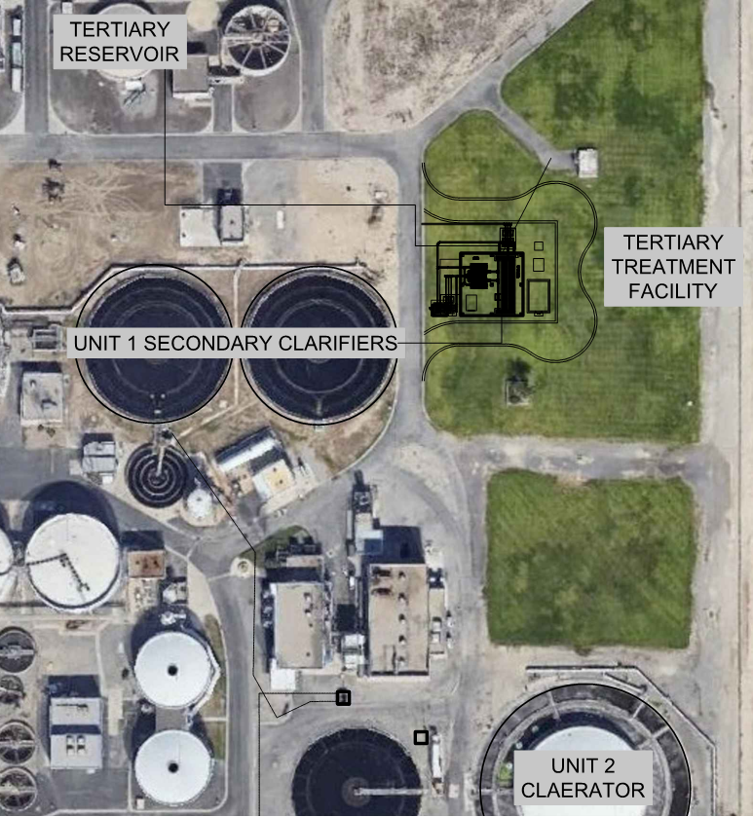
Source: AECOM, 2019, Tertiary Treatment System Design Plans (Progress Set)

Santa Ana River Discharge Considerations
Discharges to the Santa Ana River are one of the considerations for the SBWRP Facilities Master Plan. Some of the wastewater treatment and water reclamation plants that discharge to the Santa Ana River are obligated to provide certain volumes of water into the river to satisfy legal and environmental requirements downstream. Further, management of groundwater levels below the Rapid Infiltration Extraction (RIX) facility requires the extraction of additional volumes of groundwater, which are discharged to the Santa Ana River. The following sections briefly describe the Santa Ana River discharge considerations for the SBWRP.

Rapid Infiltration Extraction Facility
Effluent from the SBWRP is currently conveyed to the RIX facility located at 1990 Agua Mansa Road in Colton for additional treatment prior to discharge to the Santa Ana River. RIX was established in 1994 as a method to effectively meet the filtration and disinfection requirements for discharge to the Santa Ana River. RIX is jointly owned by the City of San Bernardino and the City of Colton through a Joint Powers Authority (JPA), which created the “Colton/San Bernardino Regional Tertiary Treatment and Reclamation Authority.”
RIX infiltrates secondary treated wastewater from the SBWRP and the City of Colton’s wastewater treatment plant. The secondary effluent plus a small volume of native groundwater is extracted prior to discharge. The soil beneath the percolation ponds provides additional filtration, which is then followed by ultraviolet (UV) disinfection before discharge to the Santa Ana River. RIX is permitted to treat an influent flow rate of up to 40 mgd, with the subsequent UV disinfection system designed to treat 64 mgd to account for the extracted groundwater.
As shown in Table 5-1, from August 2018 through July 2019, the influent flow to RIX was approximately 26.5 mgd, with 80% from the SBWRP (21.5 mgd) and 20% from the City of Colton (5.0 mgd). The monthly discharge from RIX to the Santa Ana River averaged 29.3 mgd for this 12-month period, including 2.8 mgd of extracted groundwater (Colton/San Bernardino Tertiary Treatment and Reclamation Authority, August 2018 - July 2019). The volume of native groundwater that is over extracted has been approximately 10% of the secondary influent volume in recent years, but historically has been as high as 40%.

Table 5-1: RIX Flows August 2018 – July 2019
Month |  | Influent from SBWRP | Influent from Colton | Extracted Groundwater | Discharge to Santa Ana River
Aug 2018 |  | 22.3 | 5.0 | 2.4 | 29.6
Sep 2018 |  | 22.1 | 4.8 | 2.8 | 29.8
Oct 2018 |  | 21.9 | 4.8 | 2.9 | 29.6
Nov 2018 |  | 21.6 | 4.9 | 2.5 | 28.9
Dec 2018 |  | 20.9 | 5.2 | 2.8 | 28.9
Jan 2019 |  | 21.7 | 5.2 | 2.6 | 29.5
Feb 2019 |  | 22.1 | 5.4 | 3.1 | 30.6
Mar 2019 |  | 20.7 | 5.1 | 3.1 | 28.9
Apr 2019 |  | 20.7 | 5.0 | 2.5 | 28.2
May 2019 |  | 21.0 | 4.9 | 3.1 | 29.0
Jun 2019 |  | 21.4 | 5.0 | 3.3 | 29.7
Jul 2019 |  | 22.0 | 5.1 | 2.7 | 29.8
12-month average | mgd | 21.5 | 5.0 | 2.8 | 29.3
12-month average | AFY | 24,100 | 5,600 | 3,100 | 32,800
Source: Colton/San Bernardino Tertiary Treatment and Reclamation Authority Daily Monitoring Report

1969 Judgement Water Discharge Obligations to the Santa Ana River
The “1969 Judgement” requires the City of San Bernardino, through the Valley District, be responsible for a baseflow volume in the Santa Ana River at Riverside Narrows, adjusted annually (Superior Court of the State of California for the County of Orange, 1969). The volume requirement is adjusted for quality based on the weighted annual average of total dissolved solids (TDS) in baseflow and storm flow at Prado Dam. To accomplish the legal flow obligation, the SBWRP must discharge 16,000 AFY (14.28 mgd or 22.10 cubic feet per second (cfs)) to the Santa Ana River, which is accomplished through the RIX facility.
An agreement made in 1972 between the Valley District and the City of Colton requires the City of Colton to continue discharging from its sewage works to the Santa Ana River. In the 1972 Agreement, the City of Colton agreed to discharge at least 2,450 AFY (2.19 mgd or 3.38 cfs) to the Santa Ana River (San Bernardino Valley Municipal Water District and City of Colton, 1972). The City of Colton’s discharge for the 12-month period from August 2018 through July 2019 was approximately 5,600 AFY (5 mgd or 7.74 cfs) through the RIX facility.

Upper Santa Ana River Habitat Conservation Plan
The Upper Santa Ana River Habitat Conservation Plan (HCP) is a collaborative effort among the water resource agencies of the Santa Ana River Watershed, in partnership with the United States Fish and Wildlife Service (USFWS), California Department of Fish and Wildlife (CDFW), and several other government agencies and stakeholder organizations. The purpose of the HCP is to enable the water resource agencies to continue to provide and maintain a secure source of water for the residents and businesses in the watershed, and to conserve and maintain natural rivers and streams that provide habitat for a diversity of unique and rare species in the watershed. The HCP allows water resource agencies to maintain, operate, and improve their water resource infrastructure while adhering to federal and State endangered species acts (Upper Santa Ana Habitat Conservation Plan, n.d.).
In April 2014, the SBMWD and the Valley District, together with nine other public agencies, began joint development of the HCP in order to obtain incidental take authorization under the Federal Endangered Species Act and California Endangered Species Act for various proposed water supply projects and maintenance activities in the Santa Ana River watershed. Formation of a JPA and joint funding agreements are underway. Agreements will lay out the financial and resource obligations of each agency and memorialize the minimum discharge requirements for each agency.
The HCP has preliminarily identified the need to maintain 35 cfs (22.6 mgd) of flow resulting from treated wastewater discharge to the Santa Ana River as measured in the Santa Ana River reach immediately below the RIX Facility. The 35 cfs treated wastewater discharge will be provided by RIX and other upstream dischargers.

Center for Biological Diversity Agreement
On October 2, 2018, the SBMWD entered into an agreement to settle litigation filed by the Center for Biological Diversity (CBD) and San Bernardino Valley Audubon Society. Regarding SBWRP flows to the Santa Ana River and the Clean Water Factory Project, the Agreement requires the SBMWD to:
- Maintain a minimum discharge of 28.6 cfs (18.5 mgd) to the Santa Ana River from the RIX facility from June 1 to October 15 of each year, in perpetuity, subject to certain terms and conditions.
- Coordinate the operation of the Retrofit Project with operation of the "Rialto Tank Project" to aid in temperature management of water in the Rialto Channel for Santa Ana sucker benefit, clear sand off beds and address needs for hydrologic continuity below RIX during times of RIX shutdown.
- Prepare a pumping analysis of the effects of over-extraction associated with the Clean Water Factory Project and the Retrofit Project and implement certain pumping limits that may be identified as a result of that analysis.
In January 2019, the SBMWD and the Valley District signed an agreement to work together to carry out obligations under the 2018 agreement and develop groundwater recharge projects (San Bernardino Valley Municipal Water District, 2019).
During the 12-month period analyzed, combined flows from the SBMWD, City of Colton, and groundwater over-extractions resulted in discharges to the Santa Ana River from RIX that averaged 29.3 mgd and exceeded the CBD agreement flow by 9 to 12 mgd. The discharge obligations from the 1969 and 1972 agreements were also both exceeded. Recent flows that make up the total discharge to the Santa Ana River from RIX are presented graphically in Figure 5-4. The CBD Agreement flow requirement and the discharge obligations from the 1969 Western Judgement and 1972 Agreement are also indicated.

Figure 5-4: RIX Flows and Discharge Obligations to the Santa Ana River: August 2018 – July 2019
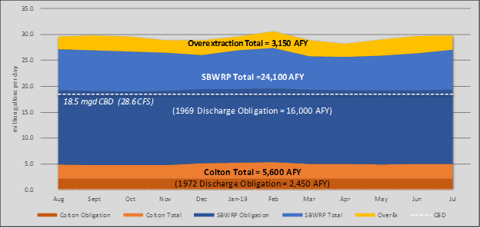

Impacts to the Facilities Master Plan
The flow of secondary effluent from the SBWRP to the RIX facility is expected to be lower in the year 2040 due to loss of wastewater flows from the East Valley Water District (EVWD) (see Section 6.1.2). Future growth will likely make up some of the lost flow; however, even with assumed future growth, 2040 flows are projected to be lower than current flows (see Section 6.1.3).
Projected 2040 discharge from the RIX facility is summarized in Table 5-2 and Figure 5-5 assuming the contribution from SBWRP is reduced to approximately 19 mgd (21,300 AFY) due to the EVWD SNRC Project. Flow from Colton was not analyzed and therefore is shown at the current rate of 5 mgd (5,600 AFY) with no adjustment for future growth. The over-extracted groundwater is assumed to remain at approximately 10% of the RIX influent. Based on these assumptions, the RIX facility is projected to discharge a maximum of approximately 26.4 mgd (29,600 AFY) to the Santa Ana River in the year 2040.

Table 5-2: Projected RIX Flows to the Santa Ana River 2040
Units | Influent from  Colton | Influent from  SBWRP | Over-Extracted Groundwater | Discharge to Santa Ana River
AFY | 5,600 | 21,300 | 2,700 | 29,600
mgd | 5.0 | 19.0 | 2.4 | 26.4
SBMWD intends to meet all discharge obligations at the RIX facility and plans to utilize remaining water for beneficial use in the Bunker Hill Groundwater Basin, which is SBMWD’s sole source of water supply. In the future, if the City of Colton decides to implement a recycled water project that results in a reduction of its discharge, the impact to the Santa Ana River will have to be considered.

Figure 5-5: RIX Flows to the Santa Ana River: 2040 with Projected Flows from SBWRP and Colton
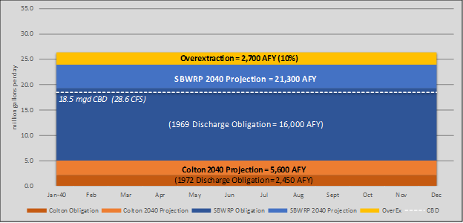

Flood Hazard
The SBWRP site is adjacent to East Twin Creek, which is a south flowing tributary to the Santa Ana River. Twin Creek is channelized by earthen levees along the eastern boundary of the SBWRP, which protects much of the site from flooding. The potential for flooding on the SBWRP site is generally higher on the southern portion of the site where Twin Creek turns southwest before merging with the Santa Ana River. In this area, offsite stormwater can flow from the adjacent former golf course under a fence located at the southern end of the plant. Stormwater either percolates into the permeable soil onsite or flows into the chlorine contact lagoon (San Bernardino Municipal Water Department, 2018).
The northern portion of the site along Orange Show Road is not mapped within a flood hazard area (Exhibit 3, attached). The remainder of the site south of Chandler Place/East Dumas Street is mapped within areas of flood hazard. Most of the site is within Zone X with a 0.2% annual chance of flood hazard, which would constitute the 500-year event. In the southeast portion near the chlorination lagoon where the creek bends to the southwest is an area mapped within Zone A with a 1% annual chance of flood hazard (100-year event). Impacts to the chlorination lagoon from flooding are minimal because the lagoon is not currently in use and is not anticipated to be used in the future. Permanently abandoning the chlorination lagoon could be considered.
Per the Waste Discharge Requirements, the SBWRP shall be designed, constructed, operated and maintained to prevent inundation or washout due to a 100-year storm event (California Regional Water Quality Control Board, Santa Ana Region, 2017).
Per the City of San Bernardino Municipal Code, a Flood Control Development Permit shall be obtained before construction begins within any area of special flood hazards. To be granted a permit, the application would be required to show that the site is reasonably safe from flooding and that the proposed improvements do not adversely affect the carrying capacity of areas where base flood elevations have been determined but the floodway has not been designated. “Adversely affects" means that the cumulative effect of the proposed development, when combined with all other existing and anticipated development, will not increase the water surface elevation of the base flood more than one (1) foot at any point (City of San Bernardino, 2019).

Stormwater Management
There are 16 cities as permittees under the San Bernardino County Municipal Separate Storm Sewer System (MS4) NPDES permit. The MS4 stormwater discharge permit is issued by the State of California through the Santa Ana Regional Water Quality Control Board. The San Bernardino County Flood Control District has been designated “Principal Permittee” and administers and coordinates many of the permit requirements on behalf of the other permittees (San Bernardino County Stormwater Program, 2019). As a permittee, the City of San Bernardino is required to comply with permit requirements for stormwater discharges.
In accordance with the Waste Discharge Requirements, a Stormwater Pollution Prevention Program (SWPPP) is maintained for the SBWRP. All significant spills and leaks that have occurred in the past five years were confined to the facility boundaries. No spills or leaks were discharged offsite or into the stormwater conveyance system (San Bernardino Municipal Water Department, 2018). Process areas are contained and drain to the headworks, and the facilities have performed as designed.
The Site Drainage Plan divides the SBWRP site into five zones, as illustrated on Figure 5-6 and described in the following sections.

Figure 5-6: Site Drainage Areas
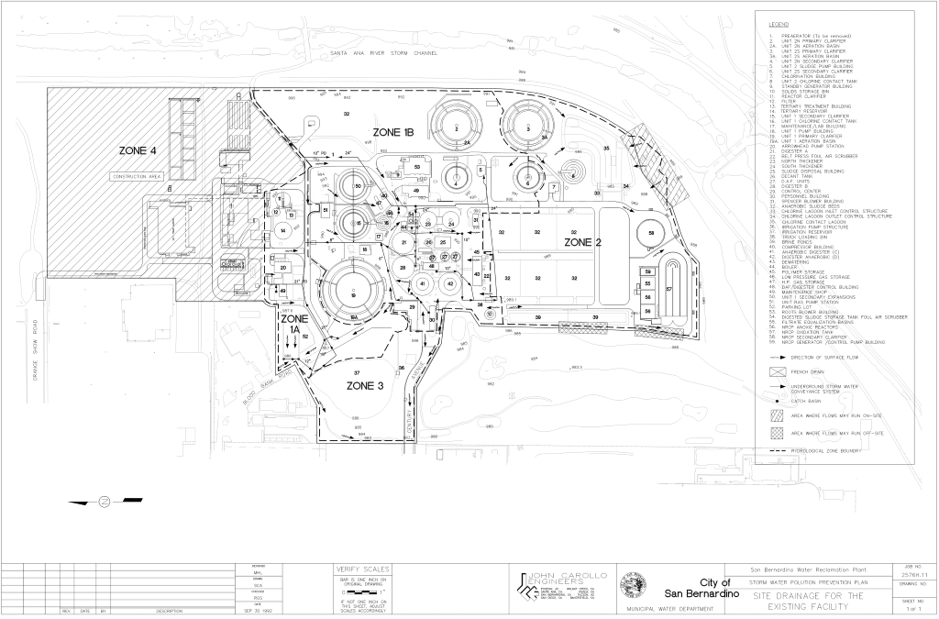

Zones 1A and 1B
Zones 1A and 1B include primary and secondary clarification, aeration, anaerobic digestion, and sludge treatment. The SBWRP boundary for Zone 1A extends to the front of the Administration Building. The boundary for Zone 1B is adjacent to East Twin Creek, a tributary to the Santa Ana River. All stormwater and non-stormwater discharges in Zones 1A and 1B are conveyed to the facility headworks for treatment.

Zone 2
Zone 2 is at the southern end of the SBWRP and includes the Unit 2 South Primary Clarifier, sludge drying beds, biosolids storage bed, heavy equipment storage, chlorine contact area, and nitrogen-removal carousel equalization and oxidation processes (NRCP).The facility boundary for Zone 2 runs adjacent to East Twin Creek and the property that is former San Bernardino Golf Club. Stormwater which enters the process areas in Zone 2 is mixed and treated with the process water in each area. An earthen berm which extends between the eastern border of the property and the primary clarifiers prevents discharge from the property. Stormwater runoff from non-process areas typically percolates onsite, although during extreme events, a small portion may drain to the chlorine contact lagoon. The first flush will typically percolate onsite, while larger storms may run off-site to the adjacent former golf course and percolate.

Zone 3
This zone is located at the western end of the SBWRP. The gravel covered area serves as parking space for heavy equipment and vehicles. There are no industrial processes located in this area. Stormwater runoff from this area drains to street gutters that flow to the off-site Municipal Separate Storm Sewer System (MS4). Stormwater samples are taken at the facility boundary (Discharge Point S-001) prior to the stormwater discharging off-site into the MS4 drain located on Century Avenue.

Zone 4
This zone is located at the northeast area of the SBWRP and includes the odor control facilities, bar screen, and grit removal processes; Administration Building and parking lot; and an undeveloped vegetated area. The drainage system of Zone 4 consists of two separate drainage systems. The first system conveys process equipment drainage areas to a series of catch basins which transfer the stormwater to the plant headworks for treatment.
The second system conveys non-process drainage areas including streets, building roofs, vegetated areas, and parking lots to a collection structure. Discharge from the collection structure is typically pumped to the plant headworks for treatment. Discharge to the Santa Ana River storm channel via East Twin Creek will occur only during extreme wet weather events which generate excess stormwater runoff. The stormwater in the collection structure (Discharge Point S-002) is sampled before being released to East Twin Creek.

Offsite Stormwater Flows
In addition to stormwater drainage from the facility area, some stormwater generated off-site occasionally flows onto the facility from the adjacent former golf course to the southwest. At this location, stormwater flows under a fence at the southern end of the plant and either percolates into the soil or flows into the chlorine contact lagoon.

Groundwater
Three SBWRP wells were originally installed in the 1990s as dewatering wells to lower the high groundwater level and protect structures at the SBWRP from liquefaction. There are three SBWRP wells located onsite:
- Orange Show Well
- Chandler Well
- Century Well
In addition, a well owned by the Valley District is located at the south end of the SBWRP that is not currently used due to lack of water.
The Orange Show Well originally fed a pipeline to the City of Riverside. After the groundwater table declined, groundwater from these wells was used for non-potable purposes. Prior to the closure of the adjacent golf course to the southwest, the groundwater was used for golf course irrigation. Currently the groundwater is used for in-plant use and Caltrans irrigation. The Orange Show and Chandler wells pump to the groundwater storage tank. The Century Well pumps straight into the plant system (not into the storage tank).
Groundwater was observed as shallow as 21 feet below ground surface (bgs) in 1999 and as deep as 121.5 feet bgs in 2017. Observed groundwater levels for each of the wells recorded during their completion in the 1990s and during recent observations in 2017 are documented in Table 5-3.

Table 5-3: Observed Groundwater Levels
 | Well Completion Report Data |  | Recent Soundings
Well | 09/07/1993 | 03/05/1999 | 04/18/2017
Orange Show | -- | 21’ bgs | 121.5’ bgs
Chandler | 50’ bgs | -- | 116.0’ bgs
Century | 52’ bgs | -- | 116.7’ bgs
Source: San Bernardino Municipal Water Department
The Department of Water Resources Water Data Library maintains data from the 1930s through 2010 from multiple wells on and near the SBWRP site. For the 80 years measured, the data show an overall declining trend in groundwater levels with the steepest declines occurring in the 1960s. Data for three wells on the SBWRP site for the 6-year period from the beginning of 2005 to the end of 2010 show the groundwater level continuing to decline. Figure 5-7 shows the groundwater level data from one onsite well declining from a depth of approximately 50 feet in 2005 to 100 feet in 2010.
Groundwater depths are approximately 50 to 100 feet below ground surface at the site. Thus, dewatering during construction of subsurface facilities is not anticipated; however, groundwater levels vary and should be re-evaluated prior to design and construction. Groundwater levels could recover in the future. Groundwater pumping for the onsite will be reduced after the Clean Water Factory is online and the groundwater storage tank is converted to recycled water storage. There was historically a risk of liquefaction as a result of high groundwater. If the groundwater table rises to similar historic levels, re-evaluation of liquefaction potential would also be needed.

Figure 5-7: Water Data Library Wells at SBWRP
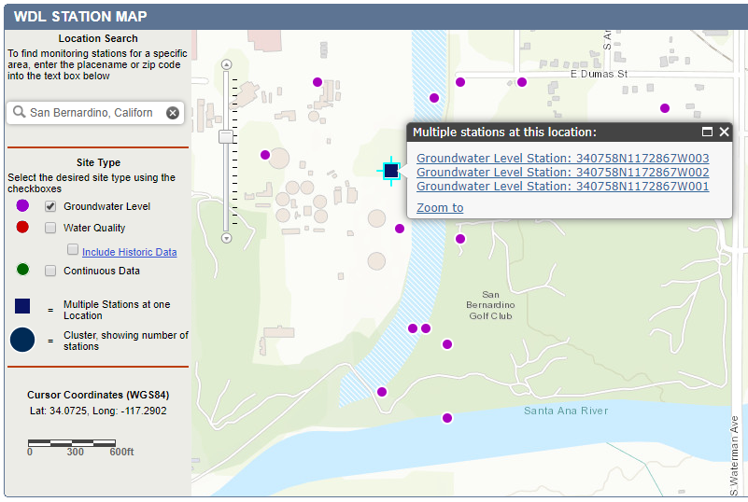

Figure 5-8: Water Data Library Wells at SBWRP
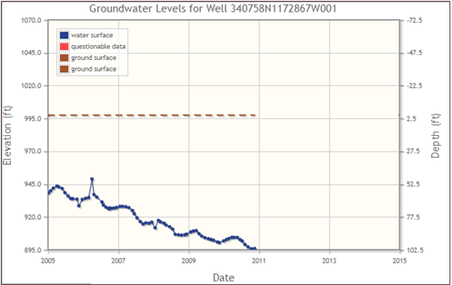
Source: http://wdl.water.ca.gov/waterdatalibrary/

Seismicity
The SBWRP is in an active seismic area and located about a mile northeast of the mapped San Jacinto fault and in an area with high potential for ground failure due to liquefaction (United States Geological Survey, 1991). The following seismic design factors were obtained from www.seismicmaps.org.
- Mapped Spectral Response Acceleration for Short Period (Ss) = 2.518
- Mapped Spectral Response Acceleration for 1-second Period (S1) = 1.154
- Design Spectral Response Acceleration for Short Period (SDS) = 1.678
- Design Spectral Response Acceleration for 1-second Period (SD1) = 1.154
- Risk Category: III
- Site: Class D (to be verified by geotechnical engineer)
- Seismic Design: Category D
- Seismic Importance Factor (IP) = 1.5
Seismic design factors shall be verified by the geotechnical engineer and considered during pre-design/design of any recommended projects. New structural facilities will be required to be designed in accordance with the California Building Code to withstand the appropriate seismic load and liquefaction potential, as applicable.

Wastewater Characteristics

Flows and Loads Analysis
This Section analyzes historic and current flows and biological loading to the SBWRP and presents the methodology used to estimate the future flows and loads within the planning period. Flows and loads are projected to the year 2040; however, the accuracy of the future estimates declines the farther the projection into the future.

SBMWD, EVWD, and Loma Linda Service Areas Population Projections
The SBWRP currently treats wastewater from the City of San Bernardino, City of Loma Linda, the service area of the EVWD and some areas of unincorporated San Bernardino County. Flow to SBWRP comes from three collection system service areas: SBMWD, City of Loma Linda and EVWD. Due to the imminent cessation of EVWD wastewater flow to SBWRP, the three services areas were analyzed separately in order to accurately assess the remaining flow that the plant would receive in the medium term and at buildout.
Multiple sources were collected on the three service areas regarding population growth projections, including the City of San Bernardino Environmental Impact Report, Loma Linda General Plan, Southern California Association of Governments (SCAG) 2016 Growth Forecast, and the 2015 San Bernardino Valley Municipal Water District Urban Water Management Plan (UWMP). The SCAG growth population model projects growth within the confines of city limits, while the UWMP utilizes the Department of Drinking Water (DWR) population tool to estimate current population and project growth within the service area boundaries. Due to the consistency with SBMWD, City of Loma Linda, and EVWD service area boundaries, and consistency with the Draft SBMWD Sewer Master Plan, the UWMP population projections were selected as the basis for this Master Plan. The growth percentages are presented in Table 6-1.

Table 6-1: Projected Population Growth for SBMWD, Loma Linda and EVWD
 | SBMWD | Loma Linda | EVWD
Current - 2020 | 0.7% | 1.3% | 3.8%
2020 - 2025 | 0.7% | 1.3% | 1.0%
2025 - 2030 | 0.7% | 1.3% | 0.8%
2030 - 2035 | 0.7% | 1.3% | 0.8%
2035 - 2040 | 0.7% | 1.3% | 0.8%
The population growth percentages were applied to current population estimates per the response letter dated February 21, 2018 from SBMWD to the Local Agency Formation Commission (LAFCO) for San Bernardino County. Current population estimates by service area are shown in Table 6-2, with projected population through 2040 in 5-year increments. Figure 6-1 depicts the projected populations for the same time period using both the San Bernardino Valley Municipal Water District UWMP figures and SCAG 2016 figures.

Figure 6-1: SBWRP Population Projections
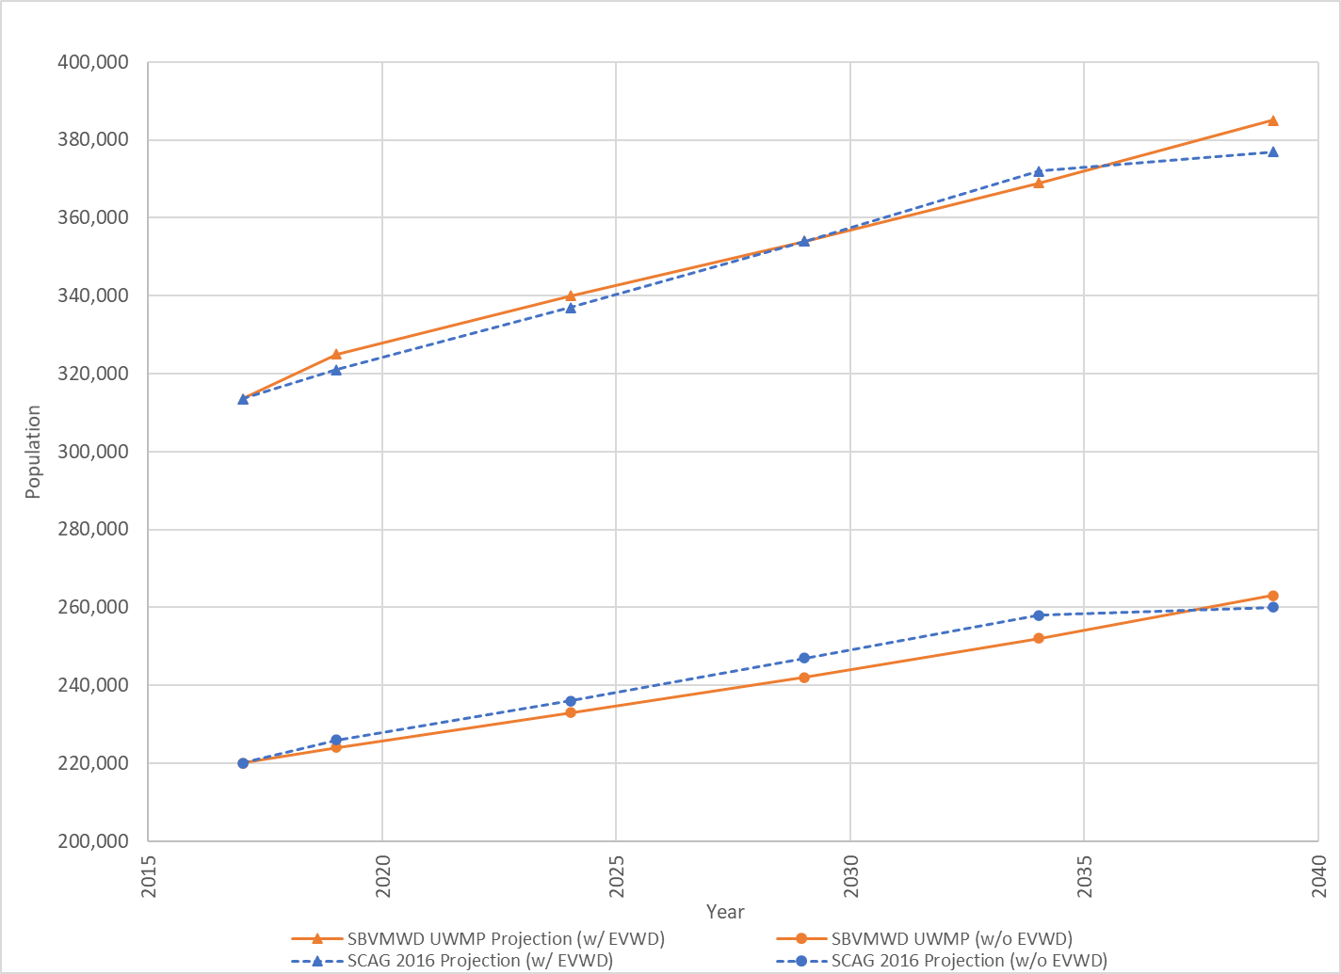

Table 6-2: Current and Projected Population of SBWRP Service Area
 | SBMWD | Loma Linda | EVWD | Total not Including EVWD | Total Including EVWD
Current | 195,000 | 25,000 | 93,500 | 220,000 | 313,500
2020 | 198,000 | 26,000 | 101,000 | 224,000 | 325,000
2025 | 205,000 | 28,000 | 107,000 | 233,000 | 340,000
2030 | 212,000 | 30,000 | 112,000 | 242,000 | 354,000
2035 | 220,000 | 32,000 | 117,000 | 252,000 | 369,000
2040 | 228,000 | 35,000 | 122,000 | 263,000 | 385,000
The population projections were used to project influent flow to the SBWRP as described in the next Section.

SBWRP Current and Projected Flows
There are three lift stations that pump influent to the SBWRP Headworks including the E Street Lift Station, which conveys flow from Loma Linda and SBMWD, Arrowhead Lift Station, which conveys flow from SBMWD, and East Influent Lift Station, which conveys from EVWD and SBMWD. Flow data was provided by SBMWD staff for SBWRP influent and effluent flow in 30-minute increments. The total influent flow data was the summation of the three lift station flow meters, E Street, Arrowhead and East. Additionally, a fourth gravity sewer from the historic Valley Truck Farm area is not metered but is relatively low flow and is counted as part of the SBWRP drain flow. There are no other flow meters within the plant that measure total plant flow prior to splitting of primary influent downstream of the headworks.
Analysis of influent flow data revealed that data associated with the East Influent Lift Station flow meter was erroneous for significant portions of the period analyzed. SBMWD staff acknowledged the past issues with East Influent Lift Station meter data and confirmed that the meter was subsequently replaced in summer of 2019. SBWRP effluent data was therefore analyzed in lieu of influent flow for projections. Effluent data is assumed to be an accurate alternative to influent data since SBWRP has not utilized flow equalization. Figure 6-2 shows representative influent flow from 2011 to 2019, utilizing plant effluent flow starting in January 2017 due to erroneous influent data from 2017 to 2019.

Figure 6-2: SBWRP Historic Flow
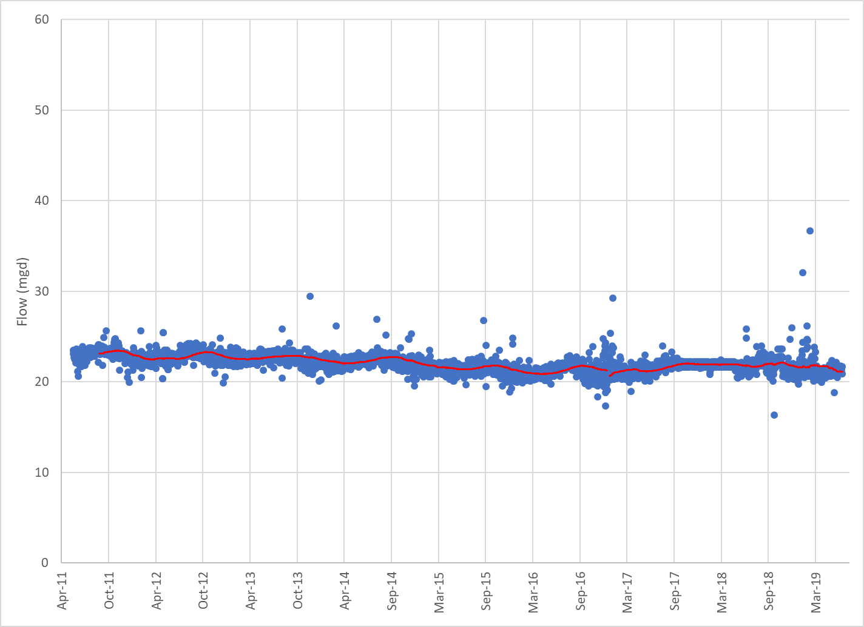
Notes:
- Flow data shown from 6/1/2014 to 12/31/2016 is average daily influent. Flow data from 1/1/2017 to 7/1/2019 is average daily effluent data.
In order to separate influent flow provided by the three service areas, Loma Linda and EVWD flows were subtracted from the total SBWRP flow. EVWD was estimated as 6.0 mgd based on the sum of the ADWF from the 6th Street and 3rd Street flow meters in the Draft EVWD Sewer Master Plan. Loma Linda influent flow was available in the form of 30-minute flow data from the North and South meters, which feed directly to the SBWRP.
The SBWRP plant effluent data was analyzed to determine plant peaking factors in relation to ADWF, the results are presented in Table 6-3.

Table 6-3: SBWRP Historic Influent Flow Peaking Factors and Flow
Scenario | Peaking Factor (xADWF) | Historic Flows (mgd)
Average Dry Weather | 1.00 | 21.5
Maximum Month | 1.07 | 22.9
Maximum Week | 1.12 | 24.1
Peak Day Dry Weather | 1.25 | 26.8
Peak Hour Dry Weather | 1.89 | 40.3
Peak Hour Wet Weather | 2.97 | 63.8
Notes:
- Historic peaking factors were calculated based on flow data from January 1, 2015 to July 1, 2019.
Using the populations projections derived in Section 6.1.1, gallon per capita-day (gpcd) usage was calculated by dividing each service area flow by the corresponding population total. The gpcd usage for each service area was assumed to remain constant and was multiplied by the projected population through 2040 in 5-year increments. Although conservation efforts in recent years have generally caused wastewater flows to decrease in Southern California, there was not a notable decrease for the SBWRP service area. Table 6-4 presents the results of the total current flow, and gpcd usage by service area. Table 6-5 presents the results of the flow projection exercise.

Table 6-4: Current Influent Flow and Per Capita Usage
 | SBMWD | Loma Linda | EVWD | Total WRP Including EVWD | Total WRP not Including EVWD
Current ADWF (mgd) | 13.4 | 2.1 | 6.0 | 21.5 | 15.5
Current ADWF (gpcd) | 69 | 85 | 64 | 69 | 71

Table 6-5: Current and Projected Average Dry Weather Flow (mgd)
 | SBMWD | Loma Linda | EVWD | Total SBWRP Including EVWD | Total SBWRP not Including EVWD
Current | 13.4 | 2.1 | 6.0 | 21.5 | 15.5
2020 | 13.6 | 2.1 | 6.5 | 22.2 | 15.8
2025 | 14.1 | 2.3 | 6.9 | 23.3 | 16.4
2030 | 14.6 | 2.5 | 7.2 | 24.2 | 17.1
2035 | 15.1 | 2.6 | 7.5 | 25.3 | 17.8
2040 | 15.7 | 2.9 | 7.8 | 26.4 | 18.6
Notes:
- Current ADWF flows estimated from available data from January 1, 2015 to July 1, 2019.
With EVWD flows remaining within the service area of SBWRP, flow would be expected to rise to 26.4 mgd by 2040; however, when factoring out EVWD’s contribution to influent flow, the 2040 projected influent flow is expected to be 18.6 mgd. To factor in a buffer for potential growth exceeding projections (about a 2% buffer), this Master Plan will assume a projected influent flow of 19 mgd by 2040.

SBWRP Current and Projected Loads
SBWRP loads were calculated using daily concentration measurements and flow data collected by SBMWD. Concentrations of biological oxygen demand (BOD), total suspended solids (TSS), ammonia, nitrate and nitrite are measured using 24-hour composite samples collected downstream of the three influent flow meters and upstream of the headworks facility.
Figure 6-3 and Figure 6-4 portray the influent concentrations of BOD and TSS to SBWRP. Prior to 2015, the SBMWD service area produced higher BOD and TSS concentrations with a wider range of scatter. This can be attributed to illegal discharges, which were eliminated in 2014. The analysis of BOD and TSS for projection purposes utilized data starting January 1, 2015 (in order to avoid using data that would influence higher loads than currently experienced at the SBWRP) and ending December 31, 2018 to provide three full years of data.

Figure 6-3: SBWRP Influent BOD Concentration
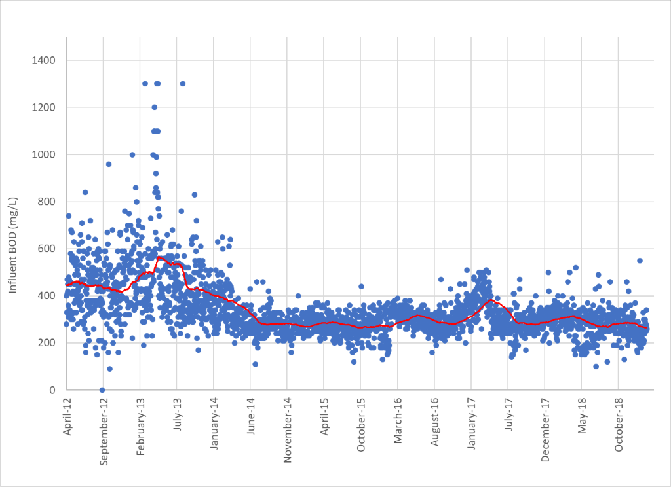
Following the reduction of high concentration discharges, the level of BOD concentrations has remained relatively flat. The peak in BOD concentration observed in the Spring of 2017 was not observed in TSS or ammonia during the same time, as can be observed in Figure 6-4 and Figure 6-5. Therefore, the peak was not factored into peaking and projection calculations.

Figure 6-4: SBWRP Influent TSS Concentration
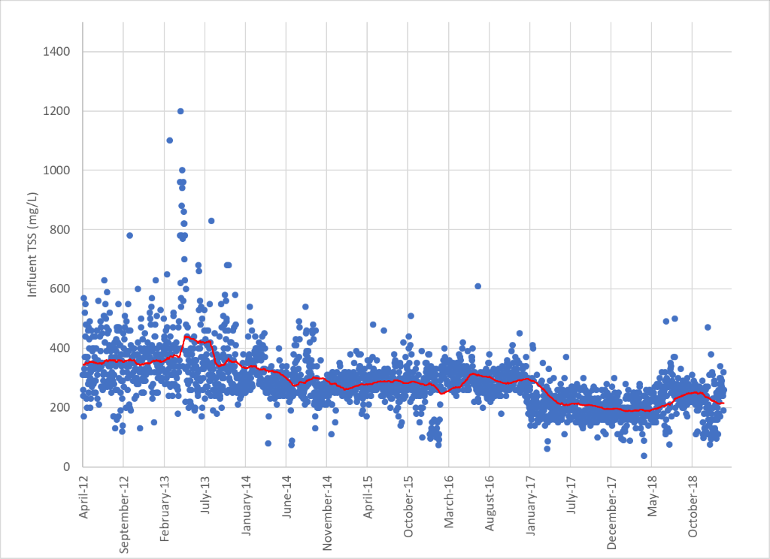
Daily composite samples for ammonia are collected at the SBWRP. Other nitrogen species such as nitrate, nitrite, and Total Kjeldahl Nitrogen (TKN) are collected on a weekly basis. TKN is ammonia plus organic nitrogen, most of which is converted to ammonia within the treatment process. Thus, this Master Plan uses ammonia to evaluate nitrogen removal throughout the plant. The average ammonia-to-TKN ratio observed in the plant is 0.63, which is within the typical range of 0.6 to 0.8.

Figure 6-5: SBWRP Influent Ammonia Concentration
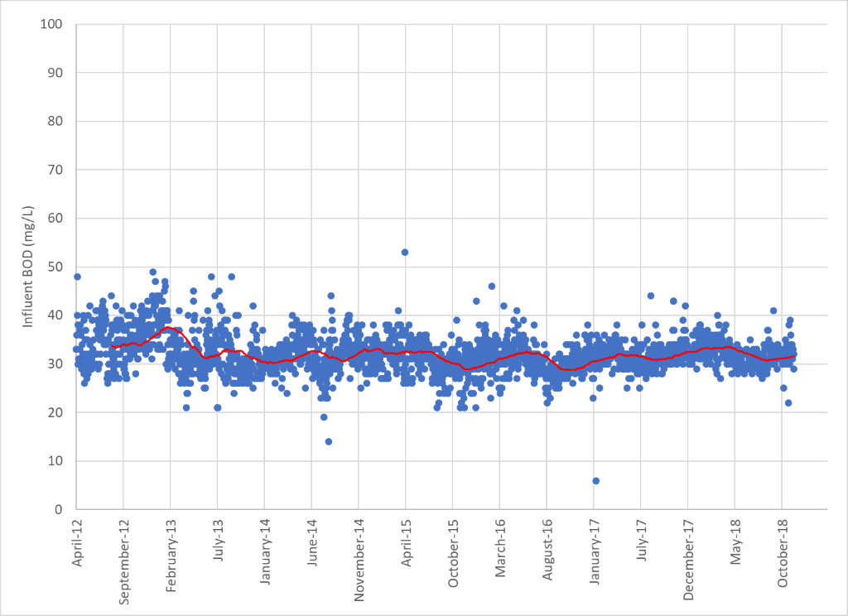
A summary on influent concentrations for BOD, TSS and ammonia is provided in Table 6-6. Due to the relatively stable levels of concentrations from 2015 to the present, these values were utilized for future loading projections.

Table 6-6: SBWRP Influent Wastewater Concentrations
Criteria | BOD  (mg/L) | TSS  (mg/L) | Ammonia  (mg/L)
Average | 293 | 248 | 31
Max Month | 429 | 429 | 34
Max Week | 466 | 325 | 38
Max Day | 550 | 363 | 53
Notes:
- Influent concentration data spans 1/1/2015 to 12/31/2018.

Table 6-7: SBWRP Current Influent Loading and Peaking Factors
Criteria | BOD Load  (lb./day) | BOD Peaking Factor  (xADWF) | TSS Load  (lb./day) | TSS Peaking Factor  (xADWF) | Ammonia Load  (lb./day) | Ammonia Peaking Factor  (xADWF)
Average | 52,700 | 1.00 | 44,100 | 1.00 | 5,700 | 1.00
Max Month | 59,900 | 1.14 | 57,100 | 1.29 | 6,900 | 1.21
Max Week | 82,300 | 1.56 | 65,200 | 1.48 | 6,300 | 1.11
Max Day | 98,200 | 1.86 | 104,100 | 2.36 | 9,100 | 1.60
Notes:
- Data utilized for loading and peaking factors spans 1/1/2015 to 12/31/2018.
BOD, TSS and Ammonia average dry weather loading were compared with maximum month, week and day values to produce their corresponding peaking factors, which are presented in Table 6-7. These peaking factors will be utilized for future capacity determinations.

Table 6-8: SBWRP Projected Influent Loading
Criteria | Service Areas Included | BOD Load  (lb./day) | TSS Load  (lb./day) | Ammonia Load  (lb./day)
Current | SBMWD, Loma Linda, EVWD | 52,700 | 44,300 | 5,700
2020 | SBMWD, Loma Linda, EVWD | 52,400 | 44,400 | 5,600
2025 | SBMWD, Loma Linda | 38,300 | 32,500 | 4,100
2030 | SBMWD, Loma Linda | 39,700 | 33,700 | 4,300
2035 | SBMWD, Loma Linda | 41,200 | 34,900 | 4,400
2040 | SBMWD, Loma Linda | 42,800 | 36,200 | 4,600
Final projected loading values are provided in Table 6-8, which assumes EVWD wastewater flow will cease in between years 2020 and 2025.

Summary of Projected Flows and Loads
The resulting flow and load projections under average and peak scenarios are provided in Table 6-9 and Table 6-10 for the years 2025 and 2040, respectively. The year 2022 was selected to represent the cessation of EVWD flows and the year 2040 was selected as the planning horizon.

Table 6-9: 2025 Projected SBWRP Flows and Loads
 | Flow  (mgd) | BOD  (lb./day) | TSS  (lb./day) | TKN  (lb./day)
Annual Average | 16.4 | 38,500 | 32,600 | 6,500
Max Month | 17.5 | 43,800 | 42,200 | 8,500
Max Week | 18.4 | 60,100 | 48,200 | 9,700
Max Day | 20.5 | 71,700 | 77,000 | 15,400
Peak Hour | 31.1 | NA | NA | NA
Notes:
1. TKN is derived from the historical ammonia to TKN ratio (0.63) of influent to the SBWRP.

Table 6-10: 2040 Projected SBWRP Flows and Loads
 | Flow  (mgd) | BOD  (lb./day) | TSS  (lb./day) | TKN  (lb./day)
Annual Average | 18.6 | 43,400 | 36,800 | 7,500
Max Month | 19.8 | 49,300 | 47,600 | 9,700
Max Week | 20.8 | 67,800 | 54,400 | 11,100
Max Day | 23.2 | 80,900 | 86,900 | 17,700
Peak Hour | 35.2 | NA | NA | NA
Notes:
- TKN is derived from the historical ammonia to TKN ratio (0.63) of influent to the SBWRP.
Following the departure of EVWD influent flows, SBWRP is not expected to reach current flow and loading levels through 2040. Table 6-9 and Table 6-10 present the flow and load values that will be utilized for capacity evaluation and project feasibility in the latter portions of this Master Plan.

Existing and Future Regulatory Considerations
This Section summarizes existing regulations for effluent discharge, biosolids, air quality, and safety that apply to the SBWRP. It also examines regulations that may potentially apply to the SBWRP or indirectly affect its operation in the future. The anticipated regulatory changes relate to air emissions, biosolids disposal, habitat conservation in the Santa Ana River, and potential changes in discharge requirements for total dissolved solids (TDS) and total inorganic nitrogen (TIN).

Discharge Requirements
Discharge from the SBWRP is regulated by several agencies including the Regional Water Quality Control Board (RWQCB), the Upper Santa Ana Habitat Conservation Plan (HCP), the Santa Ana Watershed Project Authority (SAWPA) and the Orange County Sanitation District (OCSD). The RWQCB regulates wastewater discharge from the SBWRP and RIX facility, as described in the following sections.

Rapid Infiltration/Extraction (RIX) Facility
Secondary effluent from the SBWRP is conveyed to the Rapid Infiltration Extraction (RIX) facility located at 1990 Agua Mansa Road in Colton. RIX is jointly owned by the City of San Bernardino (80%) and the City of Colton (20%) and is operated by the SBMWD. The treatment train includes infiltration of secondary treated wastewater into a series of ponds under conditions of wet and dry cycles. Infiltrated wastewater plus native groundwater are extracted, disinfected with UV, and discharged to Reach 4 of the Santa Ana River. Groundwater over-extraction is required to lower groundwater levels in the vicinity of the ponds to maintain percolation rates.
The RIX facility is permitted to treat an influent flow rate of up to 40 mgd and discharge at its UV disinfection’s design capacity of 64 mgd. Effluent discharge volume is higher than influent volume because the effluent discharge includes over-extracted groundwater. During 2016, average monthly discharges from the RIX facility to the Santa Ana River ranged from 28 to 30 mgd (California Regional Water Quality Control Board, Santa Ana Region, 2016).
Due to a decline in percolation rates, the hydraulic capacity of the basins decreased, and tertiary filtration equipment was added to cover the gap in capacity. Dyna-Sand filters were first added and then eventually the Aqua-Disc Filters. When used, the tertiary filters are used in parallel with the basins, not in series. As discussed in Section 5.2.1, RIX influent flow now averages 26.5 mgd, and the basins have enough capacity to treat this flow without using the add-on filter systems. The tertiary filtration equipment is now used only during very high flow periods to maintain the 3-basin rotation (wet / dry cycles) to minimize algae growth.
Discharge to the Santa Ana River from RIX is regulated under Order No. R8-2013-0032, NPDES No. CA8000304 which expired on July 31, 2018 and has been administratively extended since the receipt of the application prior to expiration. There are two sets of discharge requirements when dilution from the river is:
  - Below 20:1, or
  - 20:1 or more.
The discharge requirements are more stringent when dilution from the river is below 20:1 as shown in Table 7-1. For the purposes of this Facilities Master Plan, the target secondary effluent limits will be based on the discharge requirements for the lower dilution requirement (Table 7-1). Table 7-2 summarizes discharge limits when dilution is 20:1 or more.
While the RIX permit allows for discharge at less than 20:1, there is no infrastructure in place to do this at the RIX.

Table 7-1: Summary of RIX Discharge Requirements Below 20:1 Dilution
Parameter | Units | Average Monthly | Average Weekly
BOD₅ | mg/L | 20 | 30
TSS | mg/L | 20 | 30
Ammonia - Nitrogen | mg/L | 4.5 | --
TDS | mg/L | 550 (12-month flow-weighted running average)
TIN | mg/L | 10 (12-month flow-weighted running average)
Turbidity | NTU | 2 (within any 24-hour period)  5 (more than 5% in any 24-hour period)  10 (at any time)
Coliform | MPN | -- | 2.2 per 100 ml
pH | - | 6.5 - 8.5

Table 7-2: Summary of RIX Discharge Requirements at 20:1 Dilution or More
Parameter | Units | Average Monthly | Average Weekly
BOD₅ | mg/L | 30 | 45
TSS | mg/L | 30 | 45
Coliform | MPN | -- | 23 per 100 ml
pH | - | 6.5 - 8.5

SBWRP Direct Discharge to the Santa Ana River
During hydrological periods when 20:1 dilution can be achieved, the SBWRP may discharge directly to the Santa Ana River at its confluence with Twin Creek adjacent to the site of the SBWRP without going to the RIX. This discharge is regulated under Order No. R8-2017-0049, NPDES No. CA0105392 which went into effect on January 1, 2018 and will expire on December 31, 2022. This method of discharge was used in the past during heavy rainfall, but the revised discharge permit is too restrictive for compliance testing and this method of discharge is no longer used. Although not used, the infrastructure still exists at the SBWRP to accommodate discharge directly to the SAR. Discharge limits are summarized in Table 7-3. For permit renewal, the SBMWD is required to file a Report of Waste Discharge and application for renewal of its Waste Discharge Requirements and NPDES permit no later than July 5, 2022. Future renewals will likely include a requirement for a Climate Change Action Plan.

Table 7-3: Summary of SBWRP Discharge Requirements with 20:1 Dilution
Parameter | Units | Average Monthly | Average Weekly | Daily Max
BOD₅ | mg/L | 30 | 45 | --
TSS | mg/L | 30 | 45
Aldrin | µg/L | 0.00014 |  | 0.00028
pH | - | 6.5 - 8.5
Facility Design Flow | mgd | 33

Capacity Trigger in NPDES Permit
Per the SBWRP NPDES Permit No. CA0105392 Order No. R8-2017-0049, certain actions are triggered if the average dry weather discharge for any month equals or exceeds 75% of the treatment design or discharge capacity of the SBWRP (75% of 33 mgd = 24.75 mgd). If the treatment or discharge capacity trigger is exceeded, the SBMWD would have to adequately inform the RWQCB of the plant’s capacity status by submitting a report containing the following information:
- Average daily flow for the month, the date on which the instantaneous peak flow occurred, the rate of that peak flow, and the total flow for the day.
- Best estimate of when the average daily dry-weather flow rate will equal or exceed the design capacity of the treatment facilities.
- An intended schedule for studies, design, and other steps needed to provide additional capacity for the waste treatment and/or disposal facilities before the waste flow rate equals the capacity of present units.
Under the current permit, the projected flow of 19 mgd in the year 2040 would not exceed the capacity reporting trigger; however, this capacity trigger should be considered if de-rating SBWRP’s treatment capacity is contemplated due to the future decrease in flow.

Potential Future Changes to Discharge Requirements
The Santa Ana Watershed Project Authority (SAWPA) is a Joint Powers Authority (JPA) of five member agencies: Eastern Municipal Water District, Inland Empire Utilities Agency, Orange County Water District, San Bernardino Valley Municipal Water District, and Western Municipal Water District. The Santa Ana River is a significant source of recharge to groundwater management zones underlying the River and to the Orange County groundwater basin downstream. The quality of the River influences the region’s groundwater, which is used by more than 5 million people.
SAWPA serves as an administrator for several task forces within the watershed. In 1995, a task force comprising approximately 20 water, wastewater, and groundwater agencies was formed to evaluate the impact of total inorganic nitrogen (TIN) and total dissolved solids (TDS) on water resources in the Santa Ana River Watershed.
Wasteload allocations for regulating discharges of TDS and TIN to the Santa Ana River are implemented primarily through TDS and nitrogen limits in waste discharge requirements issued to municipal wastewater treatment facilities that directly or indirectly discharge to the River. SAWPA’s task force is using the Wasteload Allocation Model (WLAM) to simulate the future groundwater quality to determine whether any changes are necessary in TDS and TIN regulation (Wildermuth Environmental, Inc., 2015). The TIN/TDS task force work was divided into a series of phases and work on the TIN/TDS Task Force Study is nearing completion (Santa Ana Watershed Project Authority, n.d.).
Preliminary WLAM results indicate the potential for degradation/exceedance of water quality objectives for TDS and TIN in the groundwater management zone where RIX is located. Future regulations may come out of the WLAM that could impact the RIX discharge to the Santa Ana River.

Inland Empire Brine Line Collection Station
The SBMWD has an agreement with Valley District, who in turn has an agreement with the Santa Ana Watershed Project Authority (SAWPA) for 2.5 mgd capacity in the Inland Empire Brine Line (IEBL) formerly known as the Santa Ana Regional Interceptor (SARI). SAWPA was created to help resolve interagency conflicts and address regional water issues in the Santa Ana River Watershed. The IEBL was developed by SAWPA for the purpose of transporting high strength brine wastewater from the Inland Empire to the Orange County Sanitation District (OCSD) for treatment and disposal to the Pacific Ocean. The SBWRP has an authorized collection station onsite for the direct discharge of hauled brine waste to the IEBL (Figure 7-1). Permits are issued by the Department to indirect dischargers to dispose at the Brine Receiving Station.

Figure 7-1: Inland Empire Brine Line Collection Stations
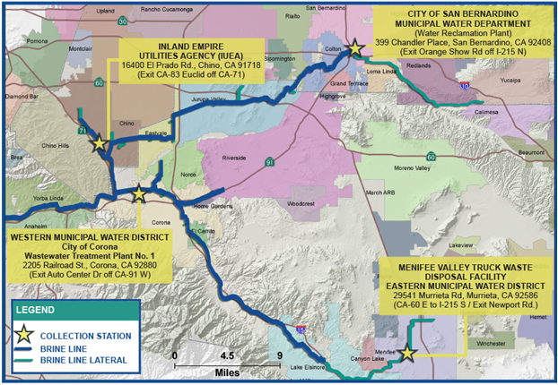
Source: https://sawpa.org/inland-empire-brine-line/
Use of the SBWRP Inland Empire Brine Line collection station is regulated by Ordinance No. 73-SARI, which includes general prohibitions and limitations on discharges, wastewater discharge permits, and monitoring, reporting, inspection, and facilities requirements (San Bernardino Valley Municipal Water District, 2011).

Hydrolysate of Human Remains
Valley District does not currently regulate the discharge of hydrolysate of human remains to the Inland Empire Brine Line collection station; however, it could potentially be a source of future revenue for the SBMWD if hydrolysate businesses develop within the service area.
Effective July 1, 2019, OCSD Ordinance No. OCSD-53 prohibits the discharge of hydrolysate wastes and wastewater resulting from hydrolysis to the Orange County Sanitation District. Per Assembly Bill No. 967 (2017-2018), the SBMWD and the OCSD would both have to authorize the disposal of hydrolysate into the SBMWD’s Inland Empire Brine Line collection station for it to be allowed.
Per Assembly Bill No. 967 (2017-2018) Section 7639.10 (a), a licensed hydrolysis facility may dispose of hydrolysate using a sewer collection system only if all the following conditions are met:
- The city, county, special district, joint powers authority, or other public agency that provides wastewater treatment and disposal services to the licensed hydrolysis facility expressly authorizes the disposal of hydrolysate into the sewer collection system. If issuance of a permit is required by another city, county, special district, joint powers authority, or other public agency that provides sewer collection services where the licensee is located, authorization from both agencies must be obtained.
- If the licensee receives the appropriate permissions required by subparagraph (A), the licensee shall comply with all local ordinances, pretreatment requirements, permitting requirements, waste discharge requirements, and all other applicable federal, state, and local laws, ordinances, and regulations governing the protection of water quality and public health, promotion of water recycling, and discharge into the sewer system.
- The licensee shall demonstrate compliance as deemed appropriate by the public agency or agencies authorizing the disposal of hydrolysate into the sewer collection system. At a minimum this should include annual water quality testing as prescribed by the public agency or agencies authorizing the disposal of hydrolysate into the sewer collection system.
- Authorization for disposal of hydrolysate using a sewer collection system shall be voluntary and at the discretion of each public agency described in subparagraph (A). Each public agency described in subparagraph (A) has the discretion to authorize or to prohibit the discharge of hydrolysate into a sewer collection system for any reason, including for purposes of promoting advanced water recycling systems (California Legislative Information, 2017-2018).

Biosolids Disposal
The regulation of biosolids involves multiple agencies at the federal, state, and local levels. The United States Environmental Protection Agency (US EPA) Region IX regulates biosolids disposal in California by the Part 503 Rule, which sets national minimum requirements for biosolids quality. The following sections describe the federal rules governing biosolids.

US EPA Part 503 Rule
The Part 503 Rule has four groups of requirements to protect the environment and public health:
- Management Practices
- Pollutant Limits
- Pathogen Reduction Requirements
- Vector Attraction Reduction Requirements

Management Practices
Bulk biosolids shall:
- Not be applied to land when it is likely to adversely affect a threatened or endangered species.
- Not be applied to a site that is flooded, frozen, or snow-covered so that the biosolids enters a wetland or other waters of the United States.
- Not be applied to a site that is 10 meters or less from waters of the United States.
- Be applied to a site at an application rate that is equal to or less than the agronomic rate for nutrient uptake.
- Be provided with a label or information sheet with the following information:
- Name and address of the person who prepared the biosolids.
- Statement that application of the biosolids to the land is prohibited except in accordance with the instructions on the label or information sheet.
- Statement of the annual whole sludge application rate for the biosolids that does not cause annual pollutant loading rates to be exceeded.

Pollutant Limits
Table 7-4 summarizes the Part 503 pollutant limits for biosolids applied to land. For biosolids meeting the pollutant concentration limits in Table 7-4, land application is limited to the agronomic rate.

Table 7-4: Part 503 Pollutant Limits for Biosolids Applied to Land
Pollutant | Ceiling Limits  (mg/kg) | Cumulative Pollutant Loading Rate  (kg/hectare) | Pollutant Concentration Limits (mg/kg) | Annual Pollutant Loading Rate  (kg/ha-year)
Arsenic | 75 | 41 | 41 | 2.0
Cadmium | 85 | 39 | 39 | 1.9
Copper | 4,300 | 1,500 | 1,500 | 75
Lead | 840 | 300 | 300 | 15
Mercury | 57 | 17 | 17 | 0.85
Molybdenum | 75 | -- | -- | --
Nickel | 420 | 420 | 420 | 21
Selenium | 100 | 100 | 100 | 5.0
Zinc | 7,500 | 2,800 | 2,800 | 140
Applies to: | Biosolids that are land-applied | Bulk biosolids | Bulk and bagged biosolids regulated under Exceptional Quality (EQ) or Pollutant Concentration (PC) options | Bagged biosolids

Pathogen Reduction Requirements
The 503 Rule defines two classes of biosolids: Class A, in which the pathogens are reduced below detectable levels and are available for use; and Class B, where the presence of reduced levels of pathogens requires site restrictions and management practices to protect against pathogen exposure. Class B site restrictions include limits on public access, crop harvesting, and animal grazing.
To produce Class A or B biosolids, one of the six alternatives for pathogen reduction listed in Table 7-5 must be met in addition to meeting the requirements for fecal coliform or Salmonella bacteria levels.

Table 7-5: Alternatives for Pathogen Reduction
Alternative | Class A Biosolids | Class B Biosolids
1 | Thermally-treated biosolids with a time/temperature-based treatment process | Monitoring of indicator organisms: Fecal coliform geometric mean of 7 sample (min) over 2 week period < 2x 10⁶ MPN/g or CFU /g
2 | High pH (alkali) – High-temperature air drying process | Process to significantly reduce pathogens (PSRP)
3 | For biosolids treated in other processes, must demonstrate reduction of enteric viruses and helminth ova | Process deemed equivalent to a PSRP by the permitting authority
4 | For biosolids treated in unknown processes, must test for pathogens – fecal coliform bacteria or Salmonella, enteric viruses, and helminth ova at the time biosolids are used or disposed | --
5 | Biosolids treatment in a process to further reduce pathogens (PFRP) | --
6 | Process deemed equivalent to a PFRP by the permitting authority | --

Vector Reduction Requirements
Vector attraction reduction at the land application sites can reduce the potential for vectors to potentially transport pathogens. Typically, anaerobic digestion facilities will use Option 1, whereby solids are reduced by 38% during the solids treatment process. All ten options are listed in Table 7-6.

Table 7-6: Vector Attraction Reduction Options for Class A Biosolids
Option | Class A Biosolids
1 | Reduction of volatile solids by at least 38%
2 | If 38% reduction of volatile solids cannot be achieved, digestion of anaerobically digested biosolids for additional 40 days (bench-scale demonstration)
3 | If 38% reduction of volatile solids cannot be achieved, digestion of anaerobically digested biosolids for additional 30 days (bench-scale demonstration)
4 | Specific oxygen uptake rate for anaerobically digested biosolids below a threshold
5 | Aerobic process for 14 days or longer at specified temperature
6 | Addition of alkali to raise the pH above a threshold
7 | Moisture reduction of biosolids (no unstabilized solids) to > 75% solids
8 | Moisture reduction of biosolids with unstabilized solids to > 90% solids
9 | Injecting biosolids below the ground
10 | Incorporating biosolids into the soil within 6 hours after land application

Synagro Composting Biosolids Requirements
The SBWRP currently produces Class B biosolids which are dewatered and transported offsite by a Contractor (Synagro) and composted offsite, resulting in a Class A final product. Synagro provides composting of biosolids and green waste at its Hawes facility in Helendale in San Bernardino County. The Contract with Synagro requires the dewatered biosolids from the SBWRP to be 15% solids or greater and meet Class B or better.
The biosolids Contract was initiated with Nursery Products, LLC and the Contract term began on October 1, 2007 and continues for 20-years. Nursery Products was purchased by Synagro in 2016. The agreement may be extended for two successive periods of three years each by mutual consent. The Contract may be terminated by Nursery Products/Synagro with 24-hours written notice or by the SBMWD with 30 days’ written notice (Nursery Products, 2007). There are no additional agreements in place for biosolids disposal.

Air Quality
This section summarizes existing and anticipated regulations that affect the SBWRP related to air quality. Applicable regulations from the South Coast Air Quality Management District (SCAQMD), the California Air Resources Board (CARB), and recent legislation regarding climate pollutants are discussed.

South Coast Air Quality Management District
The SCAQMD adopts policies and regulations that promote clean air within Los Angeles, Orange, Riverside, and San Bernardino Counties. The Federal and California Clean Air Act regulations require that SCAQMD meet clean air standards to protect public health. Ambient Air Quality Standards (AAQS) have been established for the “criteria” pollutants which include ozone, oxides of nitrogen (NOx), particulate matter less than 10 microns (PM₁₀), particulate matter less than 2.5 microns (PM_{2.5}), carbon monoxide (CO), sulfur dioxide (SO₂) and lead. California has also established its own standards for several additional pollutants including hydrogen sulfide (H₂S) and sulfate.
The SCAQMD rules and regulations establish permit requirements (Rules 201-223), prohibitions (Rules 401-481), source-specific standards (Rules 1100-1196), air toxics requirements (Rules 1401-1472), New Source Review (Rules 1300-1325), Prevention of Significant Deterioration (Rules 1701-1714), New Source Performance Standards (Regulation IX), National Emission Standards for Hazardous Air Pollutants (Regulation X), climate change requirements (Rules 2700-2702), Title V requirements (Rules 3000-3008), and others. Under Rule 201 and Rule 203, a permit is required for any equipment or process that has the potential to emit air contaminants or which may eliminate, reduce or control the issuance of air contaminants, unless specifically exempted.
The City of San Bernardino is in the SCAQMD’s South Coast Air Basin, which is designated as an “extreme non-attainment” area for ozone standards. Facilities located in extreme non-attainment areas have the lowest major source emission thresholds (i.e. 10 tons/year NOx and VOC) and some of the most stringent emission limits in the nation. In 2011, the SBWRP was granted a conditional exemption from the Title V permitting requirements after the SBWRP’s potential to emit (PTE) was permanently reduced through enforceable permit conditions to limit the PTE levels less than the emission limitations in Rule 3001(b). However, if the SBWRP’s PTE or actual annual emissions exceed the major source emission thresholds, the SBWRP is required to obtain a Title V permit.
The SBWRP operates under a Permit to Operate and 20 other permits for individual pieces of equipment including digester gas-fired engines, natural gas-fired engines, diesel engines for generators, a flare, boilers, odor control systems, and a steam washer. The source-specific rules establish emission limits, monitoring, testing, recordkeeping and reporting requirements for each category of equipment and these requirements are summarized in the individual permits. See Table 7-9 for a permit summary.
The SBWRP produces digester gas from the anaerobic digestion process and beneficially uses the gas as a fuel source for five internal combustion engines and two boilers. Thus, Rule 1110.2 (Emissions from Gaseous and Liquid-Fueled Engines) and Rule 1118.1 (Control of Emissions from Non-Refinery Flares) currently have the most significant impact on the SBWRP. Once the DGBU Project is implemented, the facility will no longer operate digester gas-fueled engines under Rule 1110.2 and the two new flares will be designed to waste digester gas that is not beneficially used without exceeding the 70% capacity threshold in Rule 1118.1. Brief summaries of the key SCAQMD rules are provided below.
Rule 1179 POTW Operations and Proposed Rule 1179.01 NOx Emission Reductions from Combustion Equipment at POTWs
Rule 1179 was adopted by the SCAQMD Governing Board on June 7, 1991, and it requires POTWs with design capacities greater than or equal to 10 MGD to develop and submit an Emissions Inventory Plan (EIP) outlining the methods to be used to quantify emissions of volatile organic compounds (VOCs) and to characterize odorous emissions. SBWRP submitted EIP and inventories were submitted in 1993.
Proposed Rule 1179.1 is being designed to address NOx emissions from combustion equipment at POTWs and will be applicable to boilers, turbines, microturbines and other biogas combustion equipment. Engines might also be covered under this rule, but flares will remain under 1118.1 (described below).
Rule 1110.2 Emissions from Gaseous and Liquid-Fueled Engines
Rule 1110.2 applies to all stationary and portable engines rated over 50 brake horsepower (bhp) burning gaseous or liquid fuels. The rule was amended in September 2012 to establish biogas ICE emission limits equivalent to those for natural gas and established an effective date of January 1, 2015. SBWRP operates five digester gas-fueled engines pursuant to District permits to operate G37211, G12477, G12476, G12499 and G12498. The engines do not meet the applicable 2015 emission limits for digester gas-fired engines. The previous and new limits are summarized in Table 7-7.

Table 7-7: Rule 1110.2 Emission Limits for Digester Gas-fired Engines
 | NOx (ppm) | VOC (ppm) | CO (ppm)
Previous Limits | 36 (bhp>=500)  45 (bhp < 500) | 250 | 2,000
New Limits (2015) | 11 | 30 | 250
Source: http://www.aqmd.gov/docs/default-source/rule-book/Proposed-Rules/1110.2/par1110-2_wgm6_final.pdf?sfvrsn=6

SBWRP participated in a demonstration project evaluating the feasibility of using a proprietary Partial Oxidation Gas Turbine (POGT) technology to meet the lower emission limits, but this technology was not found to be a commercially viable option at the time. SCAQMD amended in the rule December 2015 extending the compliance date until January 1, 2018 for facilities that implemented technology demonstration projects. SBMWD chose to defer compliance from the emission limits, in quarterly increments, for one year until January 1, 2019 by submitting an alternate compliance plan as allowed in Rule 1110.2(h) Alternate Compliance Option.
SBWRP plans to cease operation of these engines by September 1, 2021 as part of a larger Digester Gas Beneficial Use (DGBU) Program which includes a new fuel cell system, flares, digester gas storage system, newly converted pumps and new blowers. Specifically, the DGBU Program includes:
- Fuel cell project (digester gas will be used to generate the hydrogen required for the fuel cell)
- Blower decentralization project
- Ultra-Low Emissions (ULE) duty flare project (0.025 lb/MMBtu NOx)
- Backup flare project (0.06 lb/MMBtu NOx)
- Digester gas storage project
- Electrical Infrastructure Improvements Project (Arrowhead Lift Station pump conversion and SCE primary metering)
Since the DGBU Program was not going to be completed by the January 1, 2019 compliance deadline, SBMWD sought a Variance from 203(b), 1110.2(d)(1)(B(ii), 1110.2(f)(1)(C)(ii), 1110.2(f)(1)(D)(iii) and 1110.2(f)(1)(H)(i) from SCAQMD. On January 28, 2019, SCAQMD granted the Variance for the period commencing January 1, 2019 and continuing through September 1, 2020, the final compliance date.
Rule 1118.1 Control of Emissions from Non-Refinery Flares
The existing flare combusts excess digester gas that is not beneficially used. The flare was constructed in 1988 and can meet an emissions limit of 0.06 lbs/MMBTU NOx. SCAQMD Non-refinery Flares Rule 1118.1 was adopted in January 2019. Rule 1118.1 provides different emission limits for minor and major facilities as shown in Table 7-8.

Table 7-8: Emission Limits
Flare Gas | NO_{x} | CO | VOC
Flare Gas | pounds/MMBtu
Digester Gas
Major facility | 0.025 | 0.06 | 0.038
Minor facility | 0.06 | N/A | N/A
Landfill gas | 0.025 | 0.06 | 0.038
Source: SCAQMD Non-refinery Flares Rule 1118.1

The total quantity of NOx emissions from the SBWRP must be less than 10 tons in any 12-month period to be classified as a minor facility. Permit No. G40829 permits a “Sewage Treatment System” to operate at emissions levels that would allow SBWRP to remain exempt from being considered a major source. The SBWRP currently meets the requirements of a minor facility; however, in the past, there were incidences when SBWRP emitted higher amounts of NOx and classified as a major facility (2008-2011). It is expected that during the service life of the 0.06 UL flare that SBWRP will be required to meet more restrictive emissions limits; therefore, the Department decided that there be at least one flare that can satisfy the tighter limits Proposed in Rule 1118.1 for major facilities.

As part of the larger Digester Gas Beneficial Use Program, the Department will construct one 0.025 lbs/MMBtu Ultra-low Emissions (ULE) flare (0.025 Duty Flare) to be used as a duty flare and replace the existing flare with a new Low-Emissions (LE) 0.06 lbs NOx/MMBtu flare that will be utilized as a standby flare (0.06 Backup Flare). The ULE flare is designed to handle current and anticipated future gas flow conditions in coordination with the DG storage project. The future DG storage system will minimize the wasting of gas to the flare system. Coordination between the DG storage and ULE flare project (i.e. flow, operating pressure, etc.) is essential to ensure efficient and effective operation.
SCAQMD Permits
SBWRP operates the treatment plant under Permit to Operate G40829 and 20 other individual permits for five digester gas fired engines (including one cogeneration engine), two natural gas-fired engines, one digester gas-fired cogeneration engine, one natural gas generator engine, four diesel generator engines, one digester gas flare, two boilers, three odor control systems, and a steam washer. The applicable requirements for each piece of equipment are identified in the individual permits. Each permit must be renewed annually unless there are changes to the process. Table 7-9 lists a summary of existing permits and anticipated permit changes due to the DGBU Program.

Table 7-9: SCAQMD Permits to Operate
Permit Number | Equipment | Fuel | Notes
G12466* | Digester Gas Flare | Digester Gas | Will be replaced with 0.06 lb NOx/MMBtu flare with DGBU Program
G12467 | Old Blue Emergency Electrical Generator | Diesel
G12468 | Emergency Standby Electrical Generator (Admin Building) | Diesel
G12471 | Boiler # 2 (West Boiler) | Digester Gas or Natural Gas
G12472 | PHR Emergency Electrical Generator (Headworks) | Diesel
G12476* | Roots #2 - Waukesha | Digester Gas | Will be eliminated with DGBU Program
G12477* | Roots #1 - Waukesha | Digester Gas | Will be eliminated with DGBU Program
G12478 | RS-1 Emergency Standby Electrical Generator | Diesel
G12496 | NRC Emergency Electrical Generator | Diesel
G12497 | CAT #4 | Natural Gas
G12498* | CAT #3 | Digester Gas | Will be converted to propane and permit modified accordingly
G12499* | CAT #2 | Digester Gas | Will be eliminated as part of DGBU Program and permit terminated
G12500 | CAT #1 | Natural Gas
G19402 | Boiler # 1 – East Unit | Digester Gas with Flue Gas Recirculation
G33083 | Partial Oxidation Gas Turbine  (Experimental Research Operations) |  | Demonstration project; not a commercially viable option
G33167 | Landa Steam Washer | Diesel
G37211* | Cogen System #1 | Digester Gas | Will be eliminated with DGBU Program
G40829* | Sewage Treatment |  | Will be amended to include tertiary treatment system and possibly DGBU Program’s DG Storage project
R-F99434 | Odor Scrubber  (Thickeners)
R-F99435 | Odor Scrubber  (Headworks)
R-F99436 | Odor Scrubber  (Belt Press)
*Will be eliminated or amended as part of the DGBU Program.

California Air Resources Board
The project to decentralize the blowers for Unit 1 and Unit 2 will add provisions for connection of a new (Owner-provided) stationary diesel generator, which will require a Permit to Operate from the SCAQMD.

Senate Bill 1383 (Short-lived Climate Pollutants)
Short-lived climate pollutants have relatively short atmospheric lifetimes yet have a dramatic and detrimental effect on air quality, public health, and climate change. Senate Bill (SB) 1383, which was passed in September 2016, established reduction targets for short-lived climate pollutants, including methane, hydrofluorocarbons, and anthropogenic black carbon. The bill established reduction targets for the disposal of organic wastes in landfills and requires state agencies to increase the sustainable production and use of renewable gas. SB 1383 established a target of a 50% reduction in the statewide disposal of organic waste by 2020 and a 75% reduction by 2025 (based on the 2014 levels). Table 7-10 summarizes SB 1383 implementation dates and thresholds.

Table 7-10: Senate Bill 1383 Implementation Dates
Date | Implementation Thresholds
2017 - 2019 | CalRecycle will initiate formal rulemaking and adopt the regulations
January 1, 2020 | 50% statewide reduction of the disposal of organic waste (based on 2014 level)
July 1, 2020 | CalRecycle and Air Resources Board analyzes progress. If significant progress has not been made, CalRecycle may include incentives or additional requirements. Revisions to targets may also be recommended.
January 1, 2022 | CalRecycle’s regulations to meet the organic waste reduction targets for 2020 and 2025 take effect and are enforceable.
January 1, 2024 | Regulations may require local jurisdictions to impose penalties for noncompliance on generators within their jurisdiction.
January 1, 2025 | The state must achieve a 75% reduction in the level of the statewide disposal of organic waste (based on 2014 level). Not less than 20% of currently disposed of edible food must be recovered for human consumption.
Sources: https://www.calrecycle.ca.gov/climate/slcp
https://ww3.arb.ca.gov/cc/shortlived/meetings/03142017/final_slcp_report.pdf
https://www2.calrecycle.ca.gov/PublicNotices/Details/2462
Decomposition of organic matter in landfills is a significant source of methane emissions in the state. SB 1838 may limit biosolids disposal options to landfills and drive up the cost for composting biosolids. The legislation could also result in organics being diverted from landfills to WRPs that have capacity to beneficially use fat, oil, and grease (FOG) and other anaerobically digestible material (ADM) as sources of energy for wastewater treatment.
SB 1383 could result in significant impacts to biosolids disposal and digester gas facilities at the SBWRP. The existing biosolids contract expires in 2027 (see Section 7.2.2) and no backup contract is in place. Costs for composting Class B biosolids produced at the SBWRP could potentially increase significantly upon expiration of the current contract. Further, the potential for additional FOG/ADM diversion to the SBWRP should be considered when planning digester replacement and maintenance. There are currently four digesters at the SBWRP, one of which is currently inoperable (Digester B). See further discussion in Section 10.5.
The adoption of R1118.1 also included a resolution that directs SCAQMD staff to “work with the California Air Pollution Control Officers Association, California Department of Resources Recycling and Recovery, California Association of Sanitation Agencies and Southern California Alliance of Publicly Owned Treatment Works in an effort to balance air quality requirements with the state-wide effort to divert organics from landfills as required under Senate Bill 1383, and shall report back to the Stationary Source Committee within 12 months of rule adoption to present findings and potential recommendations;” and to “conduct a BACT technical assessment for flares receiving biogas derived from advanced digestion and/or organic waste digestion or codigestion that considers costs, review the current scientific literature, existing measurement methods, technology achieved in practice, reliability issues, and if necessary, field testing”

Odor Control
Controlling odor emissions is an important consideration in the operation of the SBWRP and the design of new facilities. Sensitive receptors include hospitals, schools, residences and daycare centers. Nearby sensitive receptors shown on Figure 7-2 include the Burbank Elementary School and Norton Science and Language Academy, located approximately 1 mile north of the SBWRP; the Alice Birney Elementary School, Washington High School, the Abraham Lincoln Elementary School located approximately 1-1/4 miles west of the SBWRP, and the Cooley Ranch Elementary School and Loma Linda University Children’s Hospital located less than 2 miles south of the SBWRP. The nearest residence is located on East Dumas Street east of the SBWRP.
Odorous emissions are regulated by the SCAQMD and the NPDES Permit. SCAQMD Rule No. 402 stipulates that no odorous discharge shall create a public nuisance. The SCAQMD permit limits hydrogen sulfide exhaust from scrubbers to 1 ppm. The SBWRP’s SCAQMD sewage treatment permit limits the facility’s cumulative total sulfur compounds as H₂S from all sources to less than 5 pounds per day. To comply with Rule 1179, the Department submitted an Odor Evaluation Report to SCAQMD in 1993. At that time, SCAQMD and the Department determined that the reported odors were not excessive or a nuisance. NPDES Permit No. CA0105392 for the SBWRP states that neither the treatment nor the discharge of wastes shall create a nuisance or pollution as defined by Section 13050 of the California Water Code. Odor control systems can minimize odor complaints from the surrounding communities and create a good working environment for treatment plant staff.

Figure 7-2: Sensitive Receptors
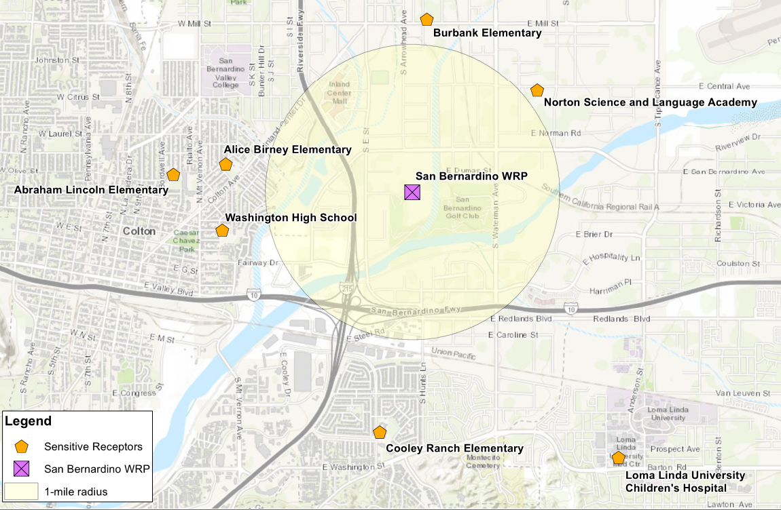

Federal Aviation Administration
The San Bernardino International Airport Authority oversees the development and reuse of the aviation portions of the former Norton Air Force Base, now known as the San Bernardino International Airport. The San Bernardino International Airport Authority is a regional Joint Powers Authority comprised of local member agencies: City of Colton, City of Highland, City of San Bernardino, City of Loma Linda, and County of San Bernardino.
The northeast corner of the SBWRP property is approximately 11,000 feet from the southwest edge of the runway at the San Bernardino International Airport. If any construction or alteration between 10,000 and 20,000 feet from the nearest point of the nearest runway exceeds an imaginary surface extending outward and upward at a 100 to 1 slope, a notice shall be filed with the FAA. Based on the approximately elevations of the SBWRP at 995 feet and the runway a 1070 ft, a new structure of approximately 185 feet in height at the SBWRP would require a notice to be filed with the FAA. A notice for construction or alteration does not need to be filed for any antenna structure of 20 feet or less in height, except one that would increase the height of another antenna structure (US Department of Transportation, Federal Aviation Administration, 2012).
For airports serving turbine-powered aircraft, the FAA recommends a separation of 10,000 feet between the farthest edge of the airport’s air operations area and an area that could potentially attract hazardous wildlife. At 11,000 feet, the SBWRP is just outside this separation; however, the FAA recommends that airport operators be notified of any potential changes to land use within 5 miles of the airport, including expansion of wastewater treatment facilities. If future facilities could potentially attract wildlife that are hazardous to aircraft, the SBWRP should notify the airport operator to provide an opportunity for plan review. Table 7-11 lists ten wildlife species groups that are most hazardous to aircraft (U.S. Department of Transportation, Federal Aviation Administration, 2007).

Table 7-11: Most Hazardous Wildlife Species to Aircraft
Species Group | Relative Hazard Score (100 = greatest potential hazard)
Deer | 100
Vultures | 64
Geese | 55
Cormorants/Pelicans | 54
Cranes | 47
Eagles | 41
Ducks | 39
Osprey | 39
Turkey/Pheasants | 33
Herons | 27
The FAA strongly recommends that airport operators immediately correct any wildlife hazards arising from existing wastewater treatment facilities near airports (U.S. Department of Transportation, Federal Aviation Administration, 2007). Accordingly, the SBWRP should incorporate reasonable measures to minimize hazardous wildlife attractants in consultation with a wildlife damage management biologist if deemed necessary by the airport operator.

Safety
New facilities and projects recommended as part of the Master Plan shall comply with all safety and health and environmental standards as outlined in the City of San Bernardino Municipal Water Department Safety Manual and required by relevant agencies including Cal/OSHA, the National Electrical Code and the San Bernardino County Fire Protection District. The SBMWD is currently working with a consultant that is preparing a Hazard Mitigation Plan that covers, among many other areas, the SBWRP. This document should be reviewed for conformance with safety regulations/codes.

Cal/OSHA
Detailed review of Cal/OSHA requirements and identification of specific safety requirements shall occur as part of the preliminary design of all recommended projects. Applicable safety considerations shall include but not be limited to providing handrails and appropriate fall protection measures, identifying and marking confined spaces, providing emergency equipment such as eye washes required for chemical storage and handling, implementing lockout/tagout procedures, attenuating occupational noise exposure and providing means of egress in buildings and structures.

San Bernardino County Fire Protection District
Coordination with the San Bernardino County Fire Protection District (SBCFPD) shall occur during the preliminary design stages of recommended facility improvement projects as needed. Specific fire and life safety requirements shall be identified at that time. Considerations shall include but not be limited to providing hydrants, sprinkler systems, sufficient water pressure for hydrants and sprinkler systems, fire alarms, and access for emergency vehicles.

National Electrical Code
The National Electrical Code (NEC) or National Fire Protection Agency (NFPA) 70 is a regionally adopted standard for the safe installation of wiring and electrical equipment in the United States. The California Electrical Code (CEC) has adopted the NEC 2017 version. As of November 2019, the NEC 2020 is available; typically, the NEC is updated every three years.
The NEC is used as a basis for all electrical design including master planning to determine the equipment and installation required to maintain safety and a reliable system. Additionally, NFPA 70E, Standard for Electrical Safety in the Workplace, is referred to as it pertains to arc flash hazards and engineering controls to provide safety when maintaining and working with electrical equipment.

Utility Considerations
Utility providers include So Cal Gas, Verizon, and Southern California Edison (SCE). SCE currently provides six electrical services for the SBWRP. There is one 4160V service at BLM, and five 480V services at Hoffman, Administration Building, Century Well, Chandler Well, and the Orange Show Well. Century Well is tapped off the transformer that feeds Hoffman. SBMWD is currently working with SCE to get one combined 4.16kV service at the existing BLM Switchgear such that Hoffman and Century Well will be fed from BLM for one combined service, which will reduce the number of utility services from six to four.
Currently, the largest transformer that SCE can provide is rated at 3750 kVA (3.75 MW). Future load estimates are currently calculated at 3.8 MW. Onsite generation is expected to increase by 1.4 MW with the addition of a fuel cell system to offset possible overloading of the substation transformer. Presently, SCE has approved allowing the projected overload on the utility transformer assuming the fuel cell system will supplement plant power needs.

Existing Process Performance and Capacity
This Section evaluates performance of the major treatment processes. Plant data from the 3-year period of March 2016 through February 2019 is compared against SBMWD goals, discharge requirements and industry standards.

Hydraulic Capacity
According to the SBWRP Operations and Maintenance (O&M) Manual (Carollo, 2000), the peak hydraulic capacity of the plant was intended to be 90 mgd with Unit 3 fully operational. The headworks and grit removal systems were constructed with 90 mgd of capacity with provisions for future expansion. Unit 3 was intended to have a capacity of 30 mgd when fully constructed, but the secondary treatment portion was never built. It currently serves to back up the Unit 1 primary clarifier if necessary, and therefore does not add to the overall plant peak hydraulic capacity.
The 1995 O&M manual listed the hydraulic capacity of Unit 1 as 38 mgd. Recent hydraulic modeling suggests that its capacity may be much less. In 2011, Carollo modeled the hydraulic capacity of Units 1 and 3 as part of their planning for Unit 1 upgrades (Carollo, 2011). They found that using either the Unit 1 or the Unit 3 primary clarifier, flow was limited to 20 mgd of forward flow, assuming mixed liquor recycle (MLR) and 6 mgd of RAS. Higher flows would submerge the primary clarifier weirs. At this flow the Unit 1 secondary clarifier flow split weirs would be submerged but this was not expected to significantly impact the flow split. Carollo recommended increasing the size of the mixed liquor pipe from the Unit 1 aeration basin to the flow splitter to help improve capacity. Black & Veatch performed a similar analysis in their 2012 Preliminary Design Report, “Overhaul of Unit 1 Primary and Aeration System Project.” They concluded that the Unit 1 hydraulic capacity would be 20 mgd with a parallel mixed liquor pipe. They also found that RAS could be increased to 12 mgd with MLR turned off.
Capacities of the major treatment units are summarized in Table 8-1. The total plant hydraulic capacity (Unit 1, 2 and NRC) based on the 1995 O&M manual is 67 mgd. With the lower capacity of 20 mgd for Unit 1, the total plant capacity is 48 mgd.
The Nitrogen Removal Carousel is designed for a consistent influent flow of 3 mgd to provide a carbon source for denitrifying recycle from dewatering. It is not designed to accept higher flows during wet weather.

Table 8-1: Peak Hydraulic Capacity of Treatment Units
Treatment Unit | Peak Hydraulic Capacity
Headworks & Grit (existing) | 90 mgd
Unit 1 | 38 mgd / 20 mgd ⁽¹⁾
Unit 2 | 25 mgd
Unit 3 (only the primaries were constructed) | 30 mgd
Nitrogen Removal Carousel (NRC) | 3 mgd
Total Current Plant | 66 mgd / 48 mgd
Notes:
- Capacities are from O&M Manual Design Criteria (Carollo, 2000), except (1) is from 2011 and 2012 studies mentioned above.
During three significant storms in January and February of 2019, instantaneous plant flows reached between 47 to 64 mgd as measured by the two effluent flow meters. Operators observed that there were no overflows or significant hydraulic issues during this event. This is not necessarily inconsistent with the 48 mgd total capacity reported above, as the primary clarifier weirs could have been submerged during the higher flow events without causing any other significant hydraulic issues.

Influent Distribution Performance
Table 8-2 shows influent flow statistics for each of the major treatment units. The headworks flow splitter and Unit 2 flow splitter work together and divide flows among the four treatment trains. NRC is designed for a stable raw wastewater influent flow of 3.0 to 3.6 to provide a carbon source for denitrification of centrate. The recorded average flow of 2.4 mgd is less than the design flow. The remainder of the flow is intended to be split 50 percent to Unit 1, and 25 percent to each of the Unit 2 trains, in accordance with the ratio of their design capacities. The data shows that on average, the flow split works well: Unit 1 receives 48 percent of the non-NRC flow, with Units 2N and 2S each receiving 27 and 25 percent respectively.

Table 8-2: WRP Flow Distribution
 | Units | Unit 1 | Unit 2 North | Unit 2 South | Nitrogen Removal Carousel
Average Flow | mgd | 9.22 | 5.08 | 4.75 | 2.35
Maximum Flow | mgd | 16.13 | 9.50 | 9.28 | 3.19
Minimum Flow | mgd | 7.35 | 3.87 | 3.30 | 0.64
Notes:
- NRC influent flow does not include centrate, which adds an average of 0.2- to 0.6 mgd of flow.

Primary Process Performance
Primary clarifier performance is summarized in Table 8-3. Average performance of the Unit 1 and 2 primary clarifiers is similar, with COD removal ranging from 40 to 46 percent, and TSS removal between 61 and 65 percent. These removals are at the high end of typical ranges and indicate that the primary clarifiers are working well. TSS removal in primary clarifiers commonly ranges from 40 to 70 percent, with 60 percent being typical. BOD removals are typically 25 to 40-percent, it is assumed that COD removal would typically be higher.
The high observed removals are most likely a result of the low overflow rates. Average overflow rates of 400 to 600 gpd/sf are low compared with the typical design range of 800 to 1200 gpd/sf (Metcalf & Eddy, p.394). The addition of ferric chloride at the headworks may also play a roll. Ferric chloride is added to precipitate sulfur and minimize hydrogen sulfide formation in the digesters but may also help with coagulation and settling of fine particles.
It is desirable for the SBWRP to remove as much of the organic load as possible in the primary sludge for a couple of reasons. Primary sludge is sent directly to the digester where it is converted to biogas and used as an energy source in the existing reciprocal engines and in the fuel cells which are planned to replace them. Load removed in primary treatment also does not require secondary treatment, reducing the energy used for aeration and freeing up capacity in Units 1 and 2.

Table 8-3: Primary Treatment Average Performance
 | Units | Unit 1 | Unit 2N | Unit 2S
Overflow Rate | gpd/sf | 599 | 449 | 420
COD Removal | % | 40% | 43% | 46%
TSS Removal | % | 61% | 63% | 65%
Primary Sludge % Total Solids | % | 4.0% | 4.3% | 4.2%

Secondary Process Overall Performance
As discussed in Section 7.1.1, the main goals of secondary treatment are to remove BOD and TSS to less than 20 mg/L each on a monthly average basis, and TIN to 10 mg/L on a 12-month average. Table 8-4 shows on average the plant is below the limit for BOD and TSS, and at the limit for TIN. For all these parameters, 95th percentile values are above the limits.

Table 8-4: SBWRP Effluent Data
 | Unit | Average | 95 Percentile
Effluent BOD | mg/L | 13.3 | 28.3
Effluent TSS | mg/L | 10.5 | 22.1
Effluent TIN | mg/L | 9.4 | 16.4
Notes:
- Effluent Data is sourced from the SBWRP lab spanning April 2012 to August 2018. Non-detect values are not included the values presented above.

Secondary Process Nitrogen Removal Performance
For plants designed to remove nitrogen, solids residence times are usually long enough that BOD removal is easily achieved. Nitrogen removal requires a longer SRT and is therefore the limiting process. It is accomplished by first converting ammonia to nitrate in the aerated zones (nitrification), then using the energy available in a carbon source such as the influent BOD to convert the nitrate to nitrogen gas (denitrification). This section explores nitrogen removal performance of the four treatment units in more detail.
Average TIN removal performance for each of the four treatment units is shown in Table 8-5. Only Unit 1 appears to be meeting its average effluent TIN goal of 10 mg/L. Most of the effluent TIN at Unit 2 appears to be nitrate, which suggests that while Unit 2N and 2S are both achieving consistent nitrification, denitrification is limited. This is likely due to the lack of internal nitrogen recycle in these units. The last halves of Unit 2N and 2S consist of aerobic bays, which is likely where most of the nitrification takes place. For the nitrate produced in these bays, only the fraction that is returned in the RAS can be denitrified.
By contrast, Unit 1 does have mixed liquor recycle. This allows more nitrate to be returned to the anoxic zones, and as a result Unit 1 effluent nitrate concentration is half of what is observed at Unit 2, resulting in a lower effluent TIN.
Unit 1 shows signs of incomplete nitrification, as indicated by its higher effluent ammonia and nitrite concentrations. Common causes of incomplete nitrification include insufficient solids residence time and insufficient dissolved oxygen. Nitrifying bacteria are relatively slow to grow. Stable nitrification requires a minimum SRT to insure a sufficient population. Metcalf and Eddy (2014, p.719) cites a wide range of 3 to 18 days of SRT as being required for complete nitrification. The longer times are required at cooler wastewater temperatures. Given the relatively warm influent temperatures at SBWRP, the retention times shown in Table 8-5 should be sufficient and do not alone explain partial nitrification.
Nitrifying bacteria grow best within a DO range of 1.5 to 2.0 mg/L (Metcalf and Eddy, 2014, p.729). While plant data shows that DO concentrations in the aerobic bays of Unit 1 are on average greater than 2.0, the levels are inconsistent. During a site visit on August 12, 2019, DO levels in bays 1 through 8 were observed to all be less than 0.7 mg/L. The blower project currently under design is intended to improve oxygen delivery and control to Units 1 and 2 and should help promote complete nitrification.

Table 8-5: Average Secondary Treatment Nitrogen Removal Performance
 | Units | Unit 1 | Unit 2N | Unit 2S | NRC
Aerobic SRT ¹ | days | 6.3 | 8.7 | 6.5 | 12.3
Effluent Ammonia | mg/L | 1.5 | 0.7 | 0.5 | 10.9
Effluent Nitrite | mg/L | 1.4 | 0.0 | 0.0 | 1.5
Effluent Nitrate | mg/L | 5.1 | 10.5 | 11.5 | 2.7
Total TIN | mg/L | 8.0 | 11.2 | 12.0 | 15.1
Influent Alkalinity | mg/L | 290 | 297 | 296 | 227
Notes:
- Aerobic SRT was calculated from total SRT using current aeration bay configurations: Unit 1 70% aerobic, Unit 2N 80% aerobic, Unit 2S 63% aerobic.

Secondary Clarifier Performance
Table 8-6 summarizes parameters for each unit related to secondary clarifier performance. All four treatment units have settleability issues as indicated by high 95th percentile SVI values ranging from 280 to 390 mL/g. For comparison, a 95th percentile SVI of 200 mL/g is a typical design value for plants without selectors. It is possible that the process configuration contributes to high SVI, but a filament analysis would be required to confirm. In Units 1 and 2N, the small pre-anoxic zone (10% of the reactor volume) is likely insufficient to provide a beneficial selector effect. Subsequent alternating small aerobic/anoxic zones may result in marginal DO concentrations that promote filament growth in addition to limiting nitrification.

Table 8-6: Secondary Clarifier Performance
 | Units | Unit 1 | Unit 2N | Unit 2S | NRC
Avg. Overflow Rate | gpd/sf | 300 | 414 | 387 | 268
Avg. MLSS | mg/L | 2501 | 2139 | 2306 | 2791
Avg. SVI | mL/g | 182 | 107 | 92 | 202
95th Percentile SVI | mL/g | 389 | 282 | 290 | 345
Avg. Effluent TSS | mg/L | 7.5 | 8.5 | 8.1 | 9.4
95th Percentile Effluent TSS | mg/L | 18.0 | 17.6 | 16.8 | 20.0

Secondary Treatment Capacity
Capacity of the secondary treatment system is defined by two measures:
- The reactor tanks and blower system must have enough capacity to meet effluent BOD and TIN requirements under typical high (max month or week) loading conditions.
- The secondary clarifiers must have enough capacity to handle peak hour flows without losing solids.
The capacity of the Unit 1 reactor tanks was evaluated in separate modeling studies by Carollo (2011) and Black & Veatch (2012). These studies both examined the ability of Unit 1 to remove TIN to 10 mg/L at max month loading with the addition of mixed liquor recycle (MLR). While Unit 1 has a rated capacity of 15 mgd, both studies concluded that in order to meet the TIN requirement, the average flow could not exceed 12 mgd. The Black & Veatch study determined that capacity would be limited by ability to transfer sufficient dissolved oxygen to meet the high demand in the first bays. The Carollo study found that capacity was limited by the ability to achieve complete nitrification.
Although modeling was not performed for the Unit 2 trains, these have the same configuration as Unit 1: ten reactor bays in series. Assuming the same primary effluent concentrations, a rough estimate of the capacity of Units 2N and 2S can be made based on the ratio of their volume to that of Unit 1. The Unit 1 reactor volume is reported as 485,000 in the 2016 Hazen and Sawyer PDR. The volume for each of the Unit 2 trains is reported as 321,000 cubic feet by the same source. If the capacity of Unit 1 is 12 mgd based on nutrient removal objectives, then the capacity of each Unit 2 train would be 7.2 mgd based on a volume ratio. This value is slightly less than the original average dry weather flow capacity of 7.5 for these units. This analysis presumes that mixed-liquor recycle pumps have been added to Unit 2N and 2S.
The peak forward flow capacity of the secondary clarifier was estimated using state point analysis (SPA). State point analysis is a graphical technique for comparing the rate at which solids are introduced and removed from the clarifier with an empirical settling rate curve. Results are summarized in Table 8-7. These capacities are based on the current 95th percentile SVI and average mixed liquor concentrations presented above.

Table 8-7: Current Secondary Clarifier Capacity
 | Units | Unit 1 | Unit 2N | Unit 2S | NRC
Firm RAS Capacity ⁽¹⁾ | mgd | 12 | 4.4 | 4.2 | 3.6
Peak Forward Flow Capacity ⁽²⁾ | mgd | 15 | 11 | 9 | 4.5 ⁽³⁾
Notes:
- RAS capacity with one pump out of service, from Carollo 2016 Capacity Update.
- Based on state point analysis using average mixed-liquor concentrations and 95th percentile SVI from the previous table. Unit 1 assumes both clarifiers are online.
- NRC is not intended to handle more than 3 mgd of raw influent.
State point analysis estimates that the peak flow capacity of Unit 1 is at its average design capacity of 15 mgd. The peak capacities of Units 2N and 2S are only slightly higher than their design average capacity of 7.5 mgd. This is an issue because at their design flows, these units will have little additional capacity to handle wet weather flows without losing solids. The discrepancy in peak capacities between Units 2N and 2S are due to the difference in MLSS concentration as shown in Table 8-6. The high SVI values limit capacities for both Unit 1 and 2. The peak capacity of the NRC’s secondary clarifier is less of a concern because it is not intended to handle flows above 3 mgd.
Table 8-8 shows how the capacity of the SBWRP’s secondary clarifiers could be increased by improving settleability and reducing the 95th-percentile SVI to a more typical value of 200 mL/g. This analysis assumes that the MLSS concentration has also been increased to a design concentration of 3000 mg/L for all units based on what the Black & Veatch modeling study predicted would be necessary to treat an average flow of 12 mgd in Unit 1.
For Unit 1, the improvement is considerable: state point analysis estimates the peak flow capacity would be increased to 25 mgd. For Unit 2, which currently has a lower SVI, improving the SVI to 200 is canceled out by the increase in MLSS concentration, resulting in no net increase in capacity.
This analysis assumes that the Unit 2 RAS capacity has been restored to its original design value of 4.5 mgd (3150 gpm) per train. Though it is common to size RAS pumps in nutrient removal systems for 100% of the average flow, state point analysis suggests that increasing the capacity of the Unit 2 RAS pumps beyond 4.5 mgd does not increase secondary clarifier capacity in any scenario.

Table 8-8: Design Secondary Clarifier Capacity with Improved SVI
 | Units | Unit 1 | Units 2N & 2S  (each) | Units 2N & 2S (each), Contact Stabilization
Design SVI | mL/g | 200 | 200 | 200
Design MLSS Concentration | mg/L | 3000 | 3000 | 1500
Firm RAS Capacity Required | mgd | 12 | 4.5 | 4.5
Peak Forward Flow Capacity | mgd | 25 | 9 | 20
An additional strategy for increasing wet weather capacity of Unit 2 above 9 mgd would be to temporarily reduce the MLSS concentration during wet weather by implementing contact stabilization. To achieve this, operators would direct most or all the primary effluent to bay(s) downstream of where the RAS is introduced. This reduces the mixed liquor concentration entering the secondary clarifiers and effectively increases their capacity. The last column of Table 8-8 shows that reducing the MLSS concentration to 1,500 mg/L by this method would double the peak flow capacity of Unit 2 to 20 mgd. This could increase the SBWRP’s total peak secondary clarifier capacity to 68 mgd, including 3 mgd of treatment at NRC. Additional detailed modeling is required to confirm.

Solids Handling Capacity and Performance
This section discussed capacity and performance of the major processes in the solids handling system:
- Dissolved Air Floatation Thickeners (DAFTs)
- Anaerobic Digesters
- Centrifuge and Belt Filter Press (BFP) Dewatering
The DAFT are used to remove water from the secondary solids to reduce the hydraulic loading to digesters. There are four DAFT units, three of which are functional. Typically, only one DAFT is in operation. Occasionally, two DAFT units are in service for transitioning from one to another. DAFT 4 is the primary unit in service, and DAF 1 and DAF 2 are rotated into service. Table 8-9 presents a summary of DAFT performance. The average loading rate is slightly higher than the 1995 design of 24 lbs./day/sf, but less than the industry-standard loading rate of 48 lbs./day/sf. Performance of the DAFT is good, with an average solids-capture of 99.7% and an average thickened concentration of 6.4%.

Table 8-9: DAFT Performance
 | Units | Value
Average Solids Loading | pounds per day | 27,360
Average Float TS | percent | 6.4%
Average Float Solids Capture | pounds per day | 27,300
Average Solids Capture Rate | percent | 99.7%
Average Surface Loading Rate | pounds per day per square foot | 28
Primary and thickened secondary solids are conditioned in three anaerobic digesters (a fourth digester is currently out of service). A key measure of digester capacity is hydraulic residence time (HRT), which is summarized in Figure 8-1, below. In order to meet the pathogen reduction requirements of the Part 503 Biosolids Rule, a 15-day residence time is required. 15 days is also a practical minimum residence time to maintain stable operations. The top line in Figure 8-1 shows that three digesters were required to stay above the 15-day minimum HRT based on loadings over the last several years. The bottom line shows the HRT with just two digesters, which would have dipped below 15-days for an extended period.

Figure 8-1: Digester Hydraulic Retention Time (30-day average)
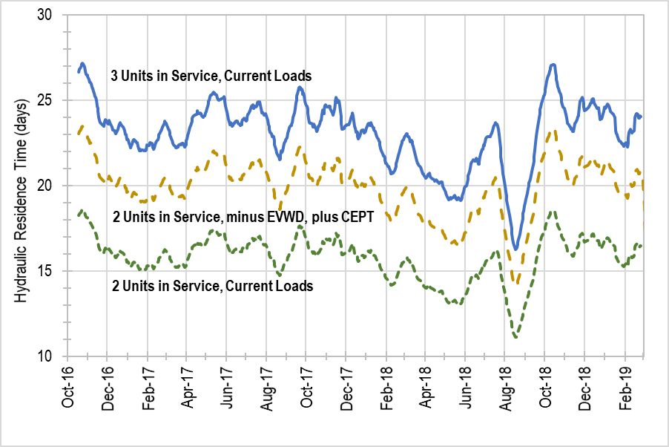
The middle line in Figure 8-1 shows the projected HRT with two digesters when EVWD departs. The solids load has been decreased proportionally to EVWD’s flow. An additional 10-percent load has been added back to account for the potential additional solids load from chemically-enhanced primary treatment, which is discussed as a possible upgrade option in Section 10. Under this scenario, two digesters are sufficient to maintain a 15-day HRT, which would provide an opportunity for the SBMWD to perform rehabilitation and upgrade work on the digesters. This is discussed further in Section 10.
A pair of centrifuges are available for dewatering. Under normal operations, one centrifuge is run 24 hours per day, 7 days per week. The second centrifuge serves as a backup. This provides sufficient capacity for current and future conditions.

Recommended Rehabilitation and Replacement Projects
To organize the rehabilitation and replacement (R&R) of assets for the Capital Improvement Plan (CIP), the assets were grouped by process location or type of work and organized into the time periods that correlate with SBMWD’s CIP format. R&R projects included in this CIP are limited to a 20-year planning period.
The time periods used for this CIP are as follows:

- Near-Term: 1 to 5 years (FY 2020/2021 through FY 2024/2025)
- Projects in this time period were selected based on assets with 5-years or less of estimated remaining useful life with additional considerations for assets that SBMWD staff saw as a priority for replacement.
- Medium-Term: 6 to 10 years (FY 2025/2016 through FY 2029/2030)
- Projects in this period were selected based on assets with less than 10 years of estimated remaining useful life that were not addressed under the near-term projects.
- Long-Term: 11 to 20 years (FY 2030/2031 through FY 2039/2040)
- Projects in this period were selected based on assets with less than 20 years of estimated remaining useful life that were not addressed under the near- or medium-term projects.
The reference for R&R projects and their costs is the Asset Register Version 90. As a part of the development of the Asset Registry, a Business Risk Exposure (BRE) analysis was used to describe and quantify the risks associated with failure of SBWRP’s assets (see Section 4: Risk Assessment). The BRE score that was assigned to each asset was used to prioritize near-term actions needed to mitigate asset risk and/or help meet level of service goals. BRE scores have three major components: Probability of failure (PoF); Consequence of failure (CoF); and redundancy. The BRE scores were used to prioritize asset R&R by process location.
The near-term R&R projects were further prioritized using the scoring system described in Section 9.1.
R&R project costs include construction markups for general conditions, electrical and I&C, contractor overhead and profit, and bonds and insurance. R&R project costs also include allowances for design and construction management (see Table 10-3). A 30% project contingency is included in all project cost estimates.

Near-Term R&R Projects (1 to 5 Years)
This section describes projects that are recommended in the Near-Term (FY 2020/2021 through FY 2024/2025). A summary of cost estimates for each project is provided in Table 9-1 with more detailed cost sheets included at the end of this section.

Table 9-1: Near-Term R&R Projects (1 to 5 Years)
R&R Project | Project Description | Project Cost
HVAC and Misc. Mechanical Asset R&R | R&R of aging and critical HVAC and miscellaneous mechanical assets. Assets to be replaced include HVAC and various valves located in the Administration and Secondary Admin Buildings, and Arrowhead Lift Station. | $500,000
Instrumentation R&R | R&R of aging and critical instrumentation assets. Instrumentation to be replaced include meters, sensors and probes located at the onsite wells, headworks buildings and outfall sample stations. | $450,000
Liner and Containment Structure R&R | R&R of aging and critical liner and containment structure assets. Assets to be replaced include liners and containment structures located at the truck unloading bed, grit dewatering bed, and ferric chloride and hazardous material storage areas. | $240,000
Solids Handling and Digester A R&R | R&R of aging and critical dewatering and digester assets. Assets to be replaced include various sludge handling, dewatering and odor control equipment located at the dewatering building, DAFTs, Digester A and sludge storage. Digester A rehabilitation should take place after the completion of the Digester B replacement. | $4,690,000
Digester C & D R&R | R&R of aging and critical assets associated with Digesters C and D. Assets to be replaced include various process mechanical equipment. R&R of Digesters C and D should not occur until Digester B is replaced (see Section 10). | $220,000
Pavement R&R | R&R of pavement throughout the treatment plant site. This cost has been spread over a 10-year period. | $3,640,000
Grit Removal System R&R | R&R of aging and critical assets associated with grit removal. Assets to be replaced include grit chamber assemblies and meters, aerator blowers, motors and VFDs. | $2,520,000
Nitrogen Removal Carrousel R&R | R&R of aging and critical assets associated with the Nitrogen Removal Carrousel and North Outlet structure. Assets to be replaced include various process equipment. | $3,830,000
Pump and VFD Replacement Project | R&R of aging and critical Pumps and Variable Frequency Drives. Assets to be replaced include pumps, VFDs and instrumentation located at the Roots Blower Building, RS-1 Pump Station and Tertiary Reservoir. | $4,940,000
Units 1 and 2 R&R | R&R of aging and critical assets associated with the Unit 1 and Unit 2 process. Assets to be replaced include diffusers, mixers, motors, VFDs, platforms, and miscellaneous mechanical equipment and instrumentation. | $3,510,000
Unit 3 R&R | R&R of aging and critical assets associated with the Unit 3 primary process. The assets under Unit 3 R&R include valves and flow meters at Low Pressure Supply Air Assembly, Flight Scraper Mechanism at Primary Clarifier No. 3D, Grinders and Gas meter at Scum Pump Station and Pumps and Motors at Primary Sludge Pump Station. | $1,720,000
Total Near-Term R&R Project Cost |  | $26,260,000
The near-term R&R projects were further prioritized using the scoring system described in the following section. The scoring system relied on four evaluation categories:
- Reducing consequence of failure (COF)
- Improving energy efficiency (Energy)
- Renewing or replacing aging assets (Life)
- Reducing operational cost and/or simplifying operations (Ops)
Each evaluation category was assigned a weight of 1 to 3, with three being the most significant and one being the least. Weights are shown in the table below. Each project was given a score of 0 to 3 in each evaluation category based its relevance to the project. A score of three indicates that the category is highly relevant to a project; zero indicates no relevance. A total score was then calculated for each project by multiplying the score for each category by its weight, then summing the weighted scores. Projects with the highest total score offer the greatest benefit to SBMWD. Note that these scores are independent of the capital costs presented previously.
Scores were only developed for the near-term R&R projects since a specific year for implementation needed to be identified. The scores for each near-term R&R project by evaluation category and total are presented in Table 9-2. The projects have been sorted in descending order based on their total score.

Table 9-2: Near-Term R&R Project Scoring and Ranking
Project | Total Score | Evaluation Category
Project | Total Score | COF | Energy | Life | Ops
Project | Total Score | Category Weight
Project | Total Score | 3 | 1 | 2 | 1
Project | Total Score | Category Score
VFD Replacement Project | 16 | 3 | 1 | 3 | 0
Solids Handling and Digester A | 16 | 3 | 1 | 3 | 0
Nitrogen Removal Carrousel | 15 | 3 | 0 | 3 | 0
Units 1 and 2 | 15 | 3 | 0 | 3 | 0
Unit 3 | 15 | 3 | 0 | 3 | 0
Digester C & D | 14 | 3 | 1 | 2 | 0
HVAC and Misc. Mechanical Assets | 14 | 2 | 1 | 3 | 1
Instrumentation | 13 | 2 | 0 | 3 | 1
Liner and Containment Structures | 12 | 2 | 0 | 3 | 0
Grit Removal System | 12 | 2 | 0 | 3 | 0
Pavement | 10 | 1 | 0 | 3 | 1

Medium-Term R&R Projects (6 to 10 Years)
This section describes projects that are recommended in the Medium-Term (FY 2025/2026 through FY 2029/2030). A summary of cost estimates for each project is provided in Table 9-3 with more detailed cost sheets included at the end of this section.

Table 9-3: Medium-Term R&R Projects (6 to 10 Years)
CIP Project | Project Description | Project Cost
HVAC and Misc. Mechanical Asset R&R | R&R of aging HVAC and miscellaneous mechanical assets. Assets to replaced include HVAC and various valves located in Electrical Administration Building, Boiler Building, and Headworks Tunnel and Splitter box. | $1,671,000
Instrumentation R&R | R&R of aging instrumentation assets. Instrumentation to be replaced include meters, sensors and probes located at the onsite wells, bar screen building and outfall sample stations. | $5,552,000
General Site Civil | R&R of aging assets at the Septage and Brine Receiving Station, Irrigation Control Building and Brine Ponds. | $340,000
Solids Handling R&R | R&R of aging dewatering and digester assets. Assets to be replaced include various sludge handling, dewatering and odor control equipment located at the dewatering building, DAFTs, Digester A and sludge storage. | $11,274,000
Lift Station R&R | R&R of aging assets associated with Arrowhead and East Influent Lift Stations. Assets to be replaced include pumps, motors, and sensors. | $2,846,000
Pavement R&R | R&R of pavement throughout the treatment plant site. This cost has been spread over a 10-year period. | $3,640,000
Headworks R&R | R&R of aging assets associated with the headworks including grit removal and odor control systems. | $3,853,000
Nitrogen Removal Carousel R&R | R&R of aging assets associated with the Nitrogen Removal Carousel. Assets to be replaced include RAS/WAS pumps and motors, and various mechanical equipment. | $1,900,000
VFD R&R | R&R of aging assets associated with Variable Frequency Drives. Assets to be replaced include VFD and instrumentation located at the Roots Blower Building and Tertiary Reservoir. Consideration should be given to replacing the Roots blowers in addition to the VFDs for this project. | $3,263,000
Units 1 and 2 R&R | R&R of aging assets associated with the Unit 1 and Unit 2 process. Assets to be replaced include diffusers, mixers, motors and miscellaneous mechanical equipment and instrumentation. | $6,296,000
Unit 3 R&R | R&R of aging assets associated with the Unit 3 primary process. Assets to be replaced include scum pumps, motors, grinders, and miscellaneous mechanical equipment and instrumentation. | $3,791,000
Total Medium-Term R&R Project Costs |  | $40,786,000

Long-Term R&R Projects (11 to 20 Years)
This section summarizes projects that are recommended in the Long-Term (FY 2030/2031 through FY 2039/2040). A summary of cost estimates for each project is provided in Table 9-4 with more detailed cost sheets included at the end of this section.

Table 9-4: Long-Term R&R Projects (11 to 20 Years)
CIP Project | Project Cost
HVAC and Misc. Mechanical Asset R&R | $8,886,000
Instrumentation R&R | $19,128,000
General Site Civil | $956,000
Solids Handling R&R | $36,745,000
Lift Station R&R | $7,701,000
Digester C & D R&R | $1,931,000
Paving R&R | $1,107,000
Headworks R&R | $10,100,000
VFD R&R | $6,232,000
Unit 3 R&R | $2,639,000
Total Long-Term R&R Project Costs | $95,425,000

Insert PDFs of the R&R cost sheets here and delete this page in PDF

Operational Efficiency and Optimization Projects
This Section considers ten capital improvement projects and four special studies to analyze opportunities for increased efficiency and address needs identified in this Master Plan including peak-flow management, reduction of flow from EVWD, energy conservation, and process reliability. The projects described in this Section are in addition to projects currently in the Capital Improvement Plan (which are discussed in Section 0).
The following list is a summary of the projects and studies that were developed and evaluated. The rest of this Section discusses each of these projects in detail:
Capital Projects
- Primary Treatment
  - Primary Flow Equalization: Increase wet-weather storage capacity by adding primary flow equalization (EQ). Project is discussed in further detail in Section 10.1.1.
  - Chemically Enhanced Primary Treatment: Improve solids removal in the primary clarifiers through chemically enhanced primary treatment (CEPT). Project is discussed in further detail in Section 10.1.2.
- Secondary Treatment
  - Liquid Process Optimization: Improve nitrogen removal and sludge settleability by studying and pilot testing different operational modes for Units 1 and 2 and the addition of Mixed Liquor Return (MLR) pumps to Unit 2. Project is discussed in further detail in Section 10.2.1.
  - Secondary Capacity Reduction: Reduce operational costs and complexity by taking one of the Unit 2 trains off-line after the reduction of flow from EVWD. Project is discussed in further detail in Section 10.2.2.
  - NRC Conversion to Diffused Air: Improve NRC process control and increase energy savings by converting mechanical aerators to diffused air and installing DO control. Project is discussed in further detail in Section 10.2.3.
  - Unit 3 Expansion and Completion: Improve overall plant efficiency and performance by replacing multiple liquid processes with a unified conventional activated sludge process designed for nitrogen removal. Project is discussed in further detail in Section •.
- Solids Handling
  - Digester B Replacement: Provide digester redundancy by replacing Digester B, which is currently offline due to leakage. Project is discussed in further detail in Section 10.3.1.
  - Digester Cleaning: Maintain digester performance and reliability by cleaning the existing digesters. Project is discussed in further detail in Section 10.3.2.
  - Digester Mixing Optimization: Save energy by optimizing digester mixing. Project is discussed in further detail in Section 10.3.3.
- Brine Line Improvements
  - Increase efficiency by installing manholes in the brine line connecting the septage/brine receiving station to the Inland Empire Brine Line to reduce cleaning time and cost. Project is discussed in further detail in Section 0.
- Influent Lift Stations
  - Downsizing of the East Influent Lift Station
- Special Studies
  - Electrical Master Plan: Electrical master plan to provide a comprehensive, strategic approach to guide future projects and improve reliability. Project is discussed in further detail in Section 10.6.1.
  - SCADA Master Plan: SCADA master plan to achieve a secure, flexible, reliable, and comprehensive SCADA environment. Project is discussed in further detail in Section 10.6.2.
  - Biosolids Strategic Plan: Strategic plan for biosolids management to identify multiple options and ensure reliable disposal and/or reuse of biosolids. Project is discussed in further detail in Section 0.
  - RIX Facility Plan: RIX master plan to evaluate the performance and current efficacy of the RIX facility, which filters and disinfects secondary effluent from SBWRP and the City of Colton for discharge to the Santa Ana River. Project is discussed in further detail in Section 10.6.4.

Basis of Cost
For each project, a conceptual/feasibility-level cost estimate was prepared, with a simple payback approach used to evaluate projects to determine whether economically viable. Projects were also evaluated based on their operational benefits. When estimates have been based on costs of recent past projects, costs have been escalated using a construction cost index (CCI) to the present day (Sept 2019) CCI of 12021.45 for Los Angeles.
The International Association for the Advancement of Cost Engineering (AACE International) suggests five levels of accuracy for cost estimates. Table 10-1 shows the five classes and their respective accuracy ranges. As this study is for preliminary planning, the provided estimates are considered Class 4 or Class 5. Some, such as the estimate for flow equalization, were based on similar projects adjusted for capacity (Class 5). Others, such as CEPT and the Unit 3 Expansion and Completion Project, were based on factored equipment costs (Class 4).

Table 10-1: Classes of Cost Estimates
Estimate Class | Level of Project Definition | Typical  Purpose | Methodology | Expected Accuracy Range | Preparation Effort Relative to Least Cost Index of 1
5 | 0% to 2% | Concept Screening | Capacity factored, parametric models, judgement or analogy | Low: -20% to -50%  High: +30% to +100% | 1
4 | 1% to 15% | Study or Feasibility | Equipment factored or parametric models | Low: -15% to -30%  High: +20% to +50% | 2 to 4
3 | 10% to 40% | Budget, Authorization, or Control | Semi-detailed unit costs with assembly level line items | Low: -10% to -20%  High: +10% to +30% | 3 to 10
2 | 30% to 70% | Control or Bid/Tender | Detailed unit cost with forced detailed take-off | Low: -5% to -15%  High: +5% to +20% | 4 to 20
1 | 50% to 100% | Check Estimate or Bid/Tender | Detailed unit cost with forced detailed take-off | Low: -3% to -10%  High: +3% to +15% | 5 to 100
Notes:
- Content comes from the AACE International Recommended Practices, No. 18R-97.
- The +/- value represents typical percentage variation of actual costs from the cost estimate after applying contingency.
Project costs include direct construction costs plus the indirect costs required to implement the project. Indirect costs include site civil engineering, environmental documentation, permits, administrative costs, construction management, and engineering services during construction. Indirect costs have been estimated as a percentage of the construction cost as shown in Table 10-3.
In addition, construction costs vary with changing conditions. For example, the bidding climate may change related to the supply and demand of construction work, the availability of qualified contractors, etc. or the project scope may change during design, or site conditions may not be known. To account for uncertainties, an estimating contingency of 30% was applied to arrive at the project cost.
Annual Costs
Annual operation and maintenance (O&M) costs are the ongoing costs to run and maintain a facility, including power, labor, chemicals, and equipment replacement. O&M costs vary by treatment process according to the flow and/or load treated. O&M costs are based on estimates of labor, energy, and material use and are used to compare the life-cycle costs of alternatives. O&M costs were based on current SBWRP rates as summarized in Table 10-2.

Table 10-2: O&M Unit Costs
Item | 2019 Cost
Labor (average) | $150 / hour
Electricity | $0.12 / kilowatt-hour
CEPT Polymer | $1.40 / active pound
Natural Gas | $ 1.05 / therm (100,000 btu)
Table 10-3 summarizes the guidelines used to estimate total project costs for the SBWRP. The 15% allowance for electrical and instrumentation is intended to capture installation and material costs for ancillary electrical equipment including cable, wire, auxiliary terminals, consumables, conduit (not including large duct banks), fittings, pull boxes, lighting, switches, support structures (not including cable trays) and grounding equipment. The allowance for planning studies and CEQA compliance varies by project. As most projects are R&R, they are not expected to require significant CEQA documentation. A project contingency of 30% was applied to all projects.

Table 10-3 Summary of Cost Estimating Markups
Item | Markup
Construction Markups
General Conditions | 15%
Electrical and Instrumentation Allowance | 15%
Contractor Overhead | 10%
Contractor Profit | 10%
Bonds & Insurance | 3%
Indirect Costs
Planning Studies / CEQA Compliance, where applicable | 0 – 1%
Engineering Design | 12%
Construction Administration | 15%
Contingency
Project Contingency | 30%

Primary Treatment

Primary Flow Equalization
The main objective of providing primary flow equalization would be to relieve downstream treatment processes during wet weather to provide onsite storage of primary flow during a large storm event. Due to the relatively even influent diurnal flow to the SBWRP, daily peak flow equalization is not considered a worthwhile investment for the plant.
The primary flow equalization basin was sized based on the influent flow experienced by the SBWRP during a large storm event on February 14, 2019. This storm was selected due to its recency and the high flow it generated. SBMWD staff confirmed that the SBWRP was able to handle the high flow throughout the processes without over-topping. Since it is not practical to design a flow equalization basin to detain the full storm flow volume generated over a 24-hour period, the primary equalization basin was designed to hold the flow above the current estimated capacity of the plant. The capacity of 38 mgd estimated in Section 10.2.2 represents the peak flow that can pass through the secondary clarifiers with all units online. The volume required to store flows above this, based on the peak flow event in February of 2019, is 4.7 million gallons (MG), and is represented by the shaded area under the curve in Figure 10-1. This sizing is based on current flows and is conservative for future peak flows when influent flow will be reduced; however, additional hydraulic capacity may be needed if one train of Unit 2 is taken offline (see project detailed in Section 10.2.2).

Figure 10-1: Peak Wet Weather Flow Event (2/14/2019)
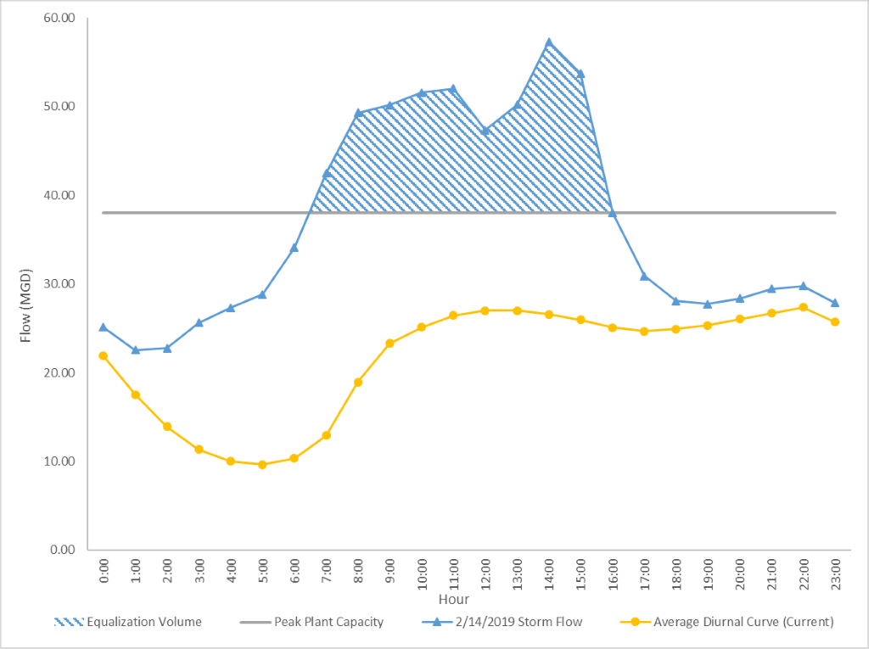
The cost estimate for the equalization basin is based on below-grade, geomembrane-lined basin, with an additional allowance for bird deterrents per FAA requirements. It is assumed that influent will flow by gravity from the existing blind flanged 42-inch primary influent line at the headworks splitter box. This same line could conceptually be utilized to pump primary equalization volume back into the splitter box when SBWRP influent flow reduces to normal levels. The pump station is assumed to be dry pit with submersible non-clog pumps. Further details of the primary equalization project would be determined during the design phase of the project.
The estimated cost of constructing a storage basin of this size, including a pump station, is $9.3 million. This cost is based on Carollo’s 2015 estimate for a 5 MG facility, and a similar 1.3 MG storage basin constructed in 2005 for the Yucaipa Valley Water District. Costs were adjusted based on volume and escalated to present day. Allowances for contractor markups, design, and construction management are included, along with a 30% project contingency.

Chemically Enhanced Primary Treatment
The primary treatment process can be optimized through the addition of chemical coagulants such as metal salts and organic polymers. This technique, known as chemically enhanced primary treatment (CEPT), improves settling, thereby increasing primary sludge volume and decreasing the load to the secondary system.
Benefits of enhancing primary clarifier removal through chemical addition include:
- Increasing diversion of organic matter directly to the digester, with a corresponding increase in biogas production and energy generation.
- Reducing organic loading to secondary treatment, with a corresponding reduction in the energy required for aeration and the creation of additional capacity to accommodate growth or optimize process performance.
- Potential for lowering the MLSS concentration, which in turn would increase the peak-flow capacity of the secondary clarifiers.
Potential drawback of enhancing primary clarifier removal through chemical addition include:
- Impact on TIN removal performance
CEPT is reported to increase TSS removal by 20 to 30 percent, and BOD removal by 25 to 40 percent (Metcalf & Eddy, 2014, p.477). Experience at the Encina Water Pollution Control Facility (EWPCF) shows a more modest increase of 10% in TSS removal and gas production, with minimal improvement in BOD removal (Carollo, 2016). Nevertheless, an economic analysis showed the practice to be worth continuing at EWPCF largely due to the 10% increase in biogas production. The SBWRP is already adding ferric chloride at the headworks to reduce hydrogen sulfide buildup in the digesters, so there may already be some enhancement of primary clarifier removal. Adding polymer downstream of the ferric chloride addition may further increase primary removals.
It is assumed that the CEPT project would consist of two new polymer skids to feed polymer ahead of Units 1 and 2 primary clarifiers. For this analysis, it is assumed that polymer would be fed into the Unit 2 influent splitter box, and into the Unit 1 above-ground influent pipe or, when the Unit 3 primary clarifier is on-line, the Unit 1 splitter box. The polymer skids would be located near the feed points in simple sheds or under roofs for weather protection. Polymer would be delivered and stored in totes. Preliminary design would investigate other locations for the skids including inside existing structures such as the Unit 1 and 2 pump stations. Preliminary design would also consider the optimum point for feeding to the process including bench scaling testing, considering available mixing energy and flocculation time. A budget cost estimate for this alternative, including design and contingency, is $390,000.

Table 10-4: Simple Payback Analysis for CEPT
 | Units | Value
Polymer Dose | mg/L | 0.5
Dry Feed Rate | ppd | 10
Annual Polymer Cost | $/year | 5,000
Operations | hour/week | 2
Annual Labor Cost | $/year | 15,600
Additional Biogas Volume | scf/day | 40,000
Additional Biogas Energy | therm/year | 83,220
Annual Value of Biogas | $/year | 87,000
Net Annual Cost | $/year | (66,400)
Capital Cost | $ | 390,000
Simple Payback | Years | 6
A simple payback analysis, presented in Table 10-4, estimates a payback time of 6 years on the capital investment, assuming a polymer dose of 0.5 mg/L results in a 10% increase in biogas production (similar performance to EWPCF). It is also assumed that the system will require an average of 2 hours per week of operations and maintenance time. Ferric addition has not been included in the payback analysis, since it is assumed that the current dosage of ferric for odor control purposes is adequate for CEPT. The estimated payback period for CEPT is relatively short, so this project is recommended. It is also recommended that SBMWD perform jar testing to help validate chemical doses and expected performance.

Secondary Treatment

Liquid Process Optimization
Several performance issues with secondary treatment in Units 1 and 2 were identified:
- Insufficient oxygen delivery and/or control may limit nitrification and process control, especially in Unit 1
- Limited TIN removal due to lack of mixed liquor recycle in Units 2N and 2S
- Inconsistent sludge settleability, indicated by high 95th-percentile SVI values, especially in Unit 1.
The first issue will be addressed, at least in part, by the aeration upgrades which are currently being designed and implemented in the 1110.2 Resultant Projects. The aeration components of the project will include new high-efficiency blowers and automatic DO control.
This liquid process optimization project is intended to address the other issues identified. It would include adding one MLR pump to both Units 2N and 2S. Redundant locations for MLR pumps are not considered necessary as the plant could operate for a limited time without MLR pumping in either Units 2N or 2S if required for maintenance.
This project also includes an optimization study to investigate and pilot test different basin configurations to improve sludge settleability. Options to evaluate include:
- Consolidating anoxic zones to the start of the treatment train to run in a Modified Ludzak-Ettinger (MLE) configuration. An MLE configuration consists of a pre-anoxic zone followed by an aerated zone, with mixed liquor return to bring nitrate back to the anoxic zone for denitrification. Each zone may consist of multiple bays. Converting to an MLE process may improve TIN removal, stabilize SVI and simplify operations.
- Switching to contact stabilization during wet weather to increase peak secondary clarifier capacity. Contact stabilization involves sending all the RAS to the first zone, with most or all the primary effluent introduced downstream. Running in this mode during wet weather concentrates the mixed liquor in the first zone, and reduces the solids loading to the secondary clarifier, temporarily increasing secondary clarifier capacity.
Any operational strategy that is considered will need to include provisions for taking pairs of bays offline, as this is critical for redundancy. An allowance of $200,000 is included for pilot testing to cover additional sampling and minor modifications to gates, mixer locations, etc. It is assumed that SBMWD staff would be available to assist with operational changes. The estimated cost for this liquid process optimization project, including the MLR pumps and the process optimization study, is $1,520,000.

Secondary Capacity Reduction
Table 10-5 summarizes current and future flows in 5-year planning increments showing the impact of the reduction of flow from EVWD on future flows to the SBWRP. The diversion of flows from EVWD is anticipated to begin at the end of 2021. As a result, the 2025 SBWRP flows are anticipated to be about 73% of current flows. With population growth (discussed in Section 6.1.3), flows are projected to return to about 90% of current flows by 2040.

Table 10-5: Summary of Current and Future SBWRP Flows
Scenario | Current  (2020) | Reduction due to EVWD (2025) | Future  (2040)
Average Dry Weather (mgd) | 22 | 16 | 19
Peak Wet Weather (mgd) | 64 | 47 | 54
The reduction of SBWRP influent flow resulting from the departure of EVWD will result in an estimated reduction in overall annual operating expense of approximately $1 million per year or 9%. The assumed components of this savings are summarized in Table 10-6. Operational cost reduction will be primarily from the decrease in aeration and corresponding electrical use, decreased polymer and ferric chloride use, and decreased biosolids volume. Chemical use was assumed to be proportional to flow. No reduction in personnel was assumed since the same treatment processes will be utilized and the same facilities will need to be maintained.

Table 10-6: Estimated Operational Savings Due to Reduction in Flow (2025)
Operational Budget Item | Current  (FY 2019-2020) | After SNRC Startup (2025) | Estimated Savings ($) | Estimated  Savings (%)
Personnel | $ 6,037,328 | $6,037,328 | N/A | 0%
Utilities - Electric | $ 2,125,000 | $1,769,186 | $356,000 | 17%
Materials & Supplies | $ 265,000 | $228,023 | $37,000 | 14%
Ferric chloride | $ 412,720 | $297,542 | $115,000 | 28%
Brine line O&M | $ 205,170 | $205,170 | N/A | 0%
Contract serv. (biosolids) | $ 1,043,410 | $825,022 | $218,000 | 21%
Polymer | $ 839,000 | $604,860 | $234,000 | 28%
Inspection services | $ 54,000 | $54,000 | N/A | 0%
Equip. parts & supplies | $ 120,000 | $120,000 | N/A | 0%
Equip. repairs | $ 129,500 | $129,500 | N/A | 0%
Street repairs | $ 120,000 | $120,000 | N/A | 0%
Other | $ 783,993 | $674,599 | $109,000 | 14%
Total | $12,135,121 | $11,065,231 | $1,069,000 | 9%
The reduction of SBWRP influent due to the reduction from EVWD will present an opportunity to take treatment processes off-line to reduce capital, operating, and maintenance costs. Unit 1 was upgraded most recently and is therefore not a candidate for removal from service. The NRC is needed to treat the high ammonia recycle flow from dewatering. This leaves Unit 2 as the most viable option for capacity reduction.
Table 10-7 shows how the overall capacity of the SBWRP could be managed to match capacity with flows by removing one or both Unit 2 trains. These scenarios are based on the capacity analysis in Section 8.7, assuming 3 mgd of treatment at NRC.

Table 10-7: SBWRP Capacity (mgd)
Capacity Measure | All Units  On-Line | One Unit 2 Train  Off-Line | Both Unit 2 Trains  Off-Line
Average Dry Weather (ADW) | 30 | 22.5 | 15
Peak Hydraulic ⁽¹⁾ | 48 | 36 | 23
Peak Secondary Clarifier, Current | 38 | 28 | 18
Peak Secondary Clarifier, Improved ⁽²⁾ | 68 | 48 | 28
Notes:
- Based on 20 mgd hydraulic capacity for Unit 1 to prevent submergence of primary clarifier weirs
- Assumes SVI reduced to 200 g/mL in Unit 1 and Unit 2, and Unit 2 run in contact-stabilization mode during peak flows
Removing all of Unit 2 (both trains) does not provide enough ADW capacity even for the lowest average flow of 16 mgd in 2025. Removing one Unit 2 train, on the other hand, would provide enough ADW capacity for the full range of future flows. Under this scenario, the plant would be at 78% capacity in 2040, exceeding the 75% threshold which typically triggers facilities upgrade planning (Section 7.1.3). Although the plant would have enough capacity for current ADW without one Unit 2 train, it is recommended to keep all of Unit 2 on-line in the near term to provide a measure of contingency and redundancy.
The current peak flow is above hydraulic capacity as modeled, but it is known that the plant can pass peak flows without overflowing based on recent wet-weather performance experience. Hydraulic capacity is therefore not considered to be an issue currently. It should also not be an issue if half of Unit 2 is taken off-line when flows decrease due to the SNRC project: the 25% drop in hydraulic capacity essentially matches the 27% drop in flows. As flows increase toward the 2040 projection, however, additional hydraulic capacity may be needed for peak flows. This could be addressed either by building equalization (refer to Project 10.1.1), or possibly by identifying and removing process bottlenecks. The latter would require creating a calibrated, full-plant hydraulic model. The expansion and completion of Unit 3 (refer to Project •) would also address capacity issues.
Peak secondary clarifier capacity also needs to be considered. Results from the state-point analyses performed previously are summarized in Table 10-7. With improved SVI, secondary clarifier capacity with one Unit 2 train off-line (three clarifiers on-line) matches the projected peak flow projected in 2025. As flows increase, additional capacity will be needed. Either both Unit 2 secondary clarifiers will need to remain online, or flow equalization will need to be constructed. Note that flow equalization would remove flows above 38 mgd, so that SVI improvements and contact stabilization would not be necessary. For this evaluation, it will be assumed that both Unit 2 secondary clarifiers remain in continuous service.
The ability to take Unit 2S off-line assumes that Primary Flow Equalization is in place and the following redundancy is available on a temporary basis:
- Unit 3 is available as a backup to the Unit 1 primary clarifier if needed.
- Flow to the remaining Unit 2 train can bypass the primary clarifier and be sent directly to the reactor bays as required on a temporary basis for maintenance of the primary clarifier, or Unit 2S can be brought back online as needed.
- Any pair of reactor bays can be taken off-line for maintenance without significantly impacting treatment ability.
- Unit 1 can operate temporarily with a single secondary clarifier.
- The cross-connection between the Unit 2 secondary clarifiers has been restored so both can remain on-line.
Taking one of the Unit 2 trains offline will result in a reduction in both annual operational cost and the capital upgrades need to keep the unit running in the long term. Operational savings are estimated to be approximately $173,000 per year (based on the current budget) and result primarily from a reduction in electrical use from taking the aeration system offline. There are also modest reductions in equipment repairs, materials, and supplies. No reduction in personnel is assumed in this analysis as the overall number of operations tasks would not be significantly reduced. Estimated operational savings due to removing Unit 2S from service are summarized in Table 10-8.

Table 10-8: Estimated Operational Savings due to Taking One Unit 2 Train Offline
Operational Budget Item | Current  (FY 2019-2020) | Estimated Savings ($) | Estimated  Savings (%)
Personnel | $ 6,037,328 | N/A | N/A
Utilities Electric | $ 2,125,000 | $101,000 | 5%
Materials & Supplies | $ 265,000 | $13,000 | 5%
Ferric Chloride | $ 412,720 | N/A | N/A
Brineline O&M | $ 205,170 | N/A | N/A
Contract Serv (biosolids) | $ 1,043,410 | N/A | N/A
Polymer | $ 839,000 | N/A | N/A
Inspection Services | $ 54,000 | N/A | N/A
Equip. parts & supplies | $ 120,000 | $10,000 | 8%
Equip. repairs | $ 129,500 | $11,000 | 8%
Street repairs | $ 120,000 | N/A | N/A
Other | $ 783,993 | $38,000 | 5%
Total | $12,135,121 | $173,000 | 1%
For capital upgrades, it is assumed that all the near-term (5-year) capital improvements identified in the condition assessment will need to occur to keep both trains of Unit 2 operational until the projected reduction in flow when the SNRC begins operations.
The savings will come in years 6 through 20, where projects for either Unit 2N or 2S could be deferred until past the 20-year planning timeframe. During this period the off-line unit will likely become sufficiently deteriorated and obsolete that it is not worth returning to service. If its capacity is needed in the future it would most likely be replaced by a new unit.
The total costs in years 6 through 20 for Unit 2N and 2S are $1.2 and $1.1 million, respectively. These costs are indistinguishable at the conceptual level of the analysis, so more detailed analysis would be required to determine which train is more cost-effective to take offline.
Additional upgrades (such as restoring the interconnect between the Unit 2 secondary clarifiers) will also need to be completed before half of Unit 2 can be taken offline. The conceptual cost estimate for this alternative includes an allowance of $200,000 for these upgrades. A more detailed preliminary design effort should be performed to refine this cost.
Cost impacts for this option are summarized in the Table 10-9.

Table 10-9: Summary of Cost Impacts of Secondary Capacity Reduction
Operational Impact | Annual Savings
Operational Savings from Flow Reduction | $1,100,000
Operational Savings from Off-Lining One Unit 2 Train | $200,000
Estimated Total Annual Savings | $1,300,000
Capital Impact | Savings
Capital Savings from Off-Lining One Unit 2 Train (long-term) | $1,200,000
Capital Projects for Off-Lining One Unit 2 Train (near-term) | Cost of $500,000
Estimated Total Capital Savings | $700,000

NRC Conversion to Diffused Air
This option considers replacing the mechanical aerators in the Nitrogen Removal Carousel (NRC) with diffused aeration to save energy. Diffused air would also provide more precise control of DO levels, with the potential to improve process performance. The depth of the existing tanks (13 to 14.5 feet) is reasonable for efficient oxygen transfer with fine bubble diffusers.
The two existing mechanical aerators are powered by two-speed electric motors rated for a maximum of 125 hp each. The aerators are run continuously at high speed to provide oxygen to the process, keep solids in suspension, and move the mixed liquor around the carousel. Assuming average power consumption is 80% of the motor rating, the mechanical aerators consume approximately $160,000 worth of electricity each year. Replacing the existing system with blowers and fine bubble diffusers could reduce the power demand and cost considerably. It would also improve operator safety and the work environment by reducing aerosolization of the wastewater.
Conceptually, the diffused air option would consist of packaged blowers mounted on pads outside near the carousel. Stainless steel pipe would distribute air to diffuser grids located in the carousel. Automatic control would be provided by a system of electrically actuated valves, air flow meters, and dissolved oxygen probes. It is assumed that without the surface aerators, submersible axial-flow pumps will be needed to keep the liquid circulating in the carousel.
With a conceptual-level cost estimate of approximately $1.8 million, and assuming a 40% reduction in electrical cost, the simple payback for this project would be on the order of 18 years. If the SBMWD wishes to pursue this option further, it is recommended that a more detailed analysis be performed to refine the payback estimate. The scope of work for this analysis should include:
- Evaluating the current mechanical aerator performance based on operating practices, SCADA information, and/or power monitoring.
- Evaluating the current DO profile in the carousel.
- Developing a spreadsheet model to estimate aeration demand.
- Evaluation of up to three blower technology options.
- Evaluation of up to three diffuser technology options.
- Preliminary design and cost estimate for a diffused aeration system.

Unit 3 Expansion and Completion
The liquid treatment processes currently in operation at SBWRP consists of Unit 1, Unit 2 North, Unit 2 South, and the NRC. Figure 10-2 depicts the estimated annual R&R and cumulative R&R costs for assets associated with Unit 1, Unit 2 North, Unit 2 South, and the NRC that have been identified over the next 30 years. By the year 2046, the cumulative R&R cost for these processes are over $150 million. In particular there is a large spike in predicted R&R costs in 2046 as significant structural assets reach their design life. The magnitude of the cumulative R&R costs presents an opportunity to replace the older multiple liquid treatment processes with a single unified process by expanding and completing Unit 3. The expanded facility would be designed to treat the anticipated future with the flow reduction by EVWD, handle the ammonia load from the centrate and meet water quality requirements for tertiary treatment at RIX or CWF. Space and connection points would be included for future additional treatment systems for any known emerging constituents.

Figure 10-2: Unit 1, Unit 2N, Unit 2S and NRC Asset R&R Costs
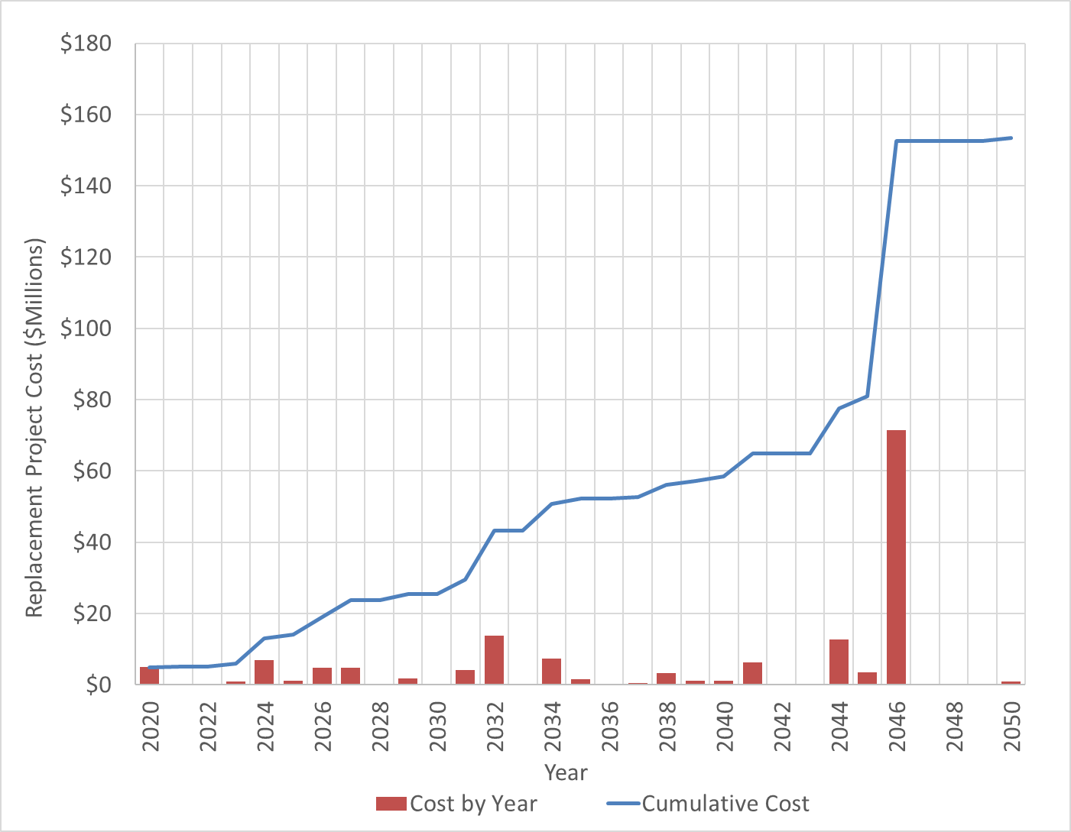
Source: Asset Register V90
The Unit 3 Expansion and Completion project would replace Unit 1, Unit 2 North, Unit 2 South, and the NRC with an activated sludge process with secondary clarification. This project would utilize the existing headworks, Unit 3 primary treatment, and solids handling facilities. Further, it is assumed that aeration is provided by the existing Roots blowers and/or new turbo blowers, which will be installed as part of a current project as described in Section 11.1.2. The project would require expansion of Unit 3 primary treatment and the R&R projects associated with Unit 3.
Figure 10-3 shows a conceptual layout for the proposed Unit 3 Expansion and Completion project in the northeast corner of the site adjacent to the existing Unit 3 primary clarifiers, south of Orange Show Road and West of East Twin Creek.

Figure 10-3: Unit 3 Expansion and Completion Project
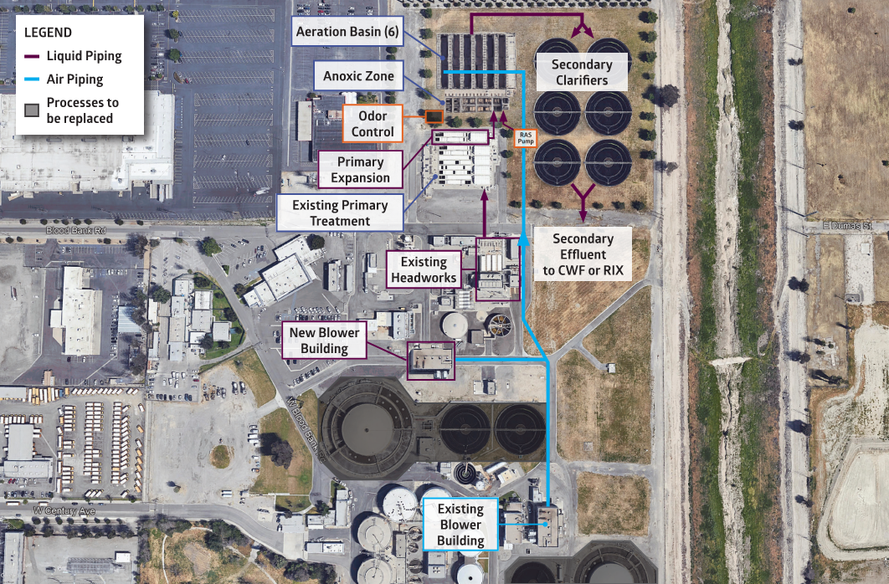
To meet the RIX effluent TIN limit of 10 mg/L for discharge to the Santa Ana River, the aeration tanks are assumed to be configured for the Modified Ludzac-Ettinger (MLE) process, including pre-anoxic zones and internal mixed-liquor return. This is similar to the flow arrangement currently in use at Unit 1 and recommended for Unit 2. The secondary system could be sized to accept the ammonia load from the centrate so that the NRC process could be taken off-line. This approach would be evaluated against sidestream deammonification to determine the best path forward. Assumptions for the conceptual cost estimate are as follows:
- Average daily flow of 20 mgd.
- Maximum month design load of 49,300 pounds BOD per day.
- Maximum month design load of 9,700 pounds TKN per day.

- Expansion of existing Unit 3 primary clarifiers by 50% to provide capacity for 54 mgd peak flow.
- Aeration basins. Covers with odor control facilities will be considered for all or part of the tanks due to the proximity to surrounding development.
- Addition 10% loading to account for centrate return to headworks.
- 30% BOD removal
- Six parallel reactor tanks, each with an anoxic zone, swing zone, aerobic zone, and mixed liquor return with mixers in the anoxic and swing zones.
- New aeration piping from an above-ground pipe from blower project currently being designed (no additional blower cost included).
- Six 100-foot diameter secondary clarifiers sized for peak flow of 54 mgd with an SVI of 150 mL/g and MLSS of 3,000 mg/L.
- Underground RAS/WAS pumping gallery with above-ground electrical/control building.
The engineer’s estimate of probable cost for the Unit 3 Expansion and Completion is based on the stated assumptions and is on the order of $100 million, within a range of $80 million to $140 million based on -20% to +40% range for Class 4 estimates. This estimate is inclusive of planning, design, and construction with a 30% project contingency applied.

Table 10-10: Unit 3 Expansion and Completion Cost Estimate (Class 4)
Project Component |  | Estimated Cost
Project Subtotal |  | $ 78,000,000
Project Contingency (+30%) |  | $ 23,500,000
Total Project Cost (2019$ rounded) ¹ |  | $ 101,500,000
Notes:
- Sequencing of the Unit 3 Expansion and Completion Project is detailed in Section 11.3.
As shown in Figure 10-4, in 2032 an expenditure over $15 million has been identified for R&R associated with the existing liquid treatment facilities. Ideally, the new unified treatment process would be installed prior to 2032 to avoid this expenditure. Timing the Unit 3 Expansion and Completion Project must consider the time needed for financing, facility planning, design, and construction. The flow reduction by EVWD is scheduled for late 2021. A facility planning level analysis of the Unit 3 Expansions and Completion can logically begin after the EVWD flow reduction occurs and resultant reduction in loads can be verified. Once more detailed planning and initial studies are complete, preliminary design can reasonably begin with sufficient time to allow construction to be complete by 2031.
Avoided R&R

Figure 10-4: Unit 3 Expansion and Completion Project Timing and Avoided R&R
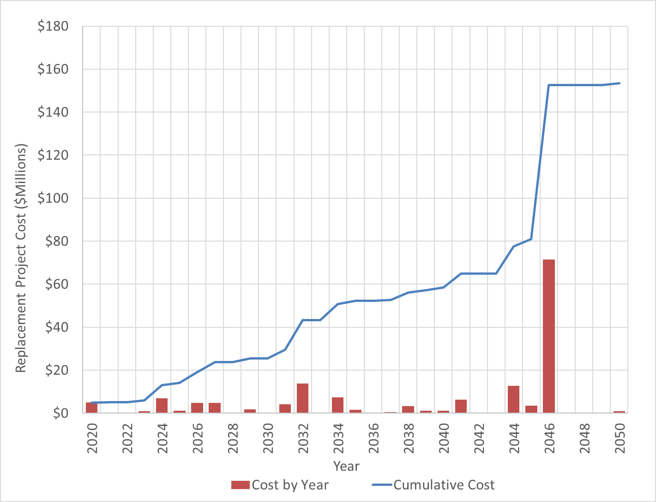
Source: Asset Register V90
Table 10-11 presents a summary of avoided R&R costs by area that could result from the construction of the Unit 3 Expansion and Completion if completed by 2031.

Table 10-11: Avoided R&R Costs with Unit 3 Expansion and Completion (2031 – 2046)
Project |  | Estimated Cost
Unit 1 |  | $ 36,000,000
Unit 2 |  | $ 45,000,000
NRC |  | $ 23,000,000
Shared Facilities |  | $ 23,000,000
Total R&R Avoided |  | $ 127,000,000
Over two-thirds of the avoided R&R costs listed above can be attributed to structural assets that reach the end of their useful lives between 2031 and 2046. The year 2046 in particular has a number of structures reaching the end of their remaining useful lives of 60-75 years, explaining the peak shown in Figure 10-4. Significant structures included in the R&R costs in Table 10-11 include:
- Mixed Liquor Splitter Box Structure
- NRC Anoxic Basin Fiber Glass Mounting
- NRC Building Structure
- NRC Secondary Clarifier Structure and Rake Arm Assembly
- Root Blower Building Structure
- RS-1 Pump Station Vault Structure
- Unit 1 Aeration Bay Structure (1 total) and Walkway Structures
- Unit 1 East Secondary Clarifier Structure and Rake Arm Assembly
- Unit 1 West Secondary Clarifier Structure and Rake Arm Assembly
- Unit 1 Pump Station Building
- Unit 2 Chlorine Contact Basin Structure
- Unit 2 North Aeration Basins Structure (6 total) and Walkway Structures
- Unit 2 North Primary Clarifier Structure
- Unit 2 North Secondary Clarifier Rake Arm Assembly
- Unit 2 South Aeration Basins Structure (4 total) and Walkway Structures
- Unit 2 South Primary Clarifier Structure
- Unit 2 South Secondary Clarifier Tank and Rake Arm Assembly
An additional 20% of the R&R listed in Table 10-11 is attributed to rehab and replacement of mechanical assets. This includes assets such as valves and gates, aerators, diffusers, mixers, screw pumps, RAS and WAS pumps, scum pumps, pump motors, and Roots Building Blowers 4 and 5. The remainder of the costs are associated with piping, electrical and I&C R&R costs.

Solids Handling

Digester B Replacement
Digester B is a concrete tank with an insulated metal lid that was originally built in 1958. It is 90-feet in diameter with a 33.5-foot sidewall and a 10-foot deep cone section.
Three digesters (Digester A, C and D) are fed continuously for the current solids loading to produce Class B biosolids. The biosolids composting contract requires Class B biosolids or better (Section 7.2). As discussed in Section 8.7, taking an existing digester offline for service or cleaning would result in shortened retention time below the requirement for Class B. There is also particular risk associated with Digester A, which is the same age as Digester B and has a heightened likelihood of failure. Restoring Digester B to operation would improve redundancy and reliability of the digestion process.
The budget estimate for replacing Digester B is $8 million based on the summation of relevant assets in the Asset Register. Costs for replacing the structure and cover were derived from Digester B assets listed in the Asset Register. Costs for ancillary equipment were derived from Digester A assets. In February 2020, the Department was provided a final “Digester B Evaluation Study” from Carollo Engineers. The Department is moving forward with an immediate project to replace Digester B due to its high criticality.

Digester Cleaning
Digesters C and D are concrete tanks with concrete lids that were built in the late 1980s. Digesters C and D have a 90-foot diameter and 36.5-foot sidewall with a 10-foot deep cone section. Digesters C and D have approximately 1.8 MG of liquid storage and 35,000 SCF of DG storage in each digester.
Anaerobic digestion occurs in a highly corrosive environment. Regular maintenance including digester cover coating is required to maximize service life and is recommended to be performed every 10 years. Digester cleaning has been identified as an area of concern as there is no record of digester cleaning since the late 1980s. The digester cleaning project is anticipated to include the following:
- Drain, remove debris, and clean tank interiors.
- Replace lid seals.
- Evaluate and address pipe penetrations and replace modular wall seals/sleeves on interior and exterior.
- Minor metal repair.
- Concrete repair.
It is anticipated that cleaning of Digesters C and D would occur sequentially after a new Digester B had been returned to service and EVWD has removed its flows and loads from the system. The budget cost estimate for cleaning Digesters C and D is approximately $3.2 million.

Digester Mixing Optimization
Replacing the existing mixing system could enhance reliability, improve dewatering performance, reduce trash and hair accumulation in the digester tanks, and optimize digester gas production. The digester mixing optimization project is anticipated to include the following:
- Evaluate mixing technology alternatives and replace existing mixing system with an alternative system.
- Develop a recommended approach to rehab the mixing systems including intermittent mixing.
If the evaluation determines that capital upgrades are recommended, they would be constructed while each digester is off-line for cleaning. The budget cost estimate for mixer replacement is approximately $1.2 million per digester and would have a payback period of over 60 years. This project is not recommended due to the long payback period. The existing mixers were all replaced or rehabilitated in the past four years and have a RUL of 15 years. Revisiting digester mixing should be done when the existing mixing pumps approach the end of their RUL.

Brine Line Improvements
A pipe connecting the SBWRP septage/brine receiving station to the Inland Empire Brine Line (IEBL) runs through the WRP site. This pipe has clogged and is difficult and costly to clean because the existing clean outs are inadequate. This project installs seven 60-inch diameter manholes in several locations along the existing pipe to allow for proper cleaning of the line.
The budget cost estimate for installing seven manholes in the pipeline within the SBWRP that connects to the IEBL is $200,000.

Influent Lift Stations

Downsizing of the East Influent Lift Station
With the departure of EVWD flows from the SBWRP influent once the SNRC is completed, the East Influent Lift Station (EILS) will receive significantly less flow than it currently does. The EILS currently receives flows from the eastern portion of the City of San Bernardino and all the EVWD flow. The total ADWF at EILS is approximately 12 mgd currently. With EWVD providing approximately 6 mgd influent flow, the lift station flow will be reduced by about half. This option explores the potential cost savings from downsizing the capacity of the EILS due to the reduced flow.

The EILS station is currently comprised of three 66-inch diameter screw pumps, two in operation and one standby. Each screw pump has a capacity of 18 mgd with a 60hp motor. The downsized lift station would consist of the same pump configuration with new 66-inch diameter single flight open screw pumps but would be equipped with a smaller horsepower motor, reduced from 60hp to 30hp. No changes to the existing trough would need to occur to accommodate the new screw pumps other than some slight changes to the lower bearing mount. Table 10-12 below presents a summary of the assumptions made for a simple payback calculation.

Table 10-12: Summary of EILS Downsizing Assumptions
Criteria | Units | Design Scenarios
Criteria | Units | Current | Downsized
Average Influent Flow | mgd | 12 | 6
Configuration | - | 2+1 Standby | 2+1 Standby
Capacity of pump (each) | mgd | 18 | 10.5
Average number of units in operation | - | 1 | 1
Daily Operation | hr | 24 | 24
Rated power, each | hp | 60 | 30
Average power draw, percent of rated | % | 80% | 80%
Average power draw | kW | 36 | 18
Annual electricity cost | $/year | 40,000 | 20,000

One pump in operation would be adequate with the reduced capacity of 10.5 mgd during dry weather but would require that two pumps be in operation to meet peak flows estimated at 21 mgd for the EILS. For simplicity, it is assumed that one pump is in operation on average in both scenarios. Table 10-13 below presents the result of a simple payback analysis based on the assumed conditions described above.

Table 10-13: EILS Downsizing Simple Payback Results
Simple Payback | Result
Electrical savings, assumed | 50%
Capital Costs
Pumps (each) | $92,000
Pumps (total) | $276,000
Mounting and Installation | $200,000
Design and soft costs | $124,000
Total Capital cost | $600,000
Simple Payback | 30 years

The 50% electrical savings provided is a based on the annual cost difference presented in Table 10-12. This estimated savings is considered conservative, as there would likely be less electrical savings when considering details such as pump efficiencies, amount of flow being conveyed, and times of operation. Given the assumptions above, it is not recommended that SBMWD pursue the downsizing of the EILS due to the long payback period. Additional analysis could be done to provide a refined payback estimate, however additional savings are not likely to reduce the payback period significantly.

Special Studies
This section describes four special studies that have been identified to respond to results of the asset inventory, enhance safety, optimize plant performance, and plan for future changes in the regulatory landscape and electrical codes. Cost placeholders have been included for potential resultant projects from the Electrical and SCADA Master Plans since these projects are anticipated to be required in the near-term (5-year) period. Costs for resultant projects from the Biosolids Strategic Plan and RIX Facilities Plan are not included since the analysis results and timing of resultant projects are unknown at this time.

Electrical Master Plan
Most of the electrical distribution panels at the plant have exceeded their useful life of 30 years, which is a typical industry standard for replacing most electrical equipment. These panels include the BLM Switchgear (5kV), Hoffman Switchgear (480V) and majority of the motor control centers (MCC) located throughout the plant. Some of the electrical panels date back to 1971 (Burner Building), other such panels were installed in the early to late 1980s. Furthermore, modifications to these panels over the years has created a lack of vendor continuity and spare parts.
The condition assessment revealed that 12% of all inspected electrical assets in use have zero remaining useful life (RUL), 20% of electrical assets have RUL of less than 5 years, and 72% less than 10 years. Many changes over the life of the plant have resulted in electrical cables, circuit breakers, and MCC buckets being abandoned in place and simply tagged as out of service. Many of the MCCs are underutilized with only a handful of actively used buckets.
Currently, the plant is undergoing CIP projects that require additional power capacity and interim solutions to handle additional load requirements (kW) and distribution. Projects such as the Blower Rehabilitation Project, Fuel Cell Project and Clean Water Factory are impacting the existing electrical distribution system. The SBMWD is presently working with Southern California Edison (SCE) to combine the two of the six services at the plant to one metered service at the existing BLM Switchgear as part of the Electrical Infrastructure Improvement Project. This work is expected to be done in 2021. Based on current load information and proposed additional loads, the existing (12kV/4160V) SCE transformer will be 109% of rated capacity when the fuel cell is not operational.
An Electrical Master Plan is recommended to provide a holistic approach to upgrading the plant’s existing electrical distribution system to improve reliability, redundancy and create equipment standards with features to enhance electrical work safety practices as defined by NFPA 70E. The Electrical Master Plan should be completed by a professional electrical engineer with municipal experience and familiarity of the NEC and CEC codes. The Electrical Master Plan should include the following tasks:
- Condition assessment of electrical distribution equipment, including evaluation and identification of current electrical code violations and recommendations for correction.
- Review of as-built documentation.
- Develop as-built single line diagram (to help confirm what is existing).
- Load calculations and capacity requirements, including future work.
- Investigate existing MCC’s and approach to consolidation. Consolidation methods should consider the RUL of the MCCs and compare to complete replacement. Replacement of the MCCs should be coordinated with process improvement projects.
- Alternative configurations including cost analysis.
- Review of arc resistant enclosure types including arc flash reduction controls such as protection relays and maintenance switches.
- Sequence of work and implementation, grouping electrical work with process improvement projects.
- Coordinate with the SCADA Master Plan.
- Report with recommendations.
- Workshops with SBMWD to review the results of the Electrical Master Plan.
The budget cost estimate for the Electrical Master Plan is approximately $130,000.
It is expected that the projects listed in Table 10-14 would be identified during the master planning process as required projects in the near-term 5-year timeframe.

Table 10-14: Potential Electrical CIP Projects
Potential Projects | Estimated Project Cost
BLM Switchgear (5kV) Replacement | $ 2,000,000
Hoffman Building Main Switchgear (480V) Replacement | $ 1,150,000
MCC Consolidation | $ 3,400,000
Burner Building - New Power Distribution | $ 250,000
Plant-wide Arc Flash Hazards Analysis and Labeling | $ 120,000
Construction Subtotal | $ 6,920,000
Design (12%) | $ 830,400
Construction Management (15%) | $ 1,038,000
Project Subtotal | $ 8,788,400
Project Contingency (30%) | $ 2,636,520
Total Estimated Cost (rounded) | $ 11,400,000

SCADA Master Plan
The existing control system at the SBWRP consists of a mix of PLCs from manufacturers including Modicon (Schneider) and Allen Bradley. The following models are in use:
- Quantum 113 02
- Compact A984-145
- Compact E984-275
- 800 Series E685
- CompactLogix
The SCADA headend is built on Wonderware InTouch. Approximately fifty graphic screens, alarm screens, and pop-up windows have been developed on the system over the course of several years. The implementation is relatively consistent and incorporates isometric representation of the plant equipment. Color is used to indicate the status of the equipment; red indicates a run, open, or energized state, while green represents a stopped, closed, or deenergized state. Utilizing colors to indicate status without the additional aid of text may be difficult for a colorblind person to recognize the change in state. The features and characteristics found on high-performance graphics have not been implemented. While color is used to alert operators to deteriorating conditions, it is typically only a single color meant only to change the contrast and draw the operator’s attention rather than indicate a specific status.
Like the electrical system, Instrumentation and Controls (I&C) assets were assessed for remaining useful life (RUL) and criticality to operations. The assessment revealed that 10% of I&C assets inspected have no remaining useful life and more than 60% have a RUL of 10 years or less; however, RUL does not consider supportability or maintainability. Many manufacturers drop product support after 10 years and replacement parts become scarce in the years that follow.
A SCADA Master Plan is recommended to provide a framework to achieve a secure, flexible, reliable, and comprehensive SCADA environment. The SCADA Master Plan should evaluate all instrumentation 10 years old and older in order to develop a replacement plan. In addition to the replacement plan, standards should also be developed that identify minimum specifications and preferred manufacturers for each type of process measurement taking into consideration the properties of the process fluid, solid, or gas being measured. The Master Plan shall include specific recommendations with budgetary cost estimates and schedule for the next five to ten years generated from a gap analysis.
The following major tasks should be included in a SCADA Master Plan:
- Existing Documentation Review
- Site Investigation and Staff Interviews
- Current-state Technical Memorandum
- Strategic Visioning Session Workshop
- SCADA Requirements Workshop and Technical Memorandum
- Draft Master Plan Report – Future Projects Scope and Budget
- Final Master Plan Report and Presentation
The budget cost estimate for the SCADA Master Plan for the SBWRP is approximately $260,000. Additional facilities such as RIX and the collection system should also be evaluated and included in the SCADA Master Plan. Ideally, a citywide SCADA Master Plan would be undertaken, which would also include the Water Utility Division. However, the RIX, collection system, and water utilities were not part of this evaluation and have not been included in the cost estimate.
SCADA systems of this vintage require common projects to upgrade, replace, and otherwise enhance the system’s operational effectiveness. It is expected that the projects listed in Table 10-15 would be identified during the master planning process as required projects. The list of projects and estimated cost is intended to provide guidance for CIP planning.

Table 10-15: Potential SCADA CIP Projects at SBWRP
Potential Projects | Estimated Project Cost
Control System Standards | $ 228,000
SCADA HMI Evaluation | $ 91,000
Standard HMI and PLC Templates | $ 248,000
SCADA Software Development Lab | $ 286,000
HMI Upgrade Project | $ 514,000
Control System Upgrade Project | $ 2,820,000
SCADA Cybersecurity Vulnerability Assessment | $ 174,000
Developing Process Control Narratives (PCN’s) | $ 568,000
Instrument Specifications and Calibration Procedures | $ 205,000
SCADA Historian and Reporting | $ 242,000
Remote Data Collection | $ 150,000
Instrumentation Study | $ 224,000
Operational Efficiency Evaluation (KPI's) | $ 131,000
Project Subtotal | $ 4,523,000
Project Contingency (30%) | $ 1,357,000
Total Estimated Cost (rounded) | $ 5,900,000

While the Evaluation and Upgrade projects in the above table are specific to the SBWRP, additional benefit could be gained if the projects were applied throughout the DepartmentDepartment-wide:
- Control System Standards
- Standard HMI and PLC Templates
- SCADA Software Development Lab
- Instrument Specifications and Calibration Procedures
- Remote Data Collection
- The results and policy recommendations from the SCADA Cybersecurity Vulnerability Assessment could be applied across the Department.
- The template produced as part of the Developing Process Control Narratives could also be applied across the Department.

Biosolids Strategic Plan
Regulations have been enacted at the State level directed towards management of organic waste that can impact options for biosolids management in California. SB 1383 requires a reduction of landfill disposal of organics of 50-percent from the 2014 levels by 2020, and a reduction of 75-percent statewide disposal from the 2014 levels by 2025. The Southern California Association of Publicly Owned Treatment Works (SCAP) 2016 Biannual Biosolids Trends Survey Report concluded that 16% of biosolids generated in California are disposed of in landfills. The diversion of biosolids and other organics from landfills to the compost market may greatly strain the demand for compost in the already limited compost end-use market. This could impact both the cost and availability of outlets for biosolids.
The goal of the Biosolids Strategic Plan is to develop a long term, reliable, cost effective and diversified approach for the management of SBMWD’s biosolids that is compliant with State, local, Federal and environmental regulations. A Biosolids Strategic Plan would identify multiple options for biosolids management and provide information needed to make informed decisions regarding potential improvements to the SBWRP.
The scope of work for a Biosolids Strategic Plan should include the following:
- Review the existing SBMWD biosolids management program. Review previous relevant studies. Meet with SBMWD staff to discuss its biosolids management views in order to refine the analysis to a reasonable number of alternatives.
- Provide a brief assessment of the current regulatory, political and public environment associated with biosolids reuse and disposal options in California. Survey other agencies and provide a brief status report on current activities, available options and future planning to resolve any identified biosolids issues. Obtain Biosolids information from neighboring agencies to assess the benefits of a regional biosolids management strategy.
- Identify potential alternative disposal strategies and marketplace opportunities for disposal of Class B biosolids for SBMWD. The goal of this element of the scope is to provide SBMWD with greater diversity and eliminate any risk associated with the long-range viability of their existing Class B disposal contract. Develop criteria for initial screening of identified alternatives. Criteria should include items such as reliability, maturity of the identified alternative, facility requirements (if any), potential impacts to operations (if any), capital cost (if any) and related O&M cost. Perform the analysis for both a regional and stand-alone approach.
- Identify potential alternative and emerging treatment technologies that could produce a Class A biosolids product to create more disposal options for SBMWD. These technologies should include but not be limited to improved digestion (thermophilic, TPAD, etc.), thermal hydrolysis (Cambi, Lystek, etc.), heat drying, pyrolysis, and alkaline stabilization. Develop criteria for initial screening of identified alternatives. Criteria should include items such as reliability, maturity of the technology, siting constraints, compatibility with existing process, marketability of final end-product, capital cost and O&M cost. Provide additional analysis of the alternatives that are preferred following the initial screening process. Perform the analysis for both a regional and stand-alone approach.
- Develop a Biosolids Strategic Plan with primary focus on long term reliability, diversification and cost. Assess the feasibility of using land currently owned by the Department for future biosolids facilities. Develop a short list of feasible alternatives for both Class B and Class A disposal/beneficial use. Develop concept level design and implementation plan that will identify regulatory, institutional, technical, schedule and monetary requirements for implementing top Class A and Class B alternatives in the Strategic Plan. Include any pilot testing and/or full-scale demonstration studies required.
The budget cost estimate for the Biosolids Strategic Plan is approximately $390,000.

RIX Facility Plan
RIX was constructed in the mid-1990s to filter and disinfect 40 mgd of secondary effluent from SBWRP and the City of Colton using percolation basins to meet discharge requirements to the Santa Ana River. Tertiary filter equipment was added to bridge the gap in treatment capacity when infiltration rate in the percolation basin was less than anticipated. With flows currently at 26.5 mgd, the tertiary filtration equipment that was added on is used only during periods of high flow. With flow rates expected to be further reduced due to recycling projects (and within the confines of multiple agreements, commitments, and obligations), the RIX facility is due for an evaluation of its treatment processes and facilities at the anticipated future flowrates.
The RIX Facilities Plan should include the following tasks:
- Evaluate existing treatment technology to meet both flow capacity and quality objections for the projected discharge requirements to the Santa Ana River.
- Flow considerations include the environmental flows determined in the HCP and other discharge obligations, and the potential for the City of Colton to recycle a portion of its secondary effluent contribution to RIX.
- Water quality considerations should include potential changes to TDS and TIN discharge limitations resulting from the SAWPA study to be finalized and impacts of emerging contaminants such as PFAS/PFOA.
- Evaluation of Electrical Infrastructure
The budget cost estimate for the RIX Facility Plan is approximately $130,000.

Project Ranking and Recommendations
This section presents scoring and ranking of capital projects based on how beneficial they would be to the SBMWD. High scoring projects are most beneficial, while lower scoring projects offer limited benefits. This ranking approach is the same as the one used for the near-term R&R projects. Based on the ranking and additional considerations, primarily capital cost and return on investment, certain projects are recommended to be carried forward into the Capital Improvement Plan presented in Section 11.
The scoring system relies on four evaluation categories, same as described in Section 9.1:
- Reducing consequence of failure,
- Improving energy efficiency,
- Renewing or replacing aging assets and
- Reducing operational cost and/or simplifying operations.
Each evaluation category was assigned a weight of 1 to 3, with three being the most significant and one being the least. Weights are shown in Table 10-16. Each project was given a score of 0 to 3 in each evaluation category based on its relevance to the project. A score of three indicates that the category is highly relevant to a project; zero indicates no relevance. A total score was then calculated for each project by multiplying the score for each category by its weight, then summing the weighted scores. Table 10-16 presents scores for each project. The projects have been sorted based on their total score in descending order. Note that the SCADA and Electrical plans are included in the scoring table below because these will result in capital projects which are well defined enough to assign scores. The RIX and Biosolids Plans will be higher level and the scope of any resulting capital projects is undefined at this point. These two plans were not included in the table but are discussed later in this section.

Table 10-16: Operational Efficiency and Optimization Project Scoring and Ranking
Project | Total Score | Evaluation Category
Project | Total Score | COF | Energy | Life | Ops
Project | Total Score | Category Weight
Project | Total Score | 3 | 1 | 2 | 1
Project | Total Score | Category Score
Recommended Projects
Unit 3 Expansion and Completion | 18 | 3 | 1 | 3 | 2
Electrical Master Plan | 16 | 3 | 0 | 3 | 1
SCADA Plan & Upgrades | 15 | 2 | 1 | 3 | 2
Digester B Replacement | 14 | 2 | 1 | 3 | 1
Digester Cleaning | 14 | 3 | 1 | 2 | 0
Liquid Process Optimization | 8 | 2 | 1 | 0 | 1
CEPT | 8 | 1 | 3 | 0 | 2
Brine Line MH | 6 | 0 | 0 | 2 | 2
Not-Recommended Projects
NRC Diffused Air | 5 | 0 | 2 | 1 | 1
Secondary Capacity Reduction | 5 | -1 | 2 | 2 | 2
Primary Flow EQ | 4 | 1 | 0 | 0 | 1
Digester Mixing Optimization | 3 | 0 | 1 | 1 | 0
The highest scoring project is the Unit 3 Expansion and Completion. SCADA and electrical plans and digester improvements were also high scoring. These projects all score high because they upgrade aging processes and assets with significant consequences of failure. They also offer energy savings and/or operational benefits. These projects are all recommended.
The first three of the lower scoring projects are also recommended. CEPT is recommended because its low cost and reasonable payback (6 years) make it worth pursuing. Liquid process optimization is recommended because it is a low-cost way to improve reliability of the existing secondary process. Adding brine-line manholes is considered a priory project from a maintenance perspective.
The remaining low-scoring projects are not recommended. While NRC Diffused Air offers some benefit, the high capital cost and long payback (18 years) do not justify the project. Secondary Capacity Reduction would offer considerable operations savings, as discussed above, but it reduces secondary capacity too much. For this reason, it is assigned a negative score in the COF category. It would also be superseded by the Unit 3 Expansion and Completion. Primary Flow Equalization and Digester Mixing Optimization have limited benefits and high capital costs.
The most significant recommended project is the expansion and completion of Unit 3. As discussed in Section 10.2.4, $127 million in R&R costs on Unit 1, Unit 2N, Unit 2S, and NRC would be avoided by building Unit 3. In addition, approximately $10 million in optimization project costs would also be avoided. Since the Unit 3 expansion would be sized to treat flows projected through 2040, including wet weather flow, there would not be a need to implement primary flow equalization or reduce the capacity of Unit 2. The estimated savings from avoided capital improvement project is approximately $35 million as shown in Table 10-17.

Table 10-17: Avoided Costs with Unit 3 Expansion and Completion
Project |  | Estimated Savings
R&R Projects Avoided
R&R Avoided on Unit 1, Unit 2N, Unit 2S, and NRC |  | $ 127,000,000
Capital Improvement Projects Avoided
Primary Flow Equalization |  | $ 9,000,000
Secondary Capacity Reduction |  | $ 500,000
Total Cost Savings |  | $ 136,500,000
Capital Improvement Projects Implemented
Unit 3 Expansion and Completion |  | Cost of $ 101,500,000
Net Cost Savings |  | $ 35,000,000
In addition to being competitive on a capital cost-basis with maintaining the existing treatment units, expanding Unit 3 would provide significant operational and maintenance advantages including:
- Operators would only need to manage one biological system, rather than the current four
- Flow split and hydraulic issues with existing plant would be corrected
- The new plant would be designed to reliably meet effluent TIN requirements
- The physical size and complexity of the plant would be reduced.
Other recommended projects relate to maximizing performance of the liquid system in the near term and maintaining long-term reliability of the solids handling system. SCADA and electrical studies are also recommended to develop strategies for upgrading and modernizing these aging systems. Evaluating current treatment facilities at RIX and developing biosolids reuse/disposal options are also recommended. Table 10-18 summarizes all project alternatives considered and identifies the projects and studies recommended to address the needs of the SBWRP for the next 20 years.

Table 10-18: Recommended Capital Improvement Projects and Studies
Project Summary | Project Description | Project Cost | Recommended?
Primary Treatment Projects
Primary Flow Equalization | Construct a primary equalization basin to capture wet-weather peak flows and reduce impacts on downstream processes. | $9,320,000 | No
Chemically Enhanced Primary Treatment | Equipment to add chemical coagulants downstream of ferric chloride addition and upstream of primary clarifiers. | $390,000 | Yes
Secondary Treatment Projects
Liquid Process Optimization | Study and pilot testing of alternate operating modes to reduce SVI and improve process performance. Addition of MLR pumps to Unit 2. | $1,520,000 | Yes
Secondary Capacity Reduction | Modifications necessary to take one train of Unit 2 offline. | $500,000 | No
NRC Conversion to Diffused Air | Replacing the mechanical aerators with fine bubble diffuser system including blower and automatic dissolved oxygen control. | $1,800,000 | No
Unit 3 Expansion and Completion | Expansion of Unit 3 primary clarifiers and addition of reactor tanks configured for biological nitrogen removal, new secondary clarifiers, a RAS gallery and electrical and control building, and associated work. This new facility would allow for decommissioning Unit 1, Unit 2 North, Unit 2 South, and NRC. | $101,500,000 | Yes
Solids Handling Projects
Digester B Replacement | Replace Digester B to provide digester redundancy. Digester B is currently offline due to leakage. | $8,000,000 | Yes
Digester Cleaning | Clean out and repair Digesters C & D. Digesters C & D are concrete tanks w/concrete lids built in late 1980s. | $3,200,000 | Yes
Digester Mixing Optimization | Replace existing digester pump mixers with high efficiency linear motion mixers; Cost is per digester. | $1,200,000 | No
Brine Line Improvements
Brine Line Improvements | Install seven manholes in the pipe connecting the septage/brine receiving station to the IEBL to allow for proper cleaning of the line. Existing cleanouts are inadequate, and cleaning is difficult and costly. | $200,000 | Yes
Influent Lift Stations
Downsizing of East Influent Lift Station | Replace the existing screw pumps with ones requiring lower energy demand to account for the reduced influent flow without EVWD flow. | $600,000 | No
Studies and Resultant Projects
Electrical Master Plan | Study to upgrade electrical distribution system to improve safety, reliability, redundancy, and create equipment standards as defined by NFPA 70E through: Condition assessment; As-built single line diagrams; Load calculations and capacity requirements; Consolidation approach for existing MCCs; Sequence of work and implementation; Arc flash hazard mitigation; Alternative configuration design. | $130,000 | Yes
Electrical Master Plan Resultant Projects | Resulting projects from the Electrical Master Plan potentially including: Switchgear replacement; MCC consolidation; New power distribution; Plant-wide hazard analysis and labeling. | $11,400,000 | Yes
SCADA Master Plan | Study to provide a framework to achieve a secure, flexible, reliable, and comprehensive SCADA environment. The SCADA Master Plan shall include specific recommendations with budgetary cost estimates and schedule for the next 5 to 10 years generated from a gap analysis. | $260,000 | Yes
SCADA Master Plan Resultant Projects | Resulting projects from the SCADA Master Plan potentially including: Control system standards and upgrades; Software Development; HMI upgrades; Process control narrative development; SCADA cybersecurity. | $5,900,000 | Yes
Biosolids Strategic Plan | Study to identify a long-term approach for biosolids management compliant with State, local, Federal and environmental regulations. SB 1383 requires 50% reduction of landfill disposal of organics by 2020 and 75% reduction by 2025. Cost increase for current biosolids end use option may occur. No backup biosolids contract in place. | $390,000 | Yes
RIX Facilities Plan | Study to evaluate the efficacy of existing treatment process facilities (percolation basins, filtration equipment, disinfection method) at projected lower flowrates considering planned water recycling projects and HCP flow obligations to the Santa Ana River. | $130,000 | Yes
Total Recommended Project Cost |  |  | $133,020,000

Capital Improvement Plan
This section presents the recommended Capital Improvement Plan (CIP) based on the discussion, analysis and recommendations presented in Sections 9 and 10. The plan schedules the recommended projects over the planning period based on priority, funding, sequencing considerations (such as maintaining a minimum number of processes on-line) and external events (such as the reduction of influent flow). The following section provides a summary of the ongoing projects funded under previous CIPs.

Ongoing Projects
The following projects are currently in design or under construction. Descriptions are from the Sewer Treatment Capital Improvement Budget Summary for Fiscal Year 2019-2020 (San Bernardino Municipal Water Department, 2019). Ongoing projects are not listed in the CIP implementation Plan presented in Section 11.4 through 11.7 since they are accounted for in SBMWD’s current CIP.

Digester Gas Beneficial Use Program / Fuel Cell Project
SBWRP beneficially uses digester gas which is produced as a byproduct of the wastewater treatment process. Most of the digester gas is currently used to fuel internal combustion engines (ICEs) to drive process equipment including blowers, pumps, and the generator that is part of the Cogen system. A portion of the digester gas is also used in boilers to heat the anaerobic digesters. The remaining digester gas is flared.
Emission limits for digester gas-fueled ICEs are governed by Rule 1110.2 of the South Coast Air Quality Management District (SCAQMD). Rule 1110.2 was amended to reduce the overall emissions from digester-gas fueled engines. To meet the emission limits and continue using digester gas-fueled ICEs, extensive retrofitting of the existing engines would be required. To comply with Rule 1110.2, SBMWD conducted a Digester Gas Beneficial Use Study (Carollo, 2018), which recommended conversion from digester gas-fueled ICEs to a fuel cell system.
SBMWD executed a power purchase agreement with FuelCell Energy (FCE) on April 29, 2019. FCE will convert digester gas produced by the SBWRP to electricity and heat through a gas pretreatment and fuel cell system. All digester gas produced at the SBWRP will be made available, free of charge, to FCE, and the electricity will be sold to the SBMWD at a rate lower than that which could be purchased from the electric utility provider (SCE). In 2021 to 2022, 2.2 MW (2,200 kW) of power is projected to be needed at the SBWRP. The vendor will provide a fuel cell system below 2.2 MW so that the SBWRP will not be a net generator of electricity.

Blower Electrification Project
The secondary treatment processes at Units 1 and 2 have an aeration system consisting of two digester gas-fueled ICE blowers and two electric-driven blowers. As part of the fuel cell conversion project, two blowers that are driven by digester gas-fueled ICEs will be replaced by more efficient electric turbo-style blowers. The blowers will be decentralized and dedicated to aeration basins Units 1 and 2.
Five high-speed electric turbo blowers will be installed in the new Unit 1 blower building to supply air to Unit 1 in a dedicated pressure zone. Air for Unit 2 will be supplied from the existing two electric rotary blowers. Control upgrades to Unit 1 will include automated dissolved oxygen (DO) control and ammonium-based aeration control (ABAC). The blower electrification project will also include installation of a generator to supply limited power to Unit 1 during an outage.

Duty Flare and Backup Flare Replacement
To meet SCAQMD Rule 1118.1 emission requirements for flares, a new 0.025 lbs/MMBtu ULE flare (0.025 Duty Flare) will be constructed and used as a duty flare. The existing duty flare will be replaced with a Low-Emissions (LE) 0.06 lbs NOx/MMBtu flare and used as a standby flare (0.06 Backup Flare). The ULE flare is designed to handle current and anticipated future gas flow conditions in coordination with the DG storage project as part of the larger Digester Gas Beneficial Use Program.

Arrowhead Lift Station Electrical Supply and Pump Conversion Project
As a direct result of the SCAQMD’s revision to Rule 1110.2, the two existing ICEs fueled by digester gas to drive the pumps at the Arrowhead Lift Station will be converted to alternative power supplies. One ICE will be converted to electricity and the other will be converted to propane.

Digester Gas Holder Project
This project will design and construct a new low-pressure digester gas (DG) holder to equalize the flow of DG to the Fuel Cell Project. The new DG storage system aims to minimize the wasting of gas to the flare system. Coordination between the DG storage and ULE flare project (i.e. flow, operating pressure, etc.) is essential to ensure efficient and effective operation.

Primary Metering Project
This project will expand the BLM to accommodate switches to power the Hoffman switchgear, Unit 1 Blower Building, Clean Water Factory, and to receive power from the Fuel Cell.

Clean Water Factory Tertiary Treatment System Design
As described in Section 5.1.3, the SBMWD is planning a recycled water project called the Clean Water Factory, which will be a Title-22 compliant tertiary treatment system that will supply recycled water for:
- Operational needs within the plant, eliminating in-plant use of groundwater from wells.
- Groundwater recharge of the Bunker Hill Groundwater Basin, which is SBMWD’s sole source of water supply.
- Recycled water customers.
The Clean Water Factory is sited east of the Unit 1 secondary clarifiers, adjacent to East Twin Creek. The design includes a new pump station and pipelines to convey secondary effluent to new filtration and disinfection processes. After treatment, the tertiary recycled water will be stored in a rehabilitated existing reservoir that currently stores groundwater. Production of tertiary disinfected recycled water from the Clean Water Factory will be phased with provisions to allow future expansion of up to 5 mgd (AECOM, 2019) using water in excess of the discharge commitments to the Santa Ana River. The Clean Water Factory is in the final design phase and is expected to be operational in 2021.

Receiving Station for Fats, Oils, Grease and Other Anaerobically Digestible Materials
Co-digestion of fats, oils and greases (FOG) and anaerobically digestible materials (ADM) can be beneficially reused to generate energy. SBMWD is evaluating installing a FOG receiving station to generate more DG to compensate for the loss of load from the SNRC. There may also be a potential economic benefit to the SBMWD from tipping fees charged to FOG haulers. ADM is defined as any waste material containing organic matter that is digestible and may include food waste, FOG, source separated organics and waste from industrial sources such as whey, glycerin, de-icing fluids, brewery waste, etc.
A preliminary review of FOG/ADM addition to the SBWRP indicated that it is feasible from a treatment standpoint (Hazen and Sawyer, 2019). Given the available digestion capacity at SBWRP, DG production could potentially increase approximately 25% to 30% over the current daily average, which could compensate for the loss of load from the SNRC.
Constructing a FOG/ADM receiving station supports the statewide goal to reduce short-lived climate pollutants. Short-lived climate pollutants, including methane, hydrofluorocarbons, and anthropogenic black carbon, have relatively short atmospheric lifetimes yet have a dramatic and detrimental effect on air quality, public health, and climate change. Senate Bill (SB) 1383, which was passed in September 2016 and will become enforceable in 2022, established reduction targets for short-lived climate pollutants and established reduction targets for the disposal of organic wastes in landfills and requires state agencies to increase the sustainable production and use of renewable gas (Section 7.3.3). The legislation could result in more organics being diverted to the SBWRP (i.e. food waste), incentivize methane production at the SBWRP, and potentially impact future biosolids disposal costs due to higher demand for composting over disposal in landfills.
Based on Hazen’s high-level FOG/ADM study, it was realized that food waste and other ADM within the specified area are not readily available for SBWRP since there are a number of facilities around the San Bernardino area that currently processes this feedstock in anaerobic digestion. Hazen identified one FOG hauler who is interested in options of disposal facility around San Bernardino at a competitive tipping fee. The market survey indicated that the availability of FOG in this area is higher than other sources and the availability of FOG ranges between 15,000 to 25,000 gpd. The existing three digesters currently have available capacity to accept FOG/ADM for codigestion. However, the SBWRP does not have firm capacity to accept FOG/ADM at the time of this study. When the EVWD flow of 6 mgd is diverted to the new facility (Around year 2022), the existing anaerobic digesters can accept higher amounts of FOG. Even with 2 digesters online (firm capacity), the SBWRP can accept over 25,000 gpd of FOG. If SBMWD implements a codigestion program after the departure of 6 MGD flow to EVWD, and accepts 25,000 gpd of FOG, digester gas production is estimated to increase over 35%. The estimated construction costs of a FOG receiving station is approximately $2.0 million and estimated annual O&M cost is $141,000. Hazen recommends conducting a more thorough analysis of the impact of FOG to the overall solids handling operation and digester gas handling and beneficial use and a more thorough market assessment to identify local or regional sources of FOG. This research may include negotiation with haulers and contract agreement.

Current Capital Improvement Projects
Capital improvement projects for sewer treatment in Fiscal Year (FY) 2018-2019 and FY 2019-2020 are listed in Table 11-1. These projects are in various stages of implementation between planning, design, and construction. All are fully-funded and are not included in the CIP for FY 2020-2021.

Table 11-1: Capital Improvements in FY 2018 – 2020 CIPs for Sewer Treatment
Item | CIP Budget FY 18-19 | CIP Budget  FY 19-20
WRP Facilities Assessment | $ 750,000 | $ 72,830
Conveyor No. 5 Modifications | $ 80,000 | $ 67,000
Unit 1 Secondary Effluent Modifications | -- | $ 250,000
E Street Lift Station Controls Upgrades | -- | $ 120,000
Annual R/R - Solids Handling System | -- | $ 60,000
Annual R/R – WRP Operational (Ferric chloride backup tank) | -- | $ 30,000
Annual R/R - WRP Structural | -- | $ 15,000
Annual R/R - WRP Mechanical | -- | $ 245,000
Annual R/R - WRP Electrical, Instrumentation and SCADA | -- | $ 45,000
Annual R/R - WRP Facilities | -- | $ 40,000
Flare Replacement Project (0.06 Backup) | $ 1,400,000 | $ 1,218,000
Flare Replacement Project (0.025 Duty) | $ 100,000 | $ 1,652,760
Blower Decentralization Project | $ 10,700,000 | $ 12,785,000
ALS Reliability Project | $ 3,000,000 | $ 2,905,673
Digester Gas Holder Project | $ 2,500,000 | $ 2,650,000
WRP Primary Metering Project | -- | $ 250,000
SBMWD Administration Building | $ 1,125,000 | $ 1,125,000
Phase 2 - Tertiary Treatment System (Design) | $ 3,585,313 | $ 2,543,554
Phase 2 - Tertiary Treatment System (Design) - Grant | $ 472,113 | -
Phase 4 - Tertiary Treatment System (Construction) | $ 13,500,000 | $ 13,500,000
Total | $ 37,212,426 | $ 39,574,817
Source: SBMWD Sewer Treatment CIP Budget Summary, 2019

2020 – 2040 CIP Implementation Road Map
The CIP plan schedules the recommended projects over the 2020-2040 planning period based on priority, funding, sequencing considerations (such as maintaining a minimum number of processes on-line) and external events (such as the reduction of influent flow). Implementation of recommended projects presented in a visual format in Figure 11-1 and described in the sections that follow. The timeline is presented on a log scale to enhance clarity on the project schedule from 2020-2025. The rows separate project categories into Liquid, Solid, Studies/Resultant Projects, and R&R projects. Only near-term R&R projects are shown on the figure. An implementation schedule was not developed for medium- and long-term R&R projects due to uncertainty.
Individual projects are color-coded: gray represent liquid process projects, green represents solids-related projects, red represents electrical and SCADA projects (with pink to represent associated plans), and tan represents general projects. The Unit 3 Expansion and completion project is split into two phases, which are described in Section 11.4.1. The design and construction phases are separated in slate and orange colors, respectively.

Figure 11-1: CIP Implementation Road Map
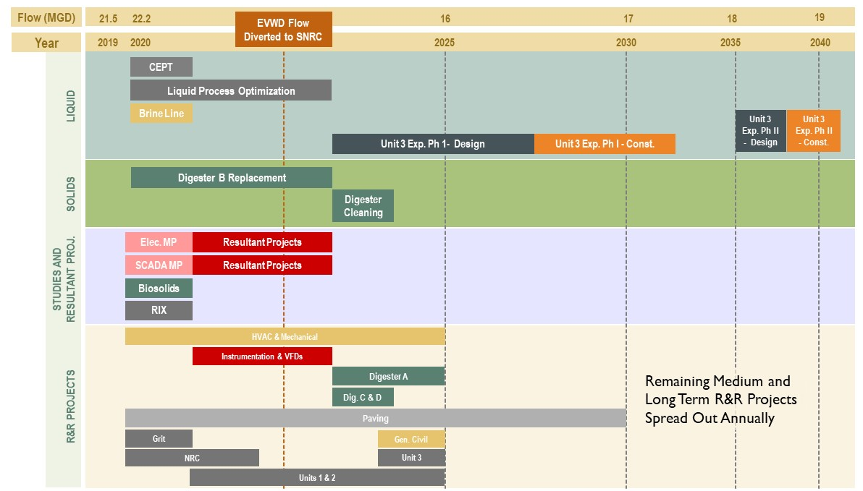

Unit 3 Expansion and Completion Project
Due to the magnitude of project cost for the Unit 3 Expansion and Completion Project, a comparison is made between:
- Maintaining existing WRP facilities without undertaking expansion of Unit 3, and
- Maintaining existing facilities while the Unit 3 Expansion and Completion Project is constructed.
Phasing of the Unit 3 Expansion and Completion Project and financing discussion are included in the following sections.

Phasing
Phasing the Unit 3 Expansion and Completion Project is recommended for two main reasons. First, the cost of implementation will be spread over a longer duration, which will make the project more financially feasible. Second, phasing of the project allows for Unit 1 to be utilized longer, taking advantage of the recent improvements performed on it.
Conceptually, the first expansion phase of Unit 3 would operate in tandem with Unit 1 to treat all of the flow that SBWRP receives, allowing Unit 2N and Unit 2S to be put out of service. The firm capacity of Unit 1 and Unit 3 combined would be 20 mgd, with a peak capacity of 54 mgd. Firm capacity is with the largest tank of each treatment process offline. For primary clarifiers, this is Unit 1. For Secondary Clarifiers it is also one of the Unit 1 tanks. For aeration, it is Unit 3 since the Unit 1 aeration has internal redundancy where just a pair of cells can be taken offline.
By keeping Unit 1 online, the firm capacity can be reached by building two thirds of Unit 3. This would consist of four new aeration trains, and four new secondary clarifiers, and no additional primary clarifiers. Additionally, certain parts of the project such as yard piping, odor control, splitter box, RAS gallery and electrical infrastructure would be built out to completion. The cost for Phase I of the Unit 3 Expansion Project would be about $80M.
Phase I of the Unit 3 Expansion would need to be completed by FY 2031/32 to avoid R&R costs associated with Unit 2N and Unit 2S. In Figure 11-2, R&R costs associated with Units 1, 2N and 2S are carried through the CIP until the completion of Phase I of the Unit 3 Expansion. After FY 2031/32, only Unit 1 R&R costs are carried through since it will continue to be in operation. Additionally, two CIP projects, Primary Flow Equalization (Section 10.1.1) and Secondary Capacity reduction (Section 10.2.2), would no longer needed with the implementation of the Unit 3 Expansion.
Phase II of the Unit 3 Expansion builds out the remainder of Unit 3 to allow for Unit 1 to go offline. Phase II would consist of new primary clarifiers, two additional new aeration trains, and two additional new secondary clarifiers. The cost for the second phase of the Unit 3 Expansion and Completion would be about $30M. This total cost of the phase approach is approximately $9M more costly than the estimate cost in Section 10.2.4 to account for inefficiencies in a phased approached from multiple design efforts and additional mobilization. Phase II of the expansion would be completed by FY 2040/41 in order to avoid R&R costs that are attributed to Unit 1. Completion of Unit 3 would also avoid the largest R&R cost in FY 2046/47, which is attributed to numerous Unit 1, 2N and 2S structures reaching their estimated end of life.

Figure 11-2: Unit 3 Expansion and Completion (Phased) with R&R avoided
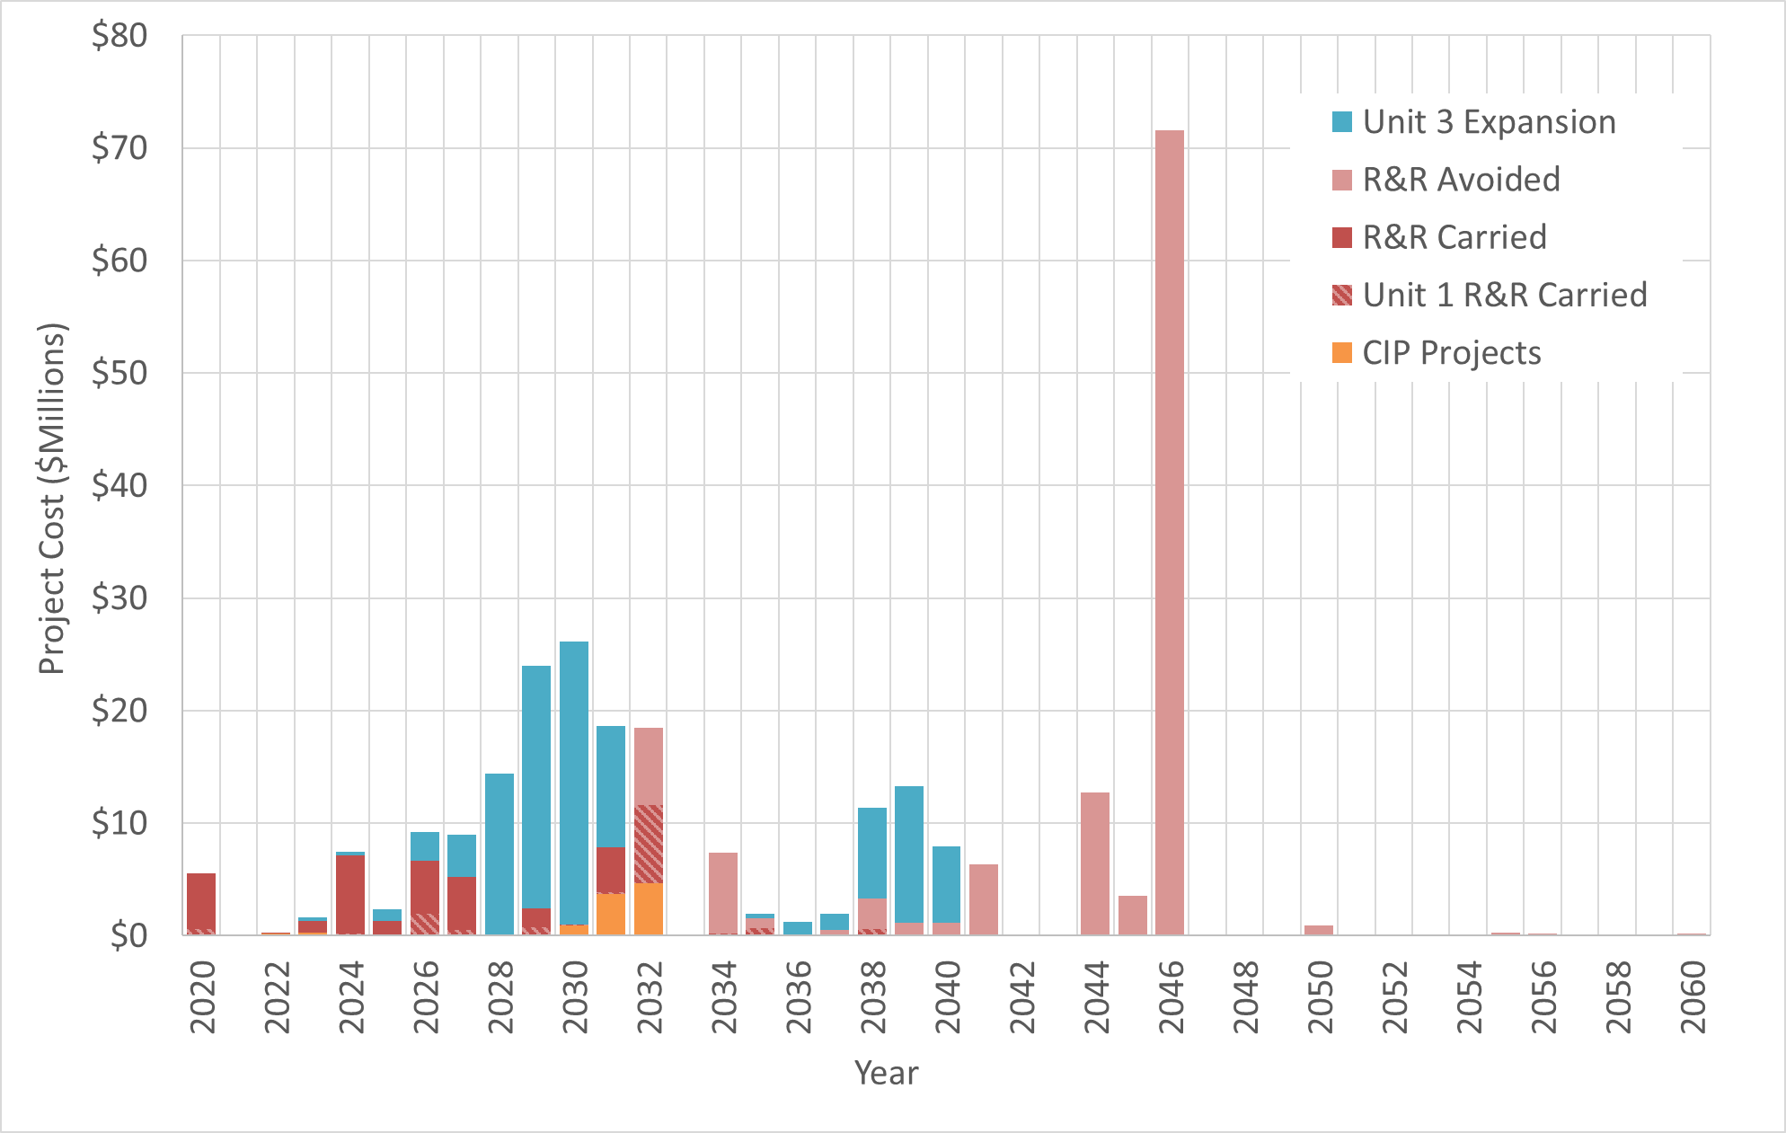

Cost Comparison and Financing
The graph below compares estimated cumulative costs with and without the Unit 3 Expansion. The blue lines represent annual costs including the Unit 3 Expansion and Completion Project and R&R on the existing facilities. The red lines represent annual R&R costs for maintaining the existing facility without the expansion project.

The solid lines represent the annual cost if SBMWD pays for the improvements “out-of-pocket” or pay as you go (PayGo). The dashed lines represent the annual cost if SBMWD pays for the improvements with bond financing. The bond financing option is based on a 2.06% interest rate that made the financing option equal to the PayGo option on a Net Present Value basis. With State/Federal loan programs, it is reasonable to assume that SBMWD will be able to get rates in that range or lower.

Figure 11-3: Cost Comparison with and without Phased Unit 3 Expansion
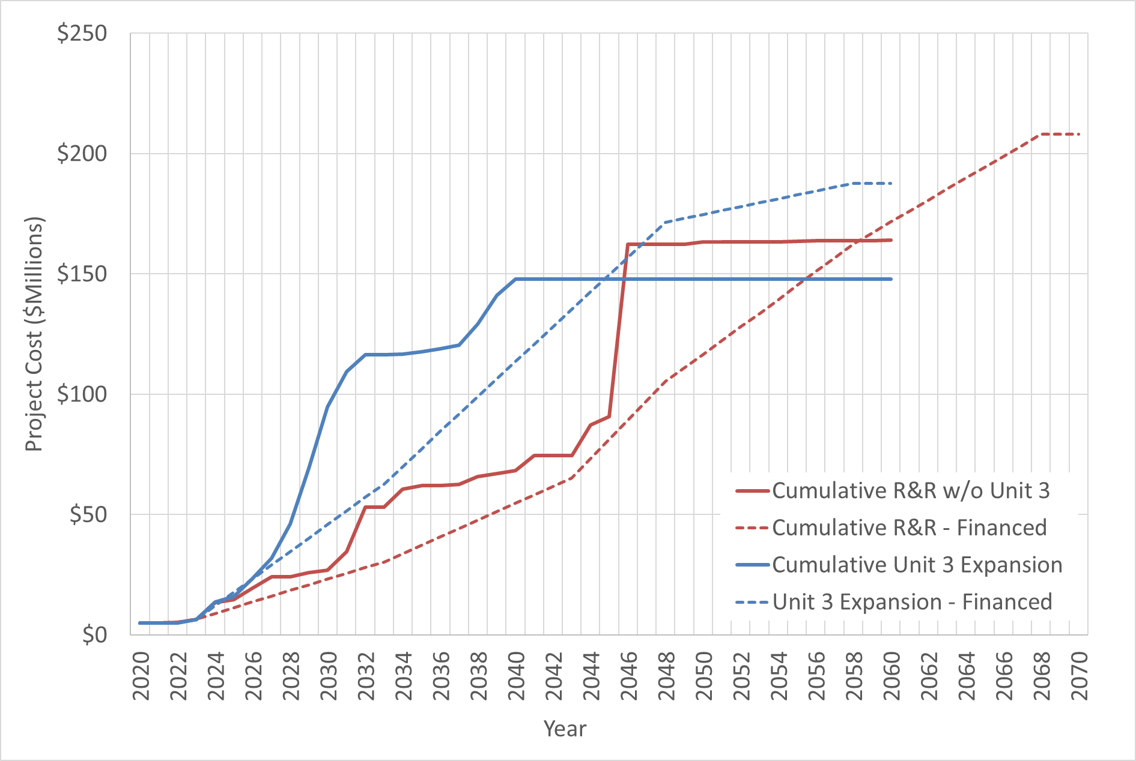

Project Implementation
This Section combines the R&R projects described in Section 9 with the optimization and efficiency projects and studies recommended in Section 10.7 to develop a CIP implementation plan.
The Phased Unit 3 Expansion and Completion Project is included in the CIP across the near-, medium- and long-term timeframes as presented in Section 11.4.1; however, costs are presented in the PayGo option rather than the financing option (described in Section 11.4.2).
Projects anticipated after July 2040 are not considered in this CIP prioritization.

Near-Term Projects (1 to 5 Years)
This section describes projects that are recommended within the next 5 years (FY 2020/2021 through FY 2024/2025). Cost estimates for each project are provided. Project cost estimates include construction markups and allowances for design, construction management, and CEQA compliance, as listed in Table 10-3, where applicable. A 30% project contingency is included in all project cost estimates, with exception to the Pavement R&R project.

Table 11-2: Near-Term Capital Improvements Project Costs
CIP Project | 2020/21 | 2021/22 | 2022/23 | 2023/24 | 2024/25 | TOTAL
Recommended Improvement Projects
Chemically Enhanced Primary Treatment (CEPT) | $360,000 |  |  |  |  | $360,000
Liquid Process Optimization | $200,000 | $660,000 | $660,000 |  |  | $1,520,000
Digester B Replacement | $800,000 | $3,600,000 | $3,600,000 |  |  | $8,000,000
Digester Cleaning |  |  |  | $3,200,000 |  | $3,200,000
Brine Line Manholes | $200,000 |  |  |  |  | $200,000
Unit 3 Expansion and Completion Phase I – Design |  |  |  | $475,000 | $476,000 | $951,000
Studies and Resultant Projects
Electrical Master Plan | $130,000 |  |  |  |  | $130,000
Electrical Master Plan Resultant Projects |  | $5,700,000 | $5,700,000 |  |  | $11,400,000
SCADA Master Plan | $260,000 |  |  |  |  | $260,000
SCADA Master Plan Resultant Projects |  | $2,950,000 | $2,950,000 |  |  | $5,900,000
Biosolids Strategic Plan | $390,000 |  |  |  |  | $390,000
RIX Facility Plan | $130,000 |  |  |  |  | $130,000
R&R Projects
HVAC and Misc. Mechanical Asset R&R | $100,000 | $100,000 | $100,000 | $100,000 | $100,000 | $500,000
Instrumentation R&R |  | $225,000 | $225,000 |  |  | $450,000
Liner and Containment Structure R&R |  |  |  |  | $240,000 | $240,000
Solids Handling and Digester A R&R |  |  | $469,000 | $2,110,500 | $2,110,500 | $4,690,000
Digester C & D R&R |  |  | $220,000 |  |  | $220,000
Pavement R&R | $364,000 | $364,000 | $364,000 | $364,000 | $364,000 | $3,640,000
Grit Removal System R&R | $2,520,000 |  |  |  |  | $2,520,000
Nitrogen Removal Carousel R&R | $1,915,000 | $1,915,000 |  |  |  | $3,830,000
VFD Replacement Project |  | $2,470,000 | $2,470,000 |  |  | $4,940,000
Units 1 and 2 R&R |  | $877,500 | $877,500 | $877,500 | $877,500 | $3,510,000
Unit 3 R&R |  |  |  |  | $1,720,000 | $1,720,000
Total | $7,399,000 | $18,861,500 | $17,635,500 | $7,027,000 | $5,787,000 | 56,710,000
Figure 11-4 provides a graphical visualization of the 5-year annual and cumulative costs as recommended in this Master Plan.

Figure 11-4: Total Near-Term Recommended Project and R&R Costs – 5 Year
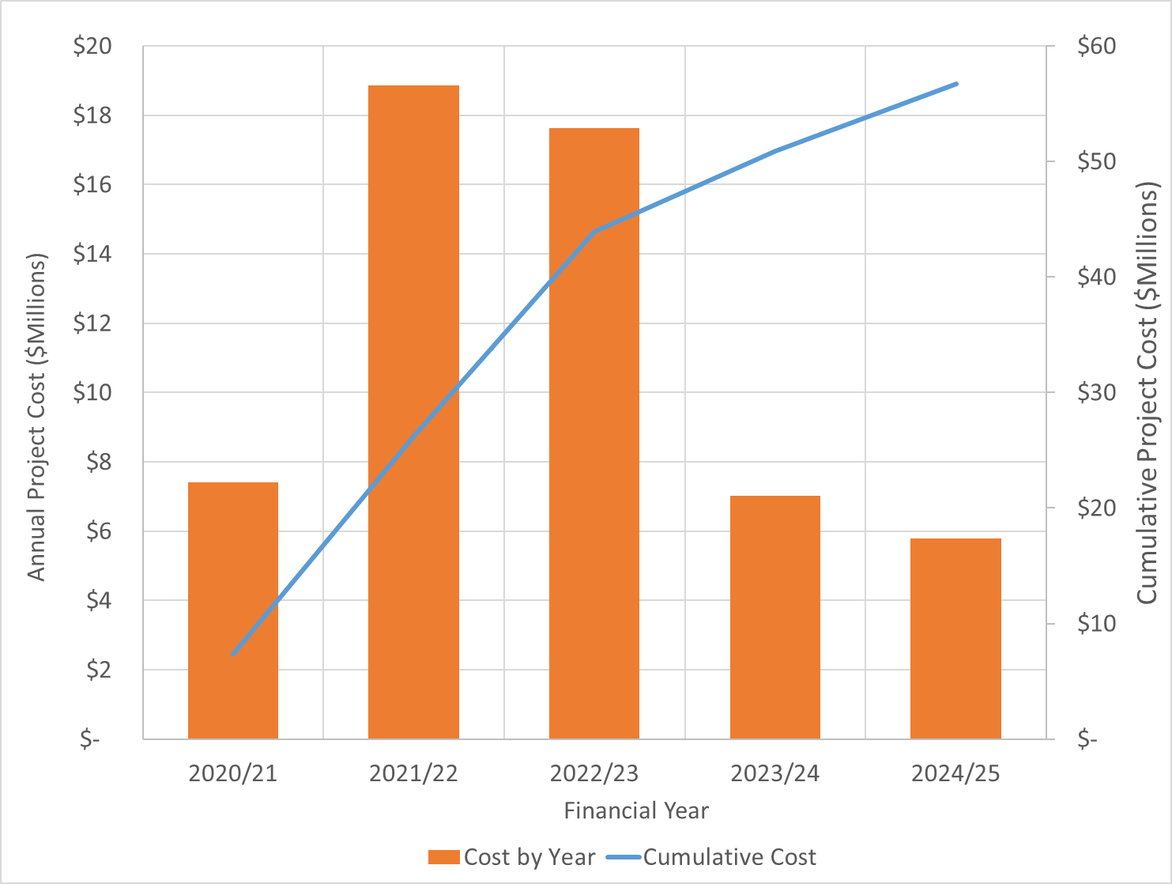

Recommended Medium-Term Projects (6 to 10 Years)
This section describes projects that are recommended within the 6- to 10-year period (FY 2025/2026 through FY 2029/2030). Table 11-3 provides project descriptions, along with construction and implementation costs for the projects over the 6- to 10-year time period. R&R projects and costs were determined by compiling assets from the asset registry with less than 10 years of remaining useful life remaining that were not addressed in the short-term projects.

Table 11-3: Recommended Medium-Term Capital Improvement Projects
CIP Project | Project Description | Construction Cost | Project Cost
Recommended Improvement Projects
Unit 3 Expansion and Completion Phase I – Design and CEQA | Design of the expanded Unit 3 treatment process to replace aging Unit 1, Unit 2 North and Unit 2 South primary and secondary process trains while keeping Unit 3 primaries in service. Evaluation would utilize multiple years of influent flow and load data following the departure of EVWD source flow to SBWRP, with design process beginning after the evaluation phase. The CEQA process would also take place during this phase. | $ - | $9,354,000
Unit 3 Expansion and Completion Phase I – Construction¹ | Construction of the expanded Unit 3 treatment process to replace aging Unit 1, Unit 2 North and Unit 2 South primary and secondary process trains while keeping Unit 3 primaries in service. Construction of a new process train would begin in the 2028/29 financial year and continue until 2031/32. | $31,250,000 | $35,937,000
R&R Projects
HVAC and Misc. Mechanical Asset R&R | R&R of aging HVAC and miscellaneous mechanical assets. Assets to be replaced include HVAC and various valves located in Electrical Administration Building, Boiler Building, and Headworks Tunnel and Splitter box. | $998,000 | $1,671,000
Instrumentation R&R | R&R of aging instrumentation assets. Instrumentation to be replaced include meters, sensors and probes located at the onsite wells, bar screen building and outfall sample stations. | $3,316,000 | $5,552,000
General Site Civil | R&R of aging assets at the Septage and Brine Receiving Station, Irrigation Control Building and Brine Ponds | $203,000 | $340,000
Solids Handling R&R | R&R of aging dewatering and digester assets. Assets to be replaced include various sludge handling, dewatering and odor control equipment located at the dewatering building, DAFTs, Digester A and sludge storage. | $6,733,000 | $11,274,000
Pavement R&R | R&R of pavement throughout the treatment plant site. This cost has been spread over a 10-year period. | $2,864,000 | $3,640,000
Lift Station R&R | R&R of aging assets associated with Arrowhead and East Influent Lift Stations. Assets to be replaced include pumps, motors, and sensors. | $1,700,000 | $2,846,000
Headworks R&R | R&R of aging assets associated with the headworks including grit removal and odor control systems. | $2,301,000 | $3,853,000
Nitrogen Removal Carousel R&R | R&R of aging assets associated with the Nitrogen Removal Carousel. Assets to be replaced include RAS/WAS pumps and motors, and various mechanical equipment. | $1,135,000 | $1,900,000
VFD R&R | R&R of aging assets associated with Variable Frequency Drives. Assets to be replaced include VFD and instrumentation located at the Roots Blower Building and Tertiary Reservoir. | $1,949,000 | $3,263,000
Units 1 and 2 R&R | R&R of aging assets associated with the Unit 1 and Unit 2 process. Assets to be replaced include diffusers, mixers, motors and miscellaneous mechanical equipment and instrumentation. | $3,760,000 | $6,296,000
Unit 3 R&R | R&R of aging assets associated with the Unit 3 primary process. Assets to be replaced include scum pumps, motors, grinders, and miscellaneous mechanical equipment and instrumentation. | $2,264,000 | $3,791,000
Total Medium-Term Project Cost |  |  | $85,919,000
Notes:
- The Unit 3 Expansion and Completion Phase I Construction spans the medium- and long-term ranges. The values in the table only present the costs from FY 2025/26 to 2029/30.

Recommended Long-Term Projects (11 to 20 Years)
This section lists projects that are recommended within the 11- to 20-year period (2030 through 2039). The cost for the Unit 3 Expansion and Completion project cost is discussed in Section • and outlined in CIP Sheet 2.4.
Table 11-4 provides construction and implementation costs for the projects over the 11- to 20-year time period. R&R projects and costs were determined by compiling assets from the asset registry with less than 20 years of remaining useful life remaining that were not addressed in the short-term or medium-term projects. R&R costs for Unit 1, Unit 2 North, Unit 2 South, and the NRC have been excluded from the long-term CIP recommended projects, since they are recommended to be abandoned after completion of the Unit 3 Expansion and Completion project.

Table 11-4: Recommended Long-Term Capital Improvement Projects
CIP Project | Construction Cost | Project Cost
Recommended Improvement Projects
Unit 3 Expansion and Completion Phase I – Construction¹ | $31,250,000 | $35,937,000
Unit 3 Expansion and Completion Phase II – Design | $ - | $3,047,000
Unit 3 Expansion and Completion Phase II – Construction | $23,437,500 | $26,953,000
R&R Projects
HVAC and Misc. Mechanical Asset R&R | $5,307,000 | $8,886,000
Instrumentation R&R | $11,424,000 | $19,128,000
General Site Civil | $571,000 | $956,000
Solids Handling R&R | $21,945,000 | $36,745,000
Lift Station R&R | $4,599,000 | $7,701,000
Digester C & D R&R | $1,153,000 | $1,931,000
Paving R&R | $661,000 | $1,107,000
Headworks R&R | $6,032,000 | $10,100,000
VFD R&R | $3,722,000 | $6,232,000
Unit 3 R&R | $1,576,000 | $2,639,000
Total Long-Term Project Cost |  | $161,362,000
Notes:
- The Unit 3 Expansion and Completion Phase I Construction spans the medium- and long-term ranges. The values in the table only present the costs from FY 2030/31 to 2031/32.

CIP Summary
Figure 11-5 depicts the next 20 years of CIP project costs summarized in annual costs and cumulative costs. The increase in capital spending from 2028 to 2031 is from the Unit 3 Expansion and Completion project. R&R costs after FY 2031/2032 are assumed to be spread out evenly across each year due to unknown scheduling more than 10 years in the future.
Approximately $305 million in project costs and R&R is expected for the SBWRP over the next 20 years.

Figure 11-5: Total Recommended Project and R&R Costs – 20 Year
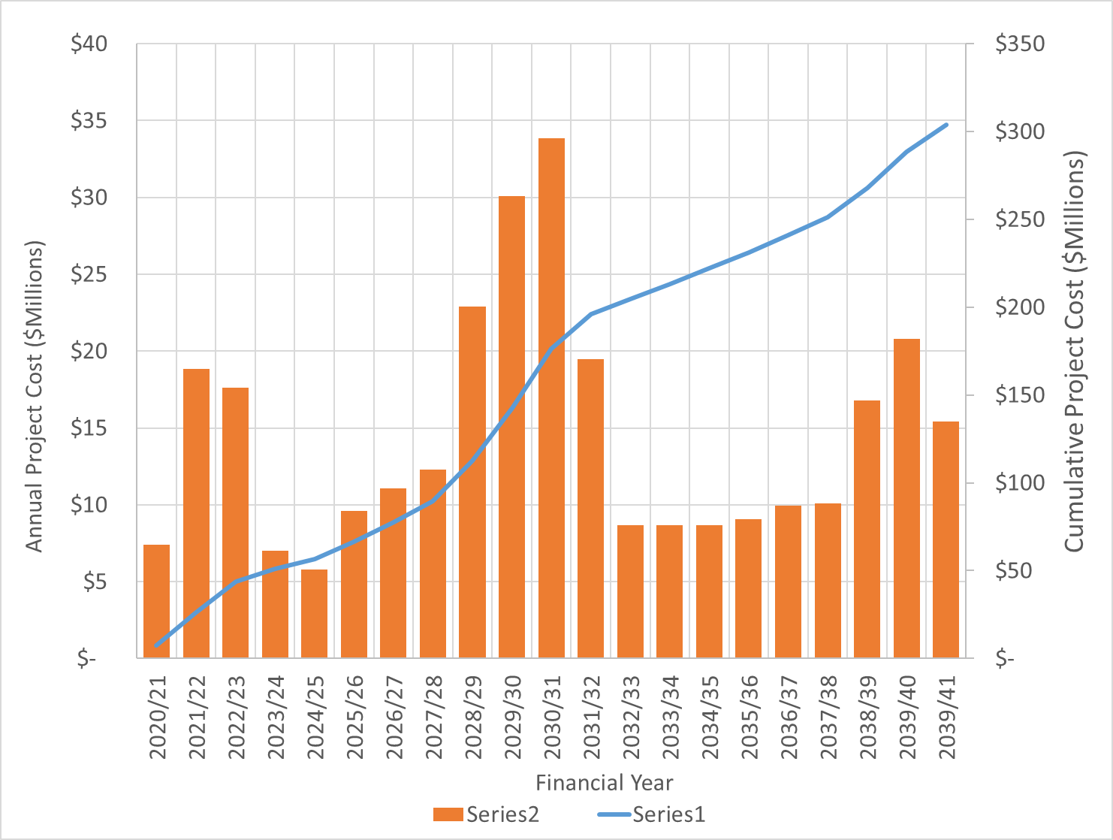

References
AECOM. (2019). Draft Preliminary Design Report, Tertiary Treatment System.
AECOM. (2019, October). San Bernardino Municipal Water Department, Tertiary Treatment System, Design Plans (Progress Set)
Black & Veatch. (2012, August). Preliminary Design Report, Overhaul of Unit 1 Primary and Aeration System Project at the San Bernardino Water Reclamation Plant. B&V Project No. 176264.
California Legislative Information. (2017-2018). AB-967 Human remains disposal: alkaline hydrolysis: licensure and regulation. Retrieved from https://leginfo.legislature.ca.gov/faces/billTextClient.xhtml?bill_id=201720180AB967
California Regional Water Quality Control Board, Santa Ana Region. (2013, August 1). Waste Discharge Requirements for the Colton/San Bernardino Tertiary Treatment and Water Reclamation Authority, Regional Tertiary Treatment Rapid Infiltration and Extraction Facility.
California Regional Water Quality Control Board, Santa Ana Region. (2016, December 16). Colton/San Bernardino Tertiary Treatment Rapid Infiltration and Extraction Facility: Update on Operational Impacts to Santa Ana Sucker.
California Regional Water Quality Control Board, Santa Ana Region. (2017, December 15). Waste Discharge Requirements for the City of San Bernardino Municipal Water Department Water Reclamation Facility, Order No. R8-2017-0049, NPDES No. CA0105392.
Carollo. (2000, August). City of San Bernardino Operations & Maintenance Manual, Water Reclamation Plant.
Carollo. (2011, September). Overhaul of Unit 1 Primary Clarifier and Aeration System, San Bernardino Municipal Water Department. Technical Memorandum No. 1, Project Development, Final.
Carollo. (2016, November). Process Master Plan for the Water Pollution Control Facility.
Carollo. (2018, May). Digester Gas Beneficial Use Study, San Bernardino Water Reclamation Plant.
Colton/San Bernardino Tertiary Treatment and Reclamation Authority. (August 2018 - July 2019). RIX DMR Data.
Hazen and Sawyer. (2019, May 9). Spec 1696, Rule 1110.2 Resultant Projects, Preliminary Design Report.
Hazen and Sawyer. (2020, March 27). San Bernardino Municipal Water Department WRP Facilities Assessment, Total Dissolved Solids and Total Inorganic Nitrogen Assessment Technical Memorandum – Draft.
Hazen and Sawyer. (undated). Understanding of the scope presented in the 1110.2 Resultant Project RFP.
Lincus Incorporated. (2019, June 24). Southern California Edison Third Party Programs, Project Feasibility Study, San Bernardino Municipal Water District, Wastewater Process Optimization.
Metcalf & Eddy. (2014). Wastewater Engineering, Treatment, Disposal, Reuse. 5th Edition.
New England Interstate Water Pollution Control Commission. (2011). TR-16, Guides for the Design of Wastewater Treatment Works.
Orange County Sanitation District. (2018, August 22). Orange County Sanitation District Memorandum to Steering Committee. General Manager's Fiscal Year 2018-2019 Work Plan.
Orange County Sanitation District. (2019, May 29). Ordinance No. OCSD-53 – An Ordinance of the OCSD Board of Directors Amending Wastewater Discharge Regulations and Repealing Ordinance No. OCSD-48.
San Bernardino County Stormwater Program. (2019). San Bernardino County Stormwater Program. Retrieved July 10, 2019, from https://sbcountystormwater.org/government/about-the-permittees/
San Bernardino Municipal Water Department. (2018, April 1). Stormwater Pollution Prevention Plan & Best Management Practices, City of San Bernardino Municipal Water Department, Water Reclamation Facility, Order No. R8-2017-0049 NPDES No. CA0105392.
San Bernardino Municipal Water Department. (2019). Capital Improvement Budget Summary, Sewer Treatment, FY 2019-2020.
San Bernardino Valley Municipal Water District. (2011). Ordinance No. 74. Ordinance of the San Bernardino Valley Municipal Water District Superceding Ordinance Number 73 which Establishes Regulations for the Use of the Inland Empire Brine Line.
San Bernardino Valley Municipal Water District. (2019, January 30). Memorandum of Understanding Regarding Upper Santa Ana River Habitat Conservation Efforts and Joint Development of Groundwater Recharge Projects.
San Bernardino Valley Municipal Water District and City of Colton. (1972, June 20). Agreement.
San Bernardino Valley Municipal Water District. (June 2016). 2015 San Bernardino Valley Regional Urban Water Management Plan.
San Manuel Band of Mission Indians and ESA. (2018). San Manuel Hotel and Casino Expansion Project, Final Tribal Environmental Impact Report. Retrieved from https://www.sanmanuel-nsn.gov/Portals/1/SanManuelTeir/San%20Manuel_Final%20TEIR_WEB.pdf
Santa Ana Watershed Project Authority. (n.d.). Inland Empire Brine Line. Retrieved July 11, 2019, from https://sawpa.org/inland-empire-brine-line/
Santa Ana Watershed Project Authority. (n.d.). TIN/TDS Task Force. Retrieved July 11, 2019, from https://sawpa.org/task-forces/tin-tds-task-force/#background
South Coast Air Quality Management District. (2019, August). Proposed Amended Rule 1110.2, Emissions from Gaseous and Liquid-fueled Engines. Retrieved from http://www.aqmd.gov/docs/default-source/rule-book/Proposed-Rules/1110.2/par1110-2_wgm6_final.pdf?sfvrsn=6
Southern California Association of Governments (2016). 2016-2040 RTP/SCS Final Growth Forecast by Jurisdiction.
Superior Court of the State of California for the County of Orange. (1969, April 17). Orange County Water District, Plaintiff vs. City of Chino, et. al., Defendants. No 117628, Judgement.
U.S. Department of Transportation, Federal Aviation Administration. (2007, August 28). Advisory Circular. Hazardous Wildlife Attractants on or Near Airports.
United States. (2018, July 1). Code of Federal Regulations, Title 40, Protection of the Environment, Part 503 - Standards for the Use or Disposal of Sewage Sludge.
United States Bureau of Reclamation. (2013). Overview of Disadvantaged Communities and Native American Tribes in the Santa Ana Watershed. Retrieved from https://www.usbr.gov/lc/socal/basinstudies/OWOWReferences/FinalReport/Tribal%20DAC%20Report.pdf
United States Geological Survey. (1991). Bulletin 1898. Liquefaction Susceptibility in the San Bernardino Valley and Vicinity, Southern California - a Regional Evaluation. Retrieved from https://pubs.usgs.gov/bul/1898/report.pdf
Upper Santa Ana Habitat Conservation Plan. (n.d.). Retrieved July 10, 2019, from http://www.uppersarhcp.com/
US Department of Transportation, Federal Aviation Administration. (2012, January 1). Code of Federal Regulations, Title 14 - Aeronautics and Space. Chapter 1 Part 77.9 Construction or Alteration Requiring Notice.
Wildermuth Environmental, Inc. (2015). Addendum to the 20089 Santa Ana River Wasteload Allocation Model Report: Scenario 8. Retrieved from https://www.sawpa.org/wp-content/uploads/2018/01/WLAM-Scenario-8-wAppendix_Final.pdf

Exhibit 1: Site Plan

Exhibit 2: Process Flow Diagram

Exhibit 3: FEMA Flood Insurance Rate Map, Panel 8683 of 9375

Appendix A: Total Dissolved Solids and Total Inorganic Nitrogen Assessment Technical Memorandum – Draft

Appendix B: Condition Assessment Appendices (2 combined)

Appendix C: Risk Assessment Appendices (4 combined)

Appendix D: Influent Flows and Loads

Appendix E: Process data analysis (Primary and secondary charts)

Appendix F: Operational Efficiency & Optimization Projects – CIP Sheets

